All About Grimpoteuthis, the Dumbo Octopus
By
Anne Marie Helmenstine, Ph.D.
Updated July 13, 2019
Deep on the ocean floor, there lives an octopus with a name straight out of a Disney movie. The dumbo octopus takes its name from Dumbo, the elephant that used its massive ears to fly. The dumbo octopus "flies" through water, but the flaps on the side of its head are specialized flippers, not ears. This rare animal displays other unusual traits that are adaptations to life in the cold, pressurized depths of the ocean.

Description

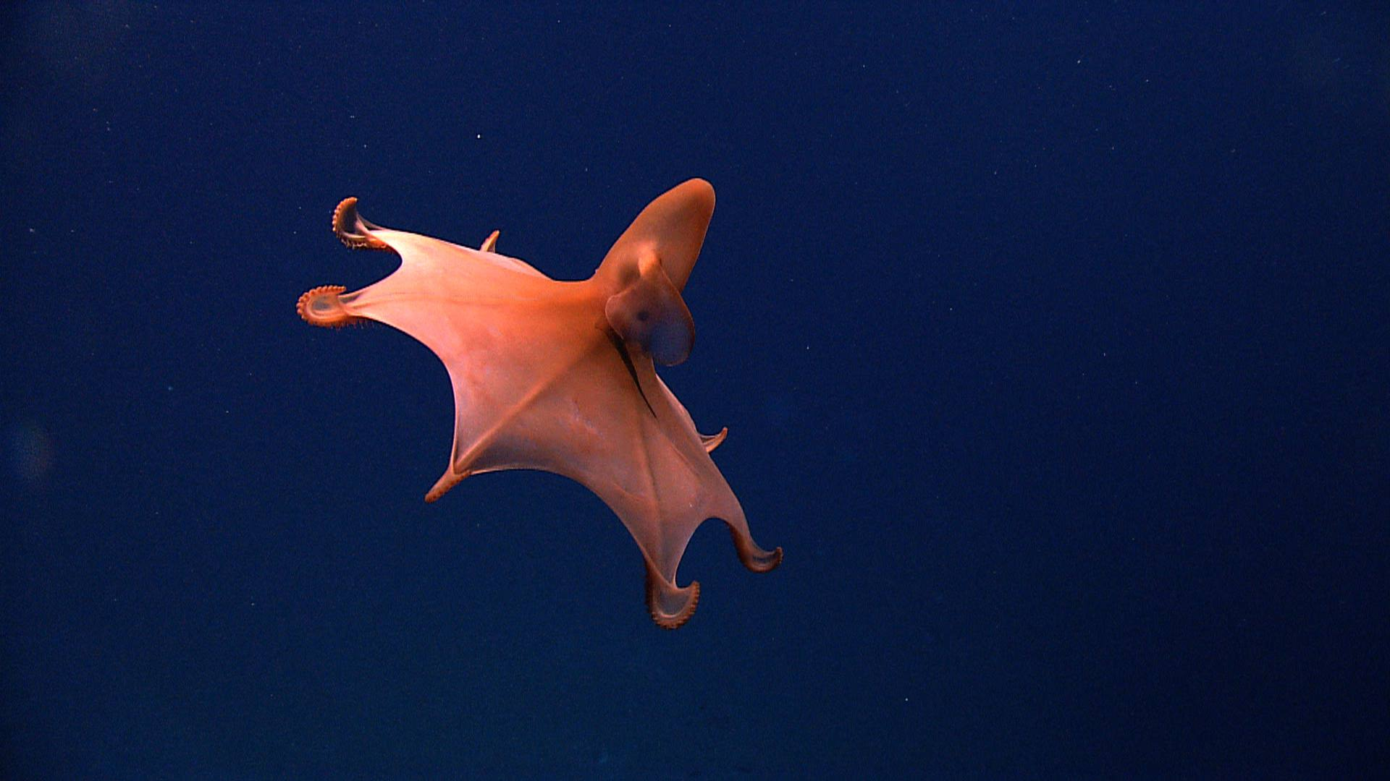

There are 13 species of dumbo octopuses. The animals are members of the genus Grimpoteuthis, which in turn is a subset of the family Opisthoteuthidae, the umbrella octopuses. There are distinctions between the dumbo octopus species, but all are bathypelagic animals found on or near the deep ocean floor. All dumbo octopuses have the characteristic umbrella shape caused by webbing between their tentacles and all have ear-like fins they flap to propel themselves through the water. While the flapping fins are used for propulsion, the tentacles act as a rudder to control the swimming direction and are how the octopus crawls along the seafloor.
The average size of a dumbo octopus is 20 to 30 centimeters (7.9 to 12 inches) in length, but one specimen was 1.8 meters (5.9 feet) in length and weighed 5.9 kilograms (13 pounds). The average weight of the creatures is unknown.
The dumbo octopus comes in various shapes, sizes, and colors (red, white, brown, pink), plus it has the ability to "flush" or change color to camouflage itself against the ocean floor. The "ears" may be a different color from the rest of the body.
Like other octopuses, Grimpoteuthis has eight tentacles. The dumbo octopus has suckers on its tentacles but lacks the spines found in other species used to defend against attackers. The suckers contain cirri, which are strands used to locate food and sense the environment.
Members of the Grimpoteuthis species have large eyes that fill about a third the diameter of their mantle or "head," but their eyes have limited use in the eternal darkness of the depths. In some species, the eye lacks a lens and has a degraded retina, likely only allowing for detection of light/dark and movement.
Habitat

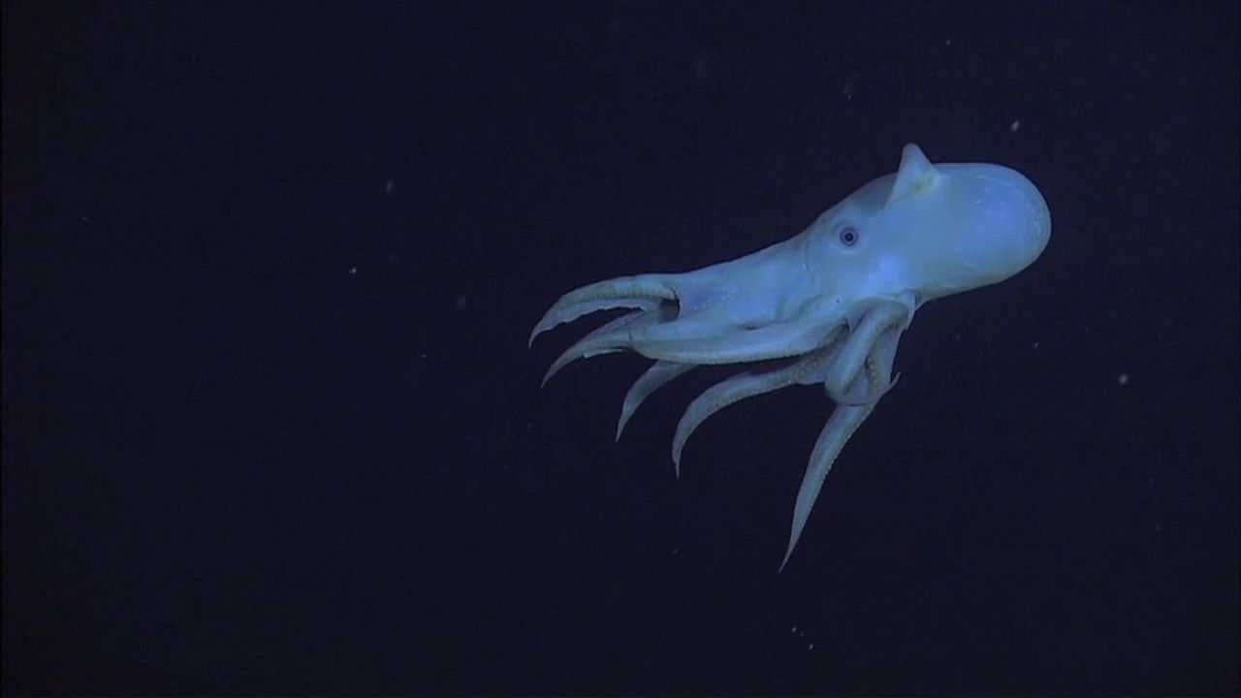
Grimpoteuthis species are believed to live worldwide in the cold depths of the ocean from 400 to 4,800 meters (13,000 feet). Some survive at 7,000 meters (23,000 feet) below sea level. They have been observed off the coasts of New Zealand, Australia, California, Oregon, Philippines, New Guinea, and Martha's Vineyard, Massachusetts. They are the deepest-living octopus, found on the seafloor or slightly above it.

Behavior
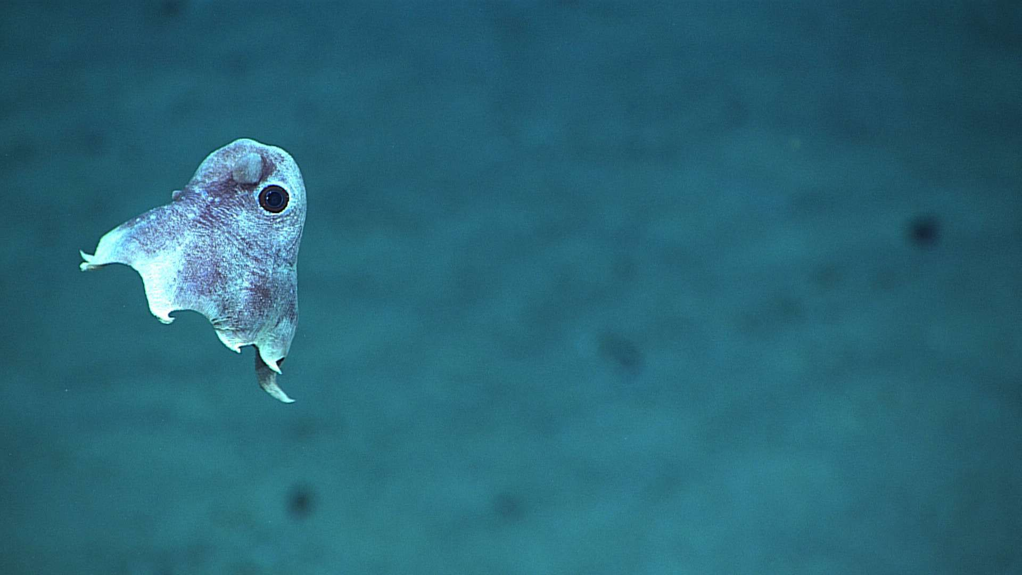
The dumbo octopus is neutrally buoyant, so it may be seen hanging suspended in the water. The octopus flaps its fins to move, but it can add a burst of speed by expelling water through its funnel or expanding and suddenly contracting its tentacles. Hunting involves catching unwary prey in the water or seeking them out while crawling along the bottom. The octopus behavior conserves energy, which is at a premium in a habitat where both food and predators are relatively scarce.

Diet
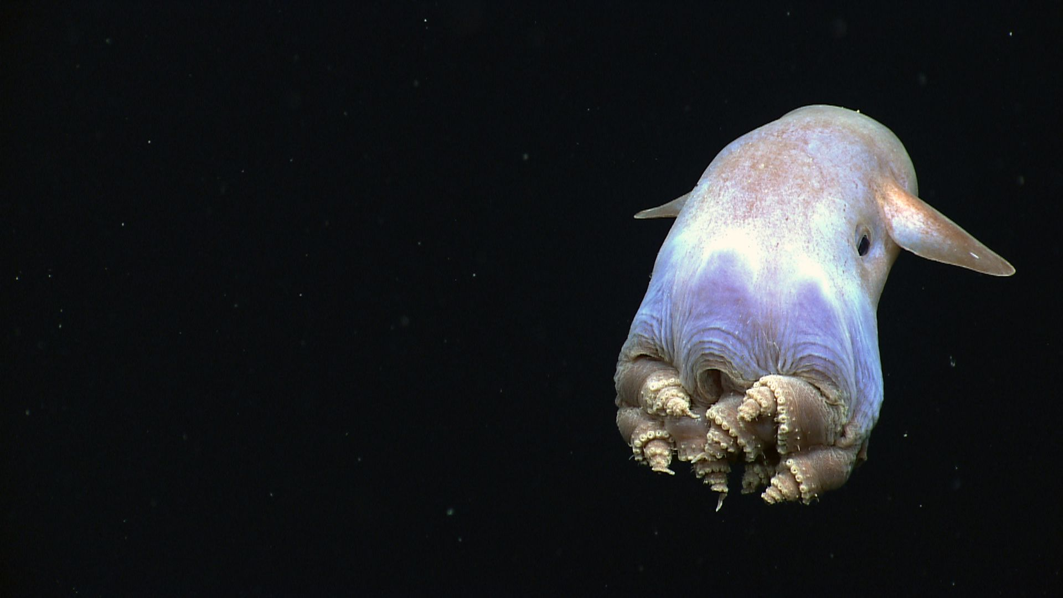

The dumbo octopus is a carnivore that pounces upon its prey and devours it whole. It eats isopods, amiphipods, bristle worms, and animals living along thermal vents. The mouth of a dumbo octopus is different from that of other octopuses, which rip and grind their food apart. In order to accommodate whole prey, the tooth-like ribbon called the radula has degenerated. Basically, a dumbo octopus opens its beak and engulfs its prey. The cirri on the tentacles may produce water currents that help force food closer to the beak.

Reproduction and Life Span
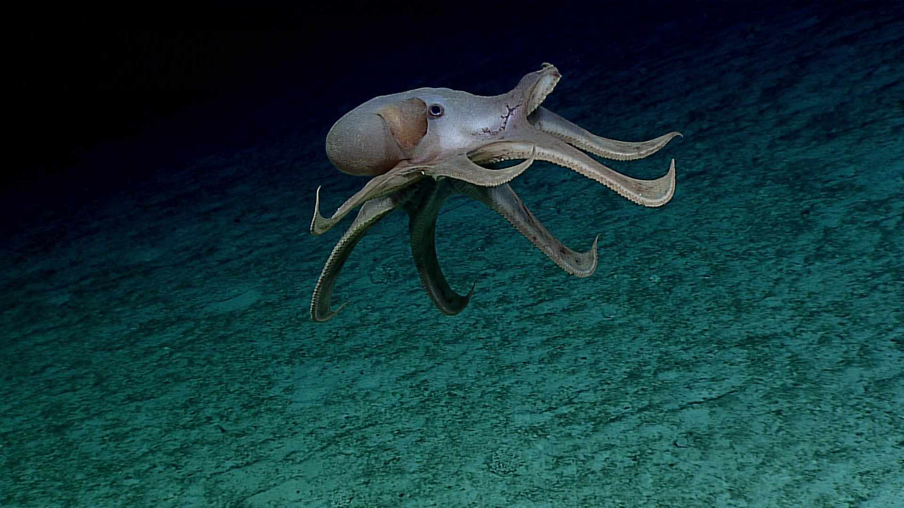

The dumbo octopus' unusual reproductive strategy is a consequence of its environment. Deep beneath the sea surface, seasons have no significance, yet food is often scarce. There is no special octopus breeding season. One arm of a male octopus has a special protuberance used to deliver a sperm packet into the mantle of a female octopus. The female stores the sperm to use when conditions are favorable for laying eggs. From studying dead octopuses, scientists know females contain eggs at different maturation stages. Females lay eggs on shells or beneath small rocks on the seafloor. The young octopuses are large when they are born and must survive on their own. A dumbo octopus lives around 3 to 5 years.

Conservation Status
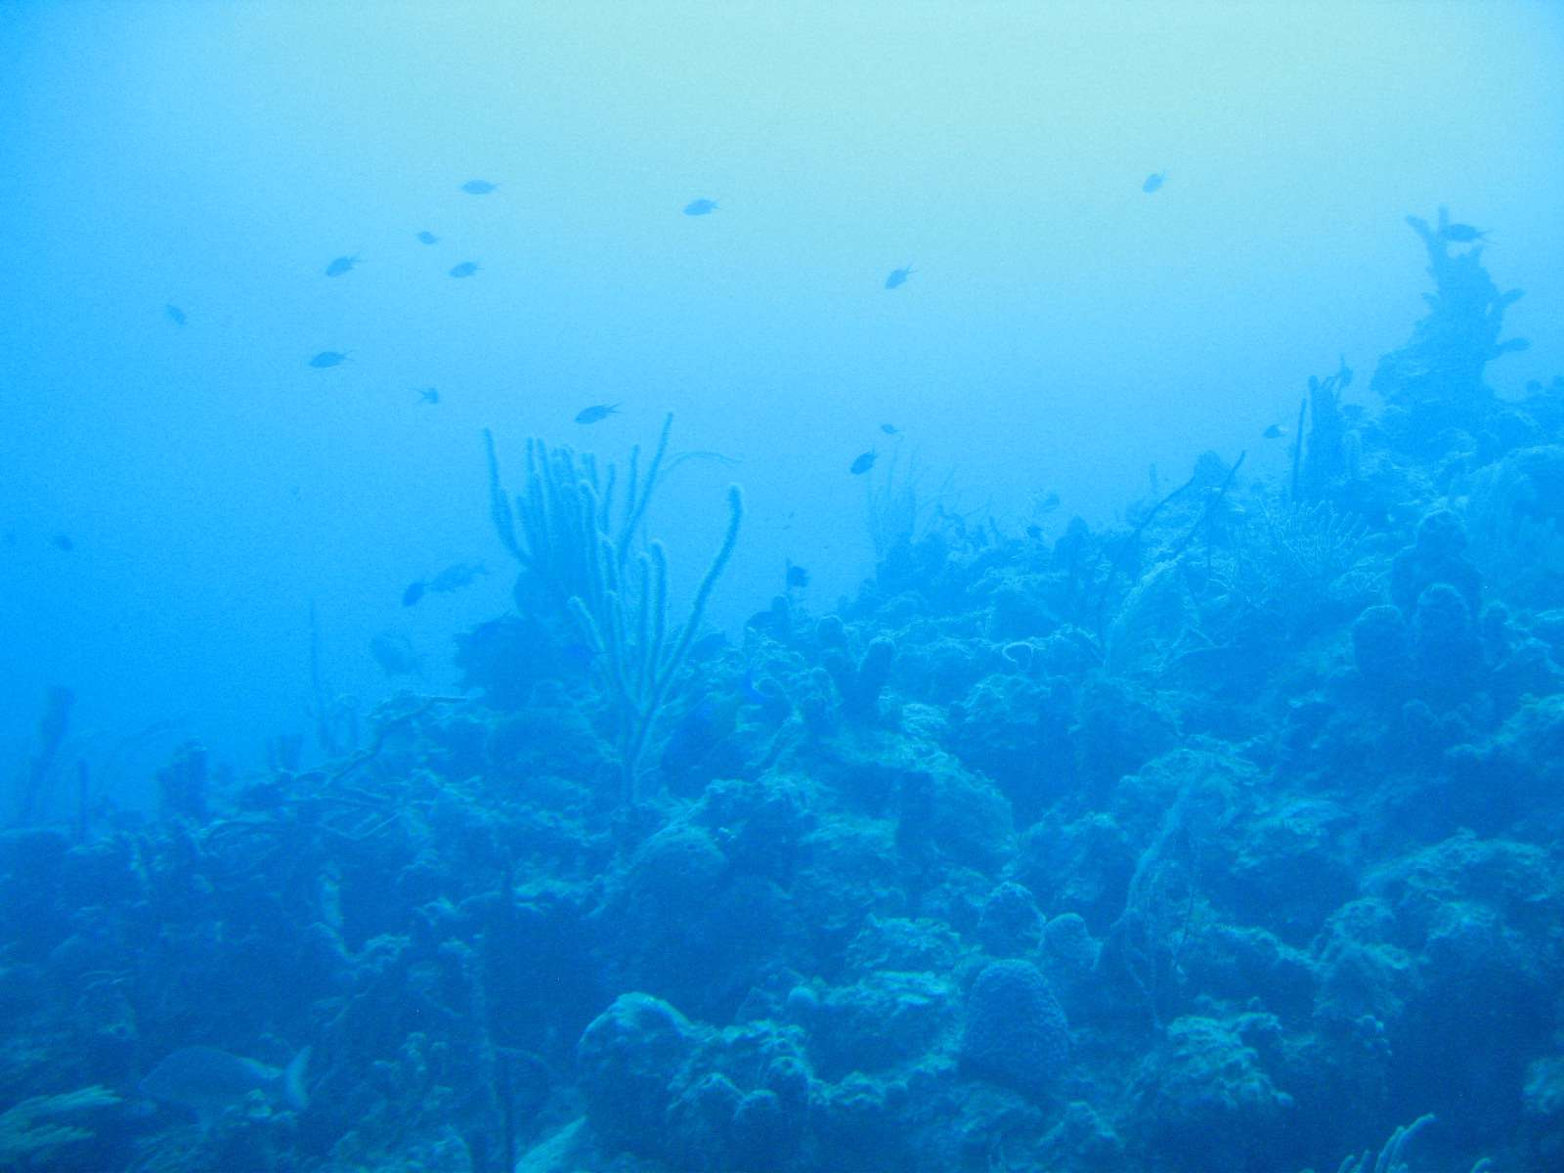

The ocean depths and seafloor remain largely unexplored, so sighting a dumbo octopus is a rare treat for researchers. None of the Grimpoteuthis species have been evaluated for conservation status. While sometimes trapped in fishing nets, they are largely unaffected by the activity of humans because of how deep they live. They are preyed upon by killer whales, sharks, tuna, and other cephalopods.

Fun Facts

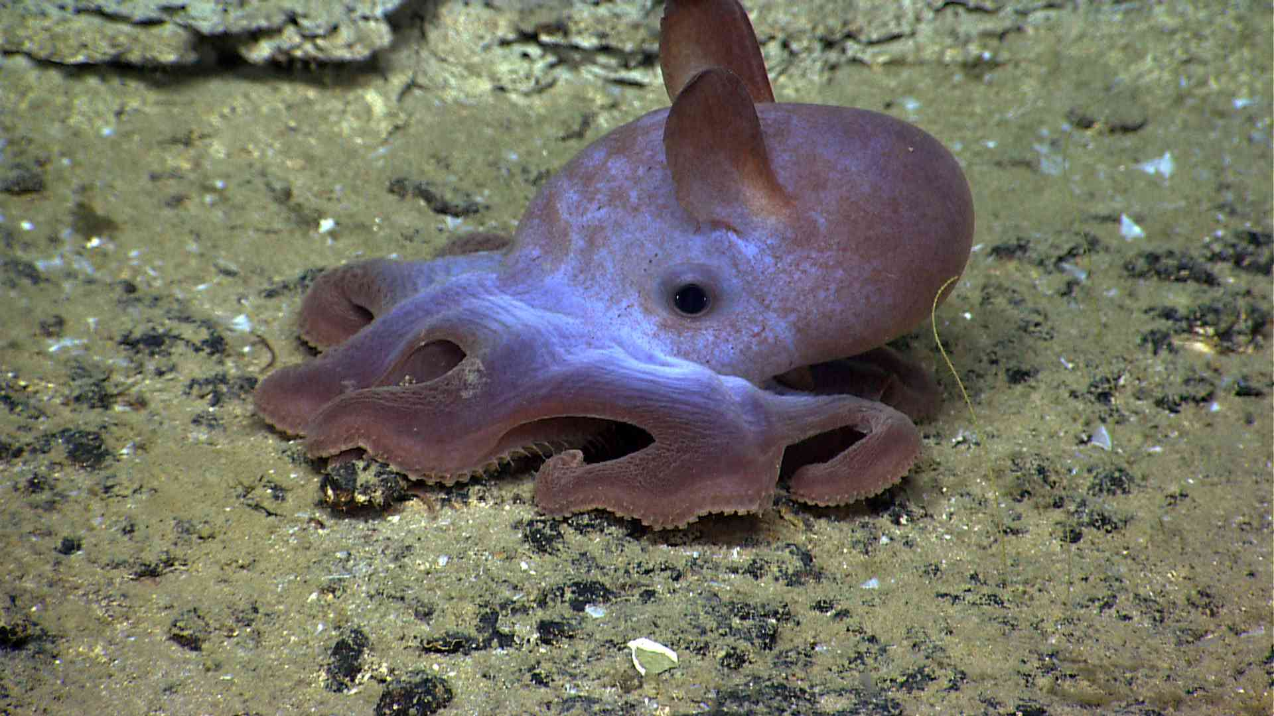

Some interesting, yet lesser-known facts about the dumbo octopus include:
- The dumbo octopus, like other deep-sea octopuses, cannot produce ink. They lack ink sacs.
- You'll never find a dumbo octopus in an aquarium or a pet store. While there are octopus species that survive under the temperature, pressure, and lighting conditions found in an aquarium, the dumbo octopus is not among them. The only way to observe this species is via deep-sea exploration of its natural habitat.
- The appearance of the dumbo octopus changes once they are removed from their highly pressurized environment. The bodies and tentacles of preserved specimens shrink, making the fins and eyes seem even larger than life.
Dumbo Octopus Fast Facts
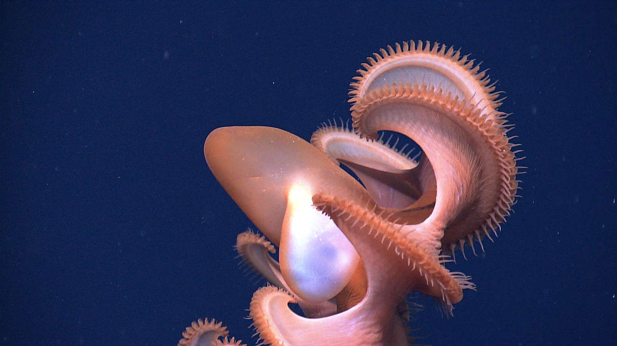

- Common Name: Dumbo Octopus.
- Scientific Name: Grimpoteuthis (Genus).
- Classification: Phylum Mollusca (Mollusks), Class Cephalopoda (Squids and Octopuses), Order Octopoda (Octopus), Family Opisthoteuthidae (Umbrella Octopus).
- Distinguishing Characteristics: This species swims using its ear-like fins, while its tentacles are used to control the swimming direction and for crawling on the surface.
- Size: The size depends on species, with an average size of 20 to 30 centimeters (about 8 to 12 inches).
- Lifespan: 3 to 5 years.
- Habitat: Worldwide at depths of 3000 to 4000 meters.
- Conservation Status: Not Yet Classified
- Fun Fact: Grimpoteuthis is the deepest-living of any known octopus species.
Sources
Collins, Martin A. "Taxonomy, ecology and behaviour of the cirrate octopods." Roger Villaneuva, In: Gibson, R.N., Atkinson, R.J.A., Gordon, J.D.M., (eds.), Oceanography and marine biology: an annual review, Vol. 44. London, Taylor and Francis, 277-322, 2006.
Collins, Martin A. "The genus Grimpoteuthis (Octopoda: Grimpoteuthidae) in the north-east Atlantic, with descriptions of three new species". Zoological Journal of the Linnean Society, Volume 139, Issue 1, September 9,2003.
Villanueva, Roger. "Observations on the behaviour of the cirrate octopod Opisthoteuthis grimaldii (Cephalopoda)." Journal of the Marine Biological Association of the UK, 80 (3): 555–556, June 2000.

https://www.thoughtco.com/grimpoteuthis-dumbo-octopus-4160927?print

