10 Dumbo Octopus Facts & Adaptations!
By
IP Factly Jun 4, 2015
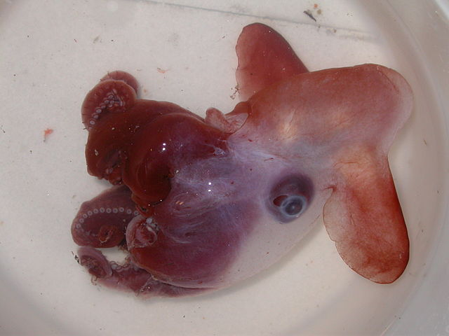
One of the rare finned octopods known as "Dumbos" collected on the summer 2009 MAR-ECO cruise. PD Image by Mike Vecchione, NOAA
Dumbo Octopus by NOAA Ocean Explorer CC BY-SA 2.0

Dumbo octopus refers to one of the 13, 14, 17 or 18 species – scientists haven’t agreed yet on how many species have been discovered – of deep-sea octopuses (that’s the generally accepted plural; not octopi) in the genus Grimpoteuthis. They are one of the cutest sea creatures but also one of the rarest, which is why not much is known about them. They remain mysteries of the deep. So far, here’s what we know:

1. They get their names from their ‘ears’.
The most obvious characteristic of dumbo octopuses is their rounded ‘ears’ sticking out of the sides of their heads. No other kind of octopus has these and they are quite large so they look like elephant ears, in particular, the ears of the famous Disney character, Dumbo. That’s how they got their name.
They are also sometimes called winged octopuses because the ‘ears’ can also look like ‘wings’. (Remember how Dumbo could fly?)
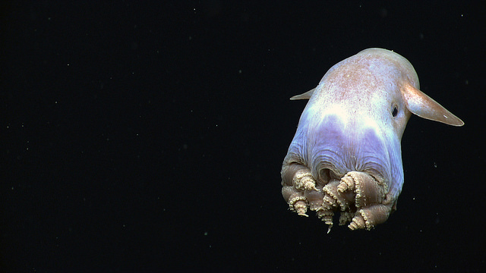
However, they are neither ears nor wings but fins and just as fishes use their fins to swim, dumbo octopuses flap these fins to float above the ocean floor and move in different directions. That’s the main way they swim around to conserve energy, although they can also swim via jet propulsion like other octopuses – swallowing a large amount of water and then letting it out all at once to push the octopus forward quickly. They can also crawl across the ocean floor.
One of the rare finned octopods known as “Dumbos” collected on the summer 2009 MAR-ECO cruise. PD Image by Mike Vecchione, NOAA

2. They have big eyes.
Aside from their ears, dumbo octopuses are also known for having bell-shaped heads and big eyes. In fact, the diameter of their eyes is about one third of the width of their head. (In comparison, the diameter of the eyes of a human adult are about 1/7 the width of their skull.)
In spite of their size, though, the eyes of a dumbo octopus can barely see, which isn’t really a problem. After all, what good is good eyesight when it’s dark? Instead, the dumbo octopus finds its way around mostly by feeling its surroundings through the suckers on its tentacles or sensing the water current using the strand-like structures around its suckers called cirri.

3. They belong to a group of octopuses called umbrella octopuses.

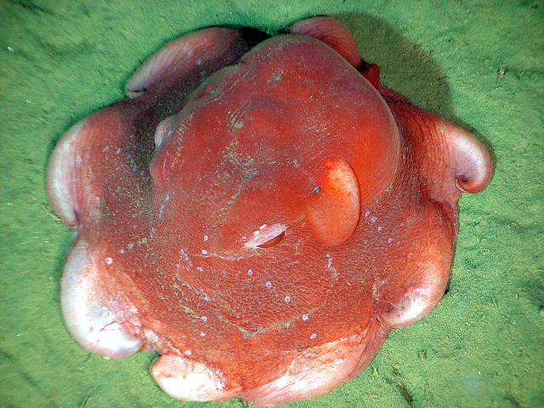
Umbrella octopus by Ed Bowlby, NOAA/Olympic Coast NMS; NOAA/OAR/Office of Ocean Exploration PD Image
Dumbo octopuses belong to the family of octopuses called Opisthoteuthidae which are also known as umbrella octopuses. They are called such because they have webbing between their arms and so when they spread their arms out, they look like umbrellas when viewed from the bottom. One of them even looks so flat and round that it is called the flapjack or pancake octopus.
Another characteristic umbrella octopuses have is that they only have suckers on their tentacles, unlike some octopuses which also have spines on their tentacles with which to defend themselves against predators.

4. They can grow over 5 feet long.
Most dumbo octopuses are small, measuring less than a foot long. However, some species can go over five feet long and the largest ever caught was 5.9 feet long – that’s longer than two pairs of pants – and weighed 13 pounds.

5. They live where it’s very deep.

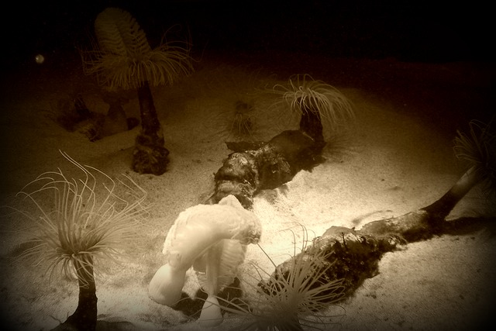
Ocean floor. Image credit: tyger_lyllie cc2.0
We mentioned that dumbo octopuses live in deep oceans. How deep? From 9,800 to 23,000 feet deep. That’s very deep and very cold and scientists have not found out yet how dumbo octopuses have adapted to the cold temperatures. They only know how dumbo octopuses adapt to such a high pressure environment and that is by having soft, jelly-like bodies that easily change shape and easily float.

6. They can change color.

Dumbo octopuses come in different colors, some white, some red, some brown, some pink. Like most octopuses, they can also change color or ‘flush’ the outermost layer of their skin to make it appear different, effectively camouflaging them against the ocean floor.

7. They do not produce ink.
Producing ink is one of the special abilities many octopuses have, enabling them to escape from predators. Dumbo octopuses, however, like other deep-sea octopuses, have no ink sacs. This makes sense as ink wouldn’t serve any purpose in the dark.
Instead of ink sacs, dumbo octopuses have cirri or strand-like structures on their suckers which help them sense their environment and also help them find food, though their function is yet to be fully understood.

8. The females can lay their eggs anytime they want.
Eggs art by geralt PD Image
As we said, living in the deep is hard. Many dumbo octopuses do not survive and those that do only live about three to five years. To compensate for this, dumbo octopuses have a high reproductive rate. In fact, scientists believe that they do not have breeding seasons. Rather, the female can store her eggs, and lay them any time of the year.
As with other octopuses, mating occurs when the male octopus hands the female a sperm packet. The female uses the sperm as she sees fit, fertilizing the eggs when she thinks the time is right. When they are fully developed, she lays them and like other octopuses, leaves them alone to fend for themselves.

9. They swallow their prey whole.
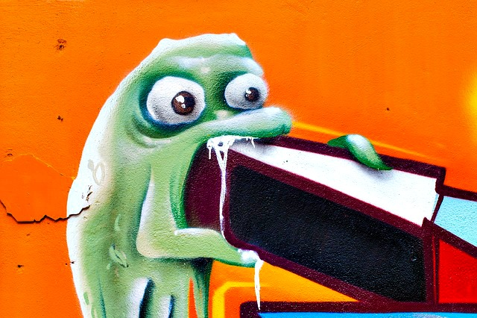
Big bite art by dife88 PD Image
Another consequence of living in the depths of the ocean is that food is hard to find so dumbo octopuses are no picky eaters. They eat copepods, isopods, amphipods, small crustaceans and worms that crawl across the ocean floor.
How do they eat? Using their ear-like fins, they hover along the ocean floor and when they find food, they pounce on it, covering it with their umbrella-like arms. Now, unlike other octopuses, dumbo octopuses do not have a radula, which is like a hard tooth-covered tongue in the octopus’ beak, so it cannot tear its food apart. Instead, the dumbo octopus swallows its prey whole.

10. They shrink.
Dumbo octopuses are also called jellyheads because of their soft bodies and because of their soft bodies, they tend to shrink out of water, just like the infamous blobfish. They don’t have enough pressure to keep them in shape. The head and the arms, in particular, shrink significantly even when the octopus is preserved and soaked in ethanol, whereas the eyes and the fins, which were already large to begin with, appear larger.

The big-eared (well… big finned) Dumbo octopus is discussed in several books from our Amazing Animals Series…
25 Weirdest Animals in the World
Alien of the Deep – the Octopus!
25 Deep Sea Creatures

Dumbo Octopus Videos
Hudson2010 720P Dumbo
Dumbo octopus filmed off the Nova Scotia coast.
Octopus Ballet
A Dumbo octopus (grimpoteuthis bathynectes) filmed at a depth of 6600 feet – 200 miles off the Oregon coast.
Rare life on the sea floor- The Abyss- BBC Wildlife
This is footage from the BBC show The Abyss. It includes the Grenadier fish, the Caimira fish and the Dumbo Octopus.

Want more? Visit:
15 Interesting Facts about the Octopus
The Octopus – Alien of the Deep!
Top 10 Examples of Awesomely Interesting Octopus Behavior!
The Amazing Octopus – Questions Answered!
Octopus Quiz!

http://ipfactly.com/dumbo-octopus/

