54 Interesting Facts About Dumbo Octopus
Written by Elise McDonaldin Marine Life

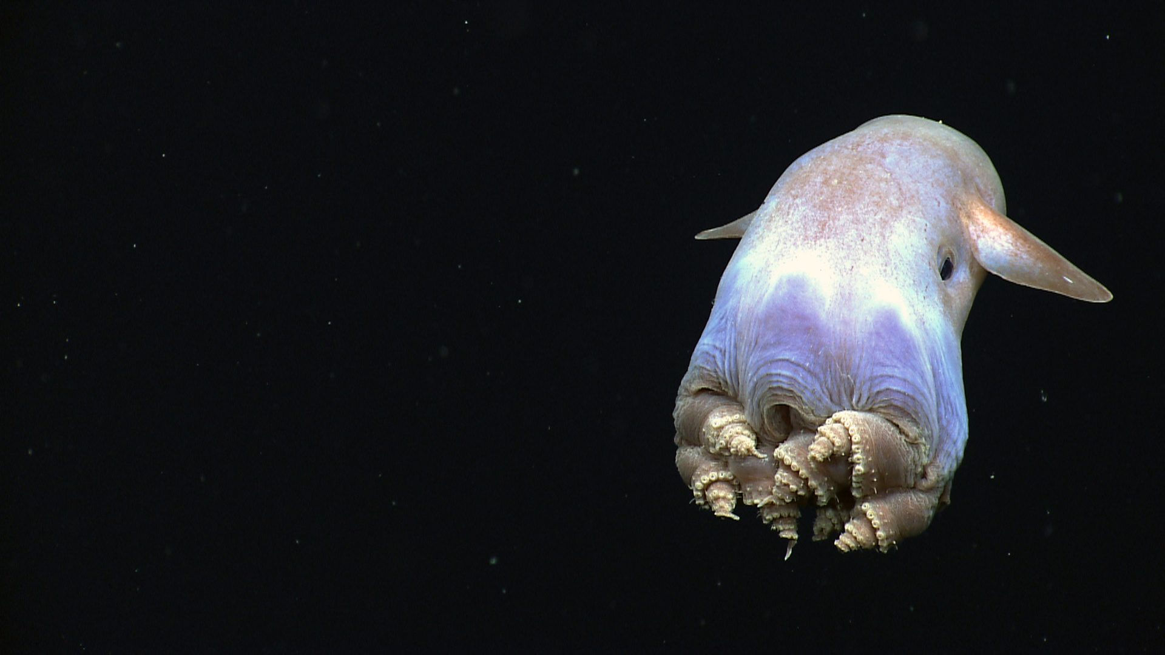
Of all the fascinating sea creatures known to man, Dumbo octopuses are one of the cutest and rarest sea creatures discovered so far. Known to inhabit the oceans at a depth of 9800 to 13000 feet (where there is no sunlight!), Dumbo octopuses are the deepest living known octopuses.
These octopuses inhabit the Atlantic and Pacific oceans, having been found in places like New Zealand, Australia, California, and Papua New Guinea.
Kingdom – Animalia
Phylum – Mollusca
Class – Cephalopoda
Order – Octopoda
Family – Opisthoteuthidae
Genus – Grimpoteuthis
Common name – Dumbo octopus, Umbrella Octopus
Diet – Shrimps, Bristle-worms, Bivalves, Snails, Pelagic copepods, Small fishes, crustaceans
Average Size – 20 to 30 centimeters
Life span – 4 to 5 years
Habitat – Atlantic and Pacific oceans
Since Dumbo octopuses live at great depths, not much information is available about them. However, they remain one of the fascinating deep-sea creatures and are unique for many reasons, right from their legendary names to their survival tactics.

The history behind their name – Dumbo Octopus

The fascinating characteristic of a Dumbo octopus is the history behind its name. Dumbo octopuses are named after the adorable animated Disney character, Dumbo elephant, due to their rounded ‘ears’ sticking out of the sides of their heads. These ears are large fins which look like elephant ears and help them ‘fly’ through the water.

Dumbo octopuses are also called jelly head or winged octopuses
Dumbo octopuses are members of the umbrella octopus’ family Opisthoteuthidae, which are known for swimming with an umbrella-like look to their mantle. For this reason and probably due to the unusual fins that protrude from the top of their mantle, dumbo octopuses are also called a jelly head, or winged octopuses.

Dumbo octopuses are known for their innovative ways of locomotion
Dumbo octopuses can crawl, swim, propel or even fly through water! Unlike other sea creatures, Dumbo octopuses are known for their many innovative ways of locomotion. They have four modes of active movement
- Crawling
- Take-off
- Finswimming and pumping
- The passive mode – umbrella-style drifting

Dumbo octopuses can swim via jet propulsion
Like other octopuses, Dumbo octopuses can swim via jet propulsion by swallowing a large amount of water and then letting it out all at once to push the octopus forward quickly. This is especially handy while escaping predators like sharks. Dumbo octopuses can also crawl across the seafloor using tentacles.
However, their most preferred mode of movement is flying through water by flapping their ear-like fins. Flying around helps these octopuses to conserve energy. They use these methods simultaneously, or one at a time.

Dumbo octopuses are very hard to spot
Not much is known about the habitat of the Dumbo octopus. As mentioned, they are pelagic animals, i.e. they live in the pelagic oceanic zone.
They may live deep down in the ocean at depths ranging from 3,000 to 4,000 meters, with some living as deep as 7,000 meters below the surface of the ocean, close to the hydrothermal vent fields or geyser.
There are approximately 17-18 known species of Dumbo octopuses. They measure between 8 to 12 inches but have been known to extend to 6 feet or upwards
A sighting of the Dumbo octopus is a rare event indeed!

Dumbo Octopuses are known for their ability to camouflage
Dumbo octopuses are pelagic animals, which come in different shapes and colors (red, white, brown, pink) and can change their color or flush out the transparent layer of their skin, whenever they wish to.

Dumbo octopuses have a bell-shaped head and large eyes
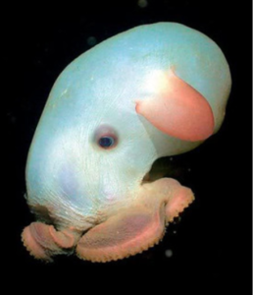

Aside from their ears, Dumbo octopuses are also known for having bell-shaped heads and large eyes. The diameter of their eyes can extend to about one-third of the width of their heads. (In comparison, the diameter of adult human eyes extends only to about 1/7 the breadth of their skull!)

Dumbo octopuses are considered to be almost blind
In spite of their size, the eyes of a Dumbo octopus can barely be put to use in the ubiquitous darkness of the deep sea. Their eyes usually lack lens and can only help them in the detection of light or dark.
Since sunlight doesn’t reach the deep ocean layers, it is believed that Dumbo octopuses can recognize only bioluminescent flashes.

Dumbo octopuses do not have teeth
Unlike the common octopuses, Dumbo octopus does not have a tongue covered in hard tooth and hence cannot land a bite. This is the reason why they swallow their food completely.

Dumbo octopuses have 8 tentacles like the common octopuses
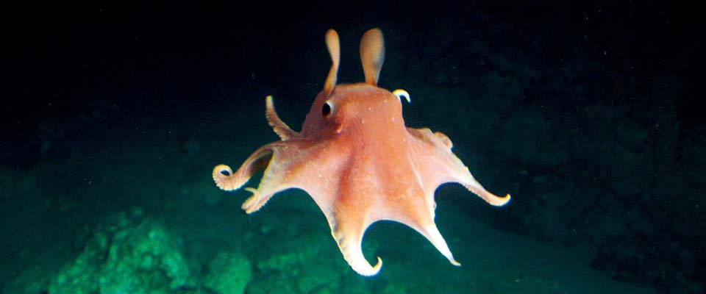

Dumbo octopuses have 8 arms that are connected by webbing. These tentacles have suckers like other octopuses but do not possess spines to help defend against predators.

Dumbo octopus has a unique strand-like structure around its suckers
The Dumbo octopus has strand-like structures around its suckers called cirri, instead of spines. These suckers are usually brown with a hint of yellow. Cirri resemble bristle-like hair and each sucker usually has one pair of cirri. Cirri help Dumbo octopuses in navigating through the dark ocean and in searching for prey.

Yes, dumbo octopuses do migrate
Dumbo octopuses have a short lifespan of 3 to 5 years. In between this short span, they are seen to migrate between places. This migration behavior is believed to be an adaptation to the finding food in the greater depths they live in.

Dumbo octopuses have a semi-gelatinous body
This octopus has a soft, semi-gelatinous body, which helps it adapt to its deep-water habitat.

Dumbo octopuses cannot squeeze through small spaces
Dumbo octopuses have a U-shaped shell inside their mantle, unlike other octopuses. This means that the body of a Dumbo octopus is not completely soft and hence, it can’t squeeze through small spaces, unlike other finless octopuses.

Dumbo octopuses do not have ink sacs like common octopuses
Dumbo octopuses do not possess ink sacs or anal flaps, and unlike other octopuses, Dumbo octopuses cannot produce ink. (This ink is especially crucial for an octopus as the expulsion of dark ink can confuse predators).

The unique shape a dumbo octopus enables it to survive in the highly pressurized deep ocean environment

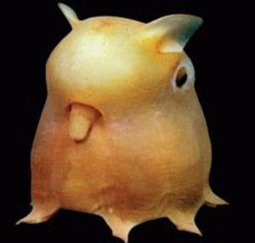
The peculiar shape of Dumbo octopuses can be attributed to the highly pressurized deep ocean environment. In fact, once these octopuses are removed from the deep oceans, the bodies and tentacles may shrink further, resulting in even larger fins and eyes.

What does a dumbo octopus eat? | Diet of a dumbo octopus
The diet of the dumbo octopus comprises marine creatures like shrimps, Bristle-worms, Bivalves, Snails, Pelagic copepods, Small fishes, and other crustaceans. Food is generally scarce and comprises whatever is found on the ocean bed or is floating in the current.

The dumbo octopus’s food chain
The food chain of the Dumbo octopuses isn’t as large as one would expect. Considering the great depths, they live in sharks & killer whales are their only predators.
A typical food chain would be the Dumbo eats the planktons, prawns and gets eaten by the sharks & killer whales.

Dumbo octopuses have different anatomy of mouth compared to other octopuses
Although the Dumbo octopus is a carnivore, its mouth is different from other octopuses. Dumbo octopuses usually lack the radula (which resembles a tongue consisting of thousands of tiny teeth used for scraping or tearing prey, found in other octopuses).
Hence, it has to swallow its food whole. To accommodate its prey, it usually opens its beak and engulfs
its prey. The cirri help in forcing the food closer to the mandible.

Marine biologists are still on the hunt to know about dumbo octopus’s reproductive cycle
As stated earlier, there is very little information about this fascinating octopus that dwells in the deepest parts of the ocean, partly due to the remoteness of its habitat. While more than a dozen species of the Dumbo octopus have been identified so far, further research will help us learn more about this unique sea creature.
Owing to their extreme habitat, not much is known about their reproductive cycle. There is no known specific breeding season.
Usually, one arm of the male octopus has a protuberance which is used to deliver sperm into the female mantle. The females store the sperm to use when conditions are favorable for laying eggs.

The unique breeding style of Dumbo octopus
The breeding style of Dumbo octopus is unique. While other species of octopuses prefer solitary brooding, the female Dumbo octopuses usually breed in groups.

Dumbo octopuses’ eggs are large when compared to the other species of octopuses
The eggs of Dumbo octopuses are comparatively larger and have a casing, which hardens in water. The females lay their eggs underneath the shells or rocks on the ocean-bed.

The lifespan of a Dumbo octopus
The life-span of a Dumbo octopus ranges from 3 to 5 years.

Dumbo octopuses show a small degree of sexual-dimorphism
The males and females of the Dumbo octopus are quite different in appearance and size. They also differ in their sucker patterns, with the male having more giant suckers than females.

Dumbo octopuses are cirrate octopuses
They are cirrate octopuses (i.e. species that live in deep-water habitat) and possess two fins which are usually dark brown.

What eats the Dumbo octopuses?
The natural predators of Dumbo octopus include killer whales, sharks, tuna and cephalopods.

Dumbo octopuses aren’t endangered
The international union for conservation of nature has placed them in the least concern list. Dumbo octopuses are not known to be under any threat from humans and have not been evaluated for any population status.
Considering the depths at which they live in they aren’t vulnerable to a direct threat from humans.

Dumbo octopuses are the closest cousin of the umbrella octopuses
Dumbo octopuses belong to the genus Grimpoteuthis, which is a subset of the family of Opisthoteuthidae, the umbrella octopuses.
Since Dumbo octopuses belong to the same family as the umbrella octopus, they have certain features in common with them, including webbed arms and fins.
However, the fins of a Dumbo octopus are long and substantial and may look quite peculiar to people who are not familiar with this rare sea creature.

The largest Dumbo octopus ever recorded caught weighed 5.9kg
Owing to the great depth, they live in finding a Dumbo octopus happens once in a blue moon. Among the few recorded catches, the largest of them weighed 5.9kg and was a whopping 1.8 meters’ in length. The average size of a Dumbo octopus is considered to be 20-30 centimeters. Their average weight is still not determined.

Dumbo octopuses are distributed globally
Though rarely sighted alive, specimens of the Dumbo octopuses are sighted off the coast of Oregon, the Philippines, Martha’s Vineyard, the Azores, New Zealand, Australia, California, Gulf of Mexico, Papua, and New Guinea.
If you are a sailor and hope to see them in any of these oceans, sorry folks you’ll be disappointed. Unless you go down to the depths of 13,000ft, you can’t possibly imagine seeing them.

Dumbo octopuses have chromatophore cells
Unlike the common octopus with ink sacks that help them change colors, the Dumbo octopuses do not have them. Instead, they have chromatophore cells that help them change their body colors to hide from predators.
The Dumbo octopuses can change their color to red, white, pink or brown. They are even capable of becoming invisible by changing colors to blend with the water around them perfectly.

Dumbo octopuses can breed anytime irrespective of their immediate environment
Unlike the other species which prefer to breed when the environmental conditions are favorable, the Dumbo octopuses can breed anytime regardless of the environmental conditions. Some biologists claim this to be an evolutionary advantage considering the fact that Dumbo octopuses are rare.
The chances of a female finding a male to fertilize her eggs are less, so they always have eggs in them. When they meet a male, she stores the sperms from the male and uses it to fertilize her most developed eggs when the environmental conditions are apt.

Mother dumbo octopus leave the eggs as soon as they hatch
One can say that Dumbo octopus moms aren’t really good mothers considering the fact that they leave the eggs as soon as it hatch. But that is not the case. The tiny Dumbo octopuses that emerge from the eggs can protect themselves and do not need help from their mother to survive.

Dumbo octopuses hover over the ocean floor for an ambush
The diet of the dumbo octopus mainly consists of polychaete worms, pelagic copepods, isopods, amphipods, and other crustaceans which are commonly seen on the ocean floor. These Dumbo octopuses hover over the ocean floor and once they spot their prey they pounce on to their target eating them in whole.

Dumbo octopuses are intelligent species
Don’t be fooled by their name; Dumbo octopuses are one of the most intelligent species in the marine world. Octopuses, in general, are extremely intelligent and are capable of using tools, solving puzzles, create gardens to camouflage, mimic other ocean animals, and so on.
Some scientists claim that each Dumbo octopus has different temperament towards different objects. This suggests that each Dumbo octopus might be having different personalities.

The male Dumbo octopuses have a specialized arm
As discussed in the earlier sections, the male Dumbo octopuses have a specialized arm that’s modified into being the reproductive part of the octopus. This arm is known as the hectocotylus.
The hectocotylus is located inside a specialized pouch where the sperms are stored. While mating this pouch ruptures and the sperms are injected to the tip of hectocotylus.
During mating, this pouch is given to the female which she keeps in her mantle cavity until all her developed eggs are fertilized.

Dumbo octopuses have a unique mode of propulsion
Unlike other common octopuses, Dumbo octopuses have a unique style of propulsion. They flap their fins (the ear like structure found on either side of their head) for propulsion while the tentacles act as a rudder to control the direction of swimming.

Dumbo octopuses have three hearts!
Similar to the other species of octopus the Dumbo octopuses have three hearts, each heart serving distinct functions. The systemic heart is responsible for pumping the blood throughout their body while the brachial hearts pump blood through their gills.
When the Dumbo octopus swims faster to evade predators the brachial heart stops functioning causing reduction in oxygenated blood. This explains why octopuses, in general, prefer to walk on the ocean floor or slowly glide around in the water.

Do dumbo octopuses sleep?
All cephalopods, especially dumbo octopuses are found to have a wavy brainwave which is associated with REM sleep. This is substantial evidence to support the claim that dumbo octopuses sleep like other vertebrates.

They have a circular system consisting of arteries, veins, and capillaries
Dumbo octopuses have a circular system comprised of arteries, veins, and capillaries which is unique for an invertebrate. They also have a cellular endothelium lining their circulatory system.
The systemic heart pumps the oxygenated blood through the aorta, and capillary system and the deoxygenated blood flows to the gills through vena cavae.
The brachial heart pumps the deoxygenated blood through the gills and back to the systemic heart.

The natural defense of a Dumbo octopus?
Unlike the common octopuses, Dumbo octopuses cannot spray ink. Instead, they evade predators with speed. Thanks to their funnel and large winged like fins they can move surprisingly fast.
They are also capable of doing Jet propulsion, enabling them to do crazy evasive maneuvers.
In general, Dumbo octopuses are small and are quite difficult to be spotted; this is an additional advantage too.

Do Dumbo octopuses make a sound?
No, not just the Dumbo octopus rather octopuses, in general, cannot make sounds.

Everything about a baby Dumbo octopus
The life of a Dumbo octopus starts with hatching from an egg. Though they are young, they would still have fully developed organs like an adult.
These young Dumbo octopuses spend most of their time in clouds of planktons feeding on the larvae of crabs & starfish. It is interesting to note that the Dumbo octopuses’ eggs aren’t seen in great depths.
These baby octopuses when living in the plankton cloud are vulnerable to attack from the plankton eaters, and hence this stage is considered to be dangerous for them. It usually takes them 2-4 weeks before they are ready to sink to the bottom of the ocean.

Sexual reproduction in Dumbo octopus
Dumbo octopuses reproduce sexually similar to other members of the octopus’s family. The female Dumbo octopuses become sexually mature in about 3 to 4 weeks. Once she becomes sexually mature and successfully mates with a male, she can lay eggs anytime she wants.
Usually, the females lay eggs only when the environment is most suitable for hatching. Owing to the great depths, they live in not much is known about the conditions that are suitable for egg hatching in their natural environment.
When they mate, the males transports sperm into their detachable arm and transfers it to the female. These hands are kept in the mantle cavity of the female, and she can use it at a time of her choice to fertilize her eggs.

The life of a female Dumbo octopus after the eggs hatch
The presence of a female Dumbo octopus is grim after the eggs hatch. Right after they lay eggs, their body slowly starts to shut down & reduces the frequency at which they eat.
Dumbo octopuses are semelparous animals like all other octopuses, i.e. they reproduce only once in their lifetime.
By the time the eggs hatch the female at most cases might have died, and her body wastes away.

The male Dumbo octopus dies soon after a successful mate
Unlike a female Dumbo octopus which dies after the eggs hatch the males die almost more quickly after a successful mate. The males to quit eating and slowly wastes away.
In some cases, the female Dumbo octopuses are seen to kill and eat the males after a successful mate.

The self-destruct hormone in Dumbo octopuses
In the year 1977, a psychologist named Jerome Wodinsky discovered something peculiar in an octopus. He figured out that there is an optic gland situated inside the head of an octopus resembling the pituitary gland in humans.
Once this gland was removed, the octopuses were found to abandon their eggs and go foraging. Jerome Wodinsky claims that the optic gland acts as a self-destruct switch that gets activated when the female lays eggs. Some octopuses were even seen to go mate again, which isn’t how it generally works.

Dumbo octopuses have a webbing connecting their arms
Not just the Dumbo octopus, almost all of the octopus family has a webbing connecting their arms. But in the case of Dumbo octopuses, they are easily detectable because these webbings are found to be almost more than half the length of their arms.
In some cases, these webbings are found to go more than three quarters the length of their arms. This webbing in a Dumbo octopus resembles a blanket like visual effect earning it the name umbrella octopus.

Do Dumbo octopuses glow?
From whatever little we know about these magnificent creatures some scientists claim that they are bioluminescent. There isn’t any substantial evidence to support this claim either. Looks like we’ll have to wait until biologists discover more about Dumbo octopuses.

Dumbo octopuses have cilia on their suckers
Cilias are hair-like strands that protrude out from the suckers of a Dumbo octopus. These cilias on their suckers may look like hairs, but they aren’t. The functions of cilia are many such as
- To generate a steady current of water towards them to lure in the prey.
- Cilia also acts as a finely tuned antenna that helps the Dumbo octopus to scan the ocean floor for potential preys.
- In the case of Female Dumbo octopus, they use cilia to aerate their eggs.

Dumbo octopuses are naturally buoyant
Unlike other octopuses, Dumbo octopuses are naturally buoyant. This enables them to float statically in an area of choice, which is an excellent advantage while foraging the ocean floor. Being buoyant makes it easier for them to swim by using their fins for propulsion. It is for this reason Dumbo octopuses are seen to swim through open waters.

Dumbo octopuses are not solitary creatures
Unlike other octopus species, the female Dumbo octopuses aren’t solitary creatures. Primarily when they brood, they are found to be together in a group, and there are observational pieces of evidence to support this claim too.
The reason for this behavior is still a mystery biologist are trying to solve.

Female Dumbo octopuses are found to brood near oceanic vents
Though they prefer colder environments while brooding, they are found to perch on vents on the ocean floors. These vents emit the geothermal heat through them. It is believed that such an atmosphere is needed when the females are caring for their hatchlings.

Dumbo octopuses as pets!
Dumbo octopuses are found to survive in aquariums in a laboratory. Which means that if you are lucky enough to get this creature that lives at 10,000ft under the ocean alive, you can keep them.
There are only a few Dumbo octopuses living in aquariums, and most of them are in marine laboratories!

https://animalhype.com/marine-life/dumbo-octopus/

