EPT Index
Some macroinvertebrate orders, such as Diptera (true flies), are generally tolerant to higher levels of pollutants in streams. Other orders, such as Ephemeroptera (mayflies), Plecoptera (stoneflies), and Tricoptera (caddisflies), are very sensitive to many pollutants in the stream environment.
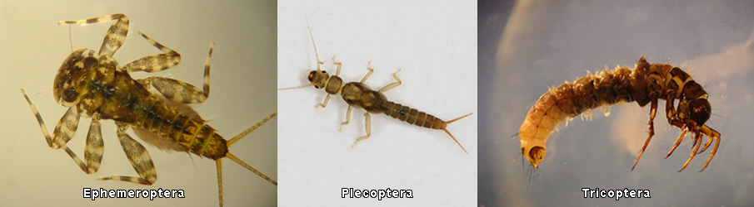
The EPT Richness Index estimates water quality by the relative abundance of three major orders of stream insects that have low tolerance to water pollution.
EPT can be expressed as a percentage of the sensitive orders (E= Ephemeroptera, P= Plecoptera, T= Tricoptera) to the total taxa found. | 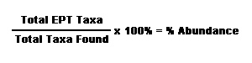
A large percentage of EPT taxa indicates high water quality.

