POLAR BEAR ADAPTATIONS FOR HUNTING
Sarah Bedolfe | May 09 2012

A weekly dose of education in the ocean.
This is the third in a five-part series about the polar bear’s adaptations to the Arctic environment.
Part one Part two Part four Part five
Polar bears are almost purely carnivorous, and survive by hunting seals. Ringed seal blubber is their favorite food. Polar bears stalk seals on the ice, often laying in wait at breathing holes. When food is plentiful, a polar bear won’t consume the whole seal, eating the blubber alone and moving on for another kill. This fat is the most energy-rich food source available, so with it, a polar bear gets the most bang for its buck.
Their closest relatives, the brown bears (which aren’t as closely related as previously thought), are omnivores. Although brown bears – especially grizzlies – are capable of hunting large animals, most of their diet is plant matter such as nuts and berries, or smaller animals like salmon. A polar bear’s habitat however, is largely devoid of vegetation. When trapped on land during the ice-free season, polar bears may forage for plants but can only subsist this way temporarily. Out on the ice, a polar bear has several methods for finding and catching seals. The polar bear is keenly adapted to this habitat, with a sharp nose, stealthy stalking ability, sharp teeth, small head, a long neck and jaw, and a physiology suited for infrequent but large meals.

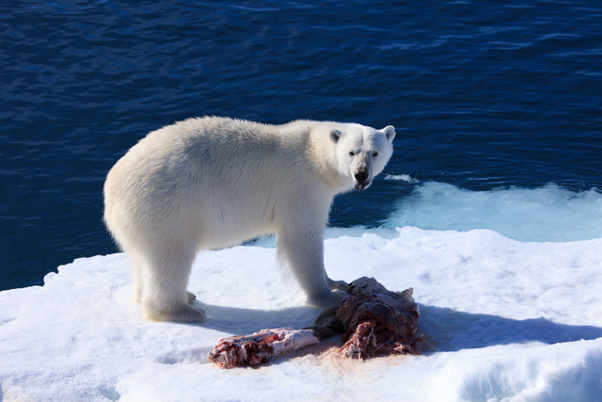
©Shaun MacGillivray/MacGillivray Freeman Films
Keen sense of smell. When food sources are scarce, as in the Arctic, being able to detect food from a distance is critical. Polar bears can’t always rely on sight – ringed seals sometimes stay in lairs underneath the snow – so polar bears have a large olfactory bulb (the part of the brain related to smell) and a very keen nose. According to Arkive, they can smell prey that is almost a kilometer away and up to a meter under the compacted snow.

Stalking skills. Polar bears are smart and sneaky hunters. They approach prey strategically. They have several hunting methods, as explained by Dr. Andrew Derocher in his new book, Polar Bears, A Complete Guide to Their Biology and Behavior. They can target a seal from a distance, then walk or swim towards it, undetected, until they’re close enough to charge; at other times, they simply sit in wait at a seal’s breathing hole, waiting for the meal to appear; and during seal pupping season in spring, polar bears target seal birth lairs. The ability to use different specialized tactics means a polar bear can survive in various Arctic conditions.

Sharp teeth and long jaw. Polar bears’ dentition reflects their diet as well as their history. The jaw and teeth
have several traits typical of carnivores, but reveal their omnivorous origins. While they can grind vegetation, they are less suited to that than brown bear teeth are, They have long, sharp canines and a row of incisors across the front for grasping prey. There is a large gap between the front row and the molars in the rear, which are pointed for shearing flesh. Their claws are also curved and sharp for catching and holding prey.

Small head and long neck. Predators whose prey is dangerous develop a more square snout, but seals are not dangerous. Compared to the rest of their bodies, polar bears have long necks and snouts with small heads. In addition to being streamlined for swimming, this also makes it easier for them to put their heads into ice holes or seal lairs looking for prey.

Feast-and-famine metabolism. Polar bears’ physiology allows them to thrive while experiencing alternating periods of plentiful and scarce food. When food is plentiful they eat only the most calorie-rich food – fat. According to Andy Derocher, the stomach can hold 20% of a bear’s mass, and the bear can eat 10% of its body weight in 30 minutes. Polar bears are well equipped to maximize the benefits when food is abundant – in preparation for times of scarcity. During periods of food deprivation, they can slow down their metabolism. Although polar bears don’t hibernate in dens each winter, polar bears can enter a state called walking hibernation when fasting. They live on fat reserves and their bodies recycle nitrogen; this means they don’t have to urinate and can conserve water, as well as maintain muscle mass. Still, the bears can remain slightly active and maintain their body temperature, as opposed to more typical, sleep-like hibernation.

http://www.oneworldoneocean.com/blog/entry/the-school-polar-bear-adaptations-for-hunting

