Name: _____________________________________ Date: _______________ Class: ___________

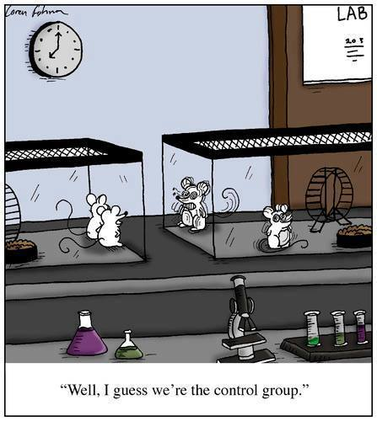Problem Set 1: Read the following information describing an experiment with mice. Then answer the questions that follow regarding the use of the Scientific Method.

A scientist observed that white mice that were fed seeds appeared to grow more than mice given leafy green and yellow vegetables. The scientist hypothesized that the protein in the seeds was responsible for the growth. She designed an experiment to test her hypothesis. She divided 200 mice of the same age, size, health, and sex into two groups of 100 mice each. The mice were kept under identical conditions for 14 days. One group was given a diet high in protein. The other group was given a normal protein diet. The mass of each mouse was recorded daily for 14 days.

Questions:

1. Which group of mice served as the control? _____________________________________________________

2. What was the independent variable? _____________________________________________________

3. What data was collected as observations of the effect of the protein diet (the dependent variable)? ________________________________________________________________________________________

4. What other effects of a protein diet could have been tested? ______________________________________

________________________________________________________________________________________5. Why were larger numbers of mice used in this experiment? ______________________________________

6. Why did the scientist ensure the two groups of 100 mice were mostly the same? ______________________

________________________________________________________________________________________

7. If the results of the experiment did not show a marked change between the two groups, what should the scientist do next? ________________________________________________________________________

Problem Set 2: Read the following information describing an experiment to understand spontaneous generation. Then answer the questions that follow regarding the use of the Scientific Method.

Long ago, many people believed that living things could come from nonliving things. They thought that worms came from wood and that maggots came from decaying meat. This idea, that living things could form from non-living matter, was called spontaneous generation. In 1668, an Italian biologist, Francesco Redi, did experiments to prove that maggots did not come from meat. One of his experiments is shown below.



Group 1

Group 2

Redi placed pieces of meat in several jars. He divided the jars into two groups. Based on his new idea, he covered the first group of jars with fine cloth. He left the second group of jars uncovered, as was common at the time. Redi observed the jars for several days. He saw flies on the cloth of the covered jars, and he saw flies laying eggs on the meat in the uncovered jars. Maggots appeared only on the meat in the group of jars left uncovered.

Questions:

1. What was the problem studied in Redi’s experiment?____________________________________________

________________________________________________________________________________________

2. What do you think his hypothesis was? (circle your choice below)

a. Do maggots form by spontaneous generation?

b. If meat is covered, then maggots will not appear on it because spontaneous generation does not occur.

c. If meat is left uncovered, then maggots will not appear because spontaneous generation does not occur.

d. If meat is covered, then maggots will appear because living things come from nonliving matter.

3. How did he test his hypothesis? ____________________________________________________________

________________________________________________________________________________________

4. What was the independent variable being tested in his experiment? ________________________________

________________________________________________________________________________________

5. Assuming Redi’s hypothesis was choice “b” for # 3 above, did his results support his hypothesis? ________

6. What do you think Redi’s conclusion was?

a. Living things come from other living things.

b. Living things are created through spontaneous generation.

c. He did not have enough data to arrive at a conclusion.

Problem Set 3:

Directions: Read the example below, then complete the three following problems.

**Example:** Problem: You have heard that taking vitamin C tablets helps to reduce the number of colds people experience during winter months.

a) Hypothesis – If a group of people are given a vitamin C tablet, then they will experience fewer colds than a group without vitamin C.

b) Control group – 100 people who do not take a vitamin C tablet

c) Experimental group – 100 people who do take a vitamin C tablet

d) Data to collect – count the number of colds experienced between Nov. through March for each group

e) Other factors that must be kept the same – age, sex, lifestyles, and diet of people in groups

f) Results that would support hypothesis – the group given vitamin C experienced a fewer number of colds than people in the control group.

1.) Problem: A student just read that one of the pigments in plants, called Chlorophyll a, absorbs light with wavelengths of 430nm (blue) and 662nm (red). He wonders about the ability of plants to grow under artificial red light, and thinks they will grow better than those grown under natural sunlight.

a) Hypothesis –

b) Control group –

c) Experimental group –

d) Data to collect –

e) Other factors that must be kept the same –

f) Results that would support hypothesis –

2.) Problem: You watch a news story that suggests that eating breakfast before school will help students feel more alert during school. You believe it is probably true, and decide to test it with your classmates in your third period class.

1. Hypothesis –

b) Control group –

c) Experimental group –

d) Data to collect –

e) Other factors that must be kept the same –

f) Results that would support hypothesis –

3.) Problem: You have just seen a commercial for the Adkins Diet which is based on eating a high protein diet and you want to test to see if it really does help people lose weight.

a) Hypothesis –

b) Control group –

c) Experimental group –

d) Data to collect –

e) Other factors that must be kept the same –

f) Results that would support hypothesis –