Animals
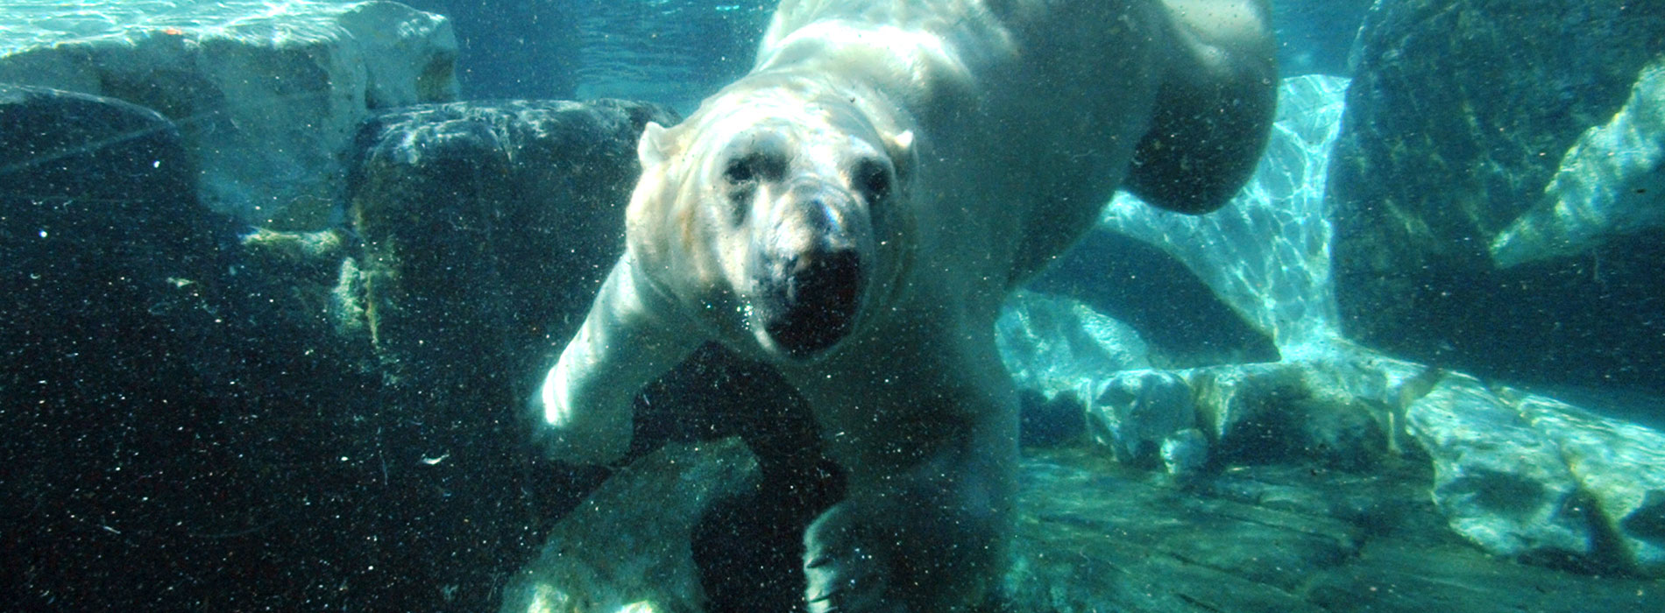

Behavior
- MORE ABOUT POLAR BEARS ›
- MORE ANIMALS ›

Daily Activity Cycle
- Polar bears are most active the first third of the day and least active the final third of the day.
- In the Canadian Arctic, adult female polar bears with cubs hunt about 19% of their time during the spring and about 38% of their time during the summer. Adult male polar bears hunt about 25% of their time during the spring and about 40% of their time during the summer.
- When not hunting, polar bears are often sleeping or resting. From July to December in Canada's James Bay region, when lack of ice prevents seal hunting, a polar bear may spend up to 87% of its time resting.
  - On warm days polar bears sprawl out on the ground or ice, sometimes on their backs with their feet in the air. They may also make temporary snow or earthen pits to lie in
  - On cold days polar bears curl up and often cover their muzzle area. During the winter, some polar bears excavate temporary dens or find natural shelters to stay warm. They may use these shelters for several months at a time.

Walking & Running
- Like humans, polar bears have a plantigrade stance: they walk on the soles of their feet with their heels touching the ground first. Like other bears, they can also stand on their hind feet and walk upright for short distances.
- Polar bears generally walk with a steady, lumbering gait. The front paws swing outward with each step, landing slightly pigeon-toed. The head swings gently from side to side. The walk has a four-beat pattern - first the right front foot touches the ground, then the left hind foot, then the left front foot, and lastly, the right hind foot.
- Their bulky build and swinging gait cause polar bears to use more than twice as much energy to move at a given speed than most other mammals.
- The average walking speed of a polar bear is 5.5 kph (3.4 mph).
- When being chased or charging prey, polar bears can run as fast as 40 kph (25 mph) for short distances.

Social Structure
Polar bears are basically solitary. Usually, only two social units exist:
- Adult females with cubs
- Breeding pairs
Polar bear aggregations:
- Polar bears may aggregate to feed on large whale carcasses and at dump sites.
- In some southern regions, like Hudson Bay, bears aggregate on land during the ice-free summer and autumn months, especially when they are staging along the coast waiting for the ice to return.
- On occasion, adult and subadult (ages 30 months to five or six years) polar bear males will feed and travel together for short periods of time.When not hunting, polar bears are often sleeping or resting. From July to December in Canada's James Bay region, when lack of ice prevents seal hunting, a polar bear may spend up to 87% of its time resting.

Social Behavior
- The most constant social interaction occurs between mother and cubs. Polar bear mothers are attentive, frequently touching and grooming their cubs.
- Polar bear breeding pairs remain together for one week or more, mating several times.
- Aggression occurs between males during the breeding season and when males attempt to steal food caught by other polar bears.
- Play fighting has been observed between aggregating subadult and adult male polar bears.
- Young polar bear cubs chase and tackle their siblings

Hibernation
- Hibernating means to pass the winter in a dormant or lethargic state. Animals that hibernate store body fat when food is plentiful. When food is scarce, they hibernate, living off their stored body fat. Deep hibernation, or winter sleep, generally occurs in smaller mammals. In deep hibernation, an animal's body temperature can drop to a few degrees above freezing for a period of days or weeks. It is also characterized by a marked drop in heart rate and a decreased respiratory rate. Deep hibernators are slow to awaken when disturbed.
- Polar bears aren't deep hibernators, but enter a state of carnivore lethargy. Their body temperatures do not drop substantially, and other body functions continue. Scientists, however, use the term "hibernation" in a general sense when referring to carnivore lethargy and the term is used in this booklet as well.
- Only females, especially pregnant females, enter into a state of carnivore lethargy, or "hibernation". They do so from about October or November through March or April.
  - The female polar bear's heart rate slows to about 27 beats per minute from a normal resting heart rate of about 46 beats per minute.
  - When hibernating, a female's body temperature may drop slightly, perhaps to 35°C (95°F), or it may remain normal at 37°C (98.6°F).
  - Females fast throughout hibernation. They may lose most or all of their fat stores.
  - Unlike most other hibernators, female polar bears give birth while hibernating. High body temperature is needed to meet the demands of pregnancy, birth, and nursing.Though hibernating females sleep soundly, they're easily and quickly aroused.
- Researchers have found that non-hibernating polar bears, during times of food scarcity, can efficiently utilize their energy reserves much like hibernating bears.

Attacks on Humans
- Humans may encounter polar bears wherever human and polar bear habitats overlap. With loss of sea ice habitat, polar bears are shifting their habitat to land areas and humans may increasingly encounter polar bears as a result. This could be dangerous to humans since polar bears are large predators. Bear spray is a reliable defense and should be carried by people for protection in areas where they may encounter polar bears.
- Polar bear subadults and females with cubs attack most often. They're also the chief scavengers (among polar bears) of human dump sites. Both groups tend to be thinner and hungrier; subadults are inexperienced hunters, and females with cubs must feed themselves and their young.
https://seaworld.org/animals/all-about/polar-bear/behavior/

