Arctic Reindeer / Caribou Facts and Adaptations
Rangifer tarandus

Mainly an animal of the far north, most of the 15 subspecies live their lives above the northern tree line in the Arctic tundra, they are also found on many arctic islands. There are woodland reindeer in Finland and Siberia in the forests.

REINDEER / CARIBOU FACTS BASICS
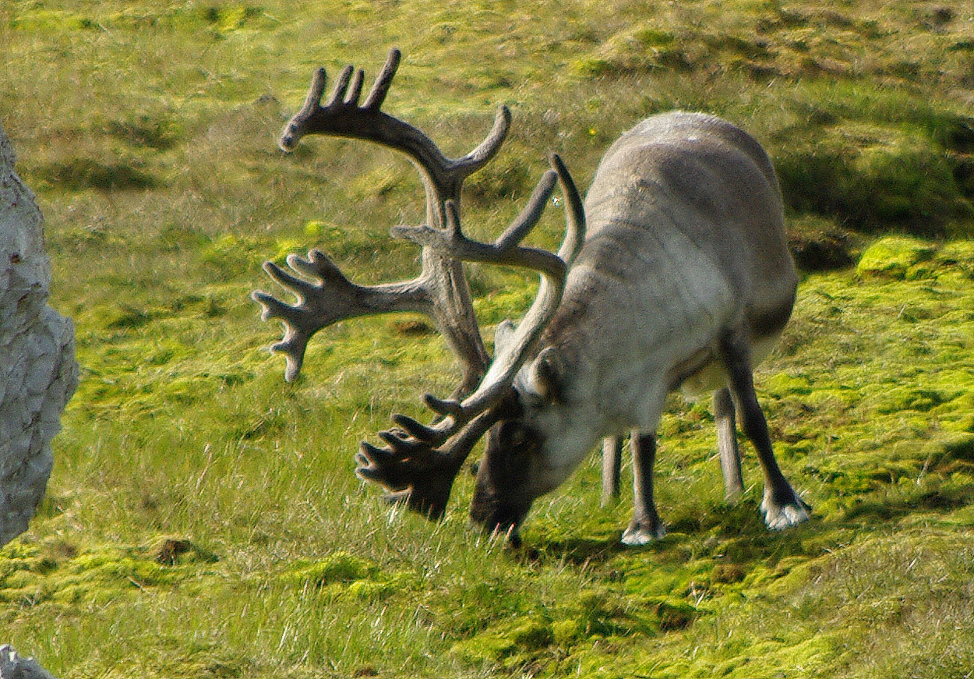
Average Weight: 60 to 300kg (132 - 660 lbs)
Average Length: 160 to 200 cm long (5.3 - 6.6 feet) plus a short tail of 14 - 20 cm (6 - 8 inches), 80 to 150cm (2.6 - 4.9 feet) tall at the shoulder.
Females are smaller than males, the extent of the difference varies in the different subspecies, domesticated reindeer have shorter legs and are heavier then wild reindeer/caribou.
Breeding Season: Mating is from late September to early November when males compete with each other for access to females. Most encounters between males are dealt with at a distance without contact, though this does happen by locking antlers and pushing when a pair of males both think they are the strongest. A successful male may mate with 15-20 females during this time. The requirement for constant vigilance against other males during the mating season means that dominant males have no time to eat and lose much of their stored reserves. A male may only be able to display this level of dominance for one season in his lifetime when he is large enough at around 6 years old.
Calves are born in May or June. Newborns can follow the mother within about an hour of birth, they start to graze after about 45 days but continue to suckle from their mothers as a supplement for several months.
Estimated world population: - 1 million worldwide, fluctuations that appear to be cyclic over 40-60 years.
Feeding & diet: In the summer months reindeer eat sedges, grasses, herbs, ferns and mosses on the tundra. They will also eat shoots and leaves of trees when available being particularly fond of willow and birch. They have been recorded as being opportunistic carnivores eating lemmings, birds eggs and arctic char (fish).
In the winter months they feed almost exclusively on lichens and fungi which they often gain access to by sweeping snow and ice away with their antlers and/or hooves. Reindeer have the unique adaptation amongst mammals of having a n enzyme called lichenase which enables them to break down tough lichens to release glucose.
Conservation status: Least Concern.
Distribution: Circumpolar including many islands, native to the far north.
Predators: Reindeer are predated upon mainly by wolves which hunt them in packs, particularly in the winter. The calves in the calving season are subject to heavy predation, mainly by golden eagles and sea eagles, but also by wolverine and less commonly brown bears and polar bears.
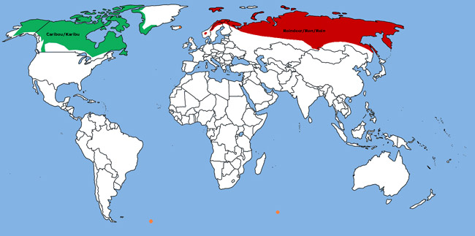
Distribution range of reindeer / caribou
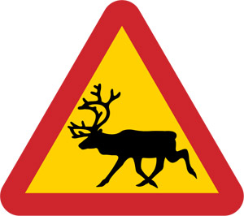In Europe these animals are called reindeer only. In North America they are called caribou when wild and reindeer when domesticated.
Reindeer live in areas of Arctic tundra (a cold treeless plain, frequently poorly drained) and the northern boreal forests that make up the southern edge of the tundra. They are herbivores and ruminants meaning they feed on plant material which they ferment with bacteria in a large intestinal chamber called the rumen which is then regurgitated to be chewed again (chewing the cud) before passing further down the intestines.
Reindeer live within families (mothers and calves) within herds of various sizes. Tundra reindeer live in large herds, though they fragment and become smaller in the winter months. Wood reindeer live in groups of no more than 20-30 throughout the year.

What are Reindeer / Caribou like? how do they survive?
The Reindeer is mainly an animal of the far north. Most subspecies live their lives above the northern tree line in the Arctic tundra, they are also found on many arctic islands. There are groups in Finland and Siberia that are regarded as woodland reindeer that are found in the forests in those regions.

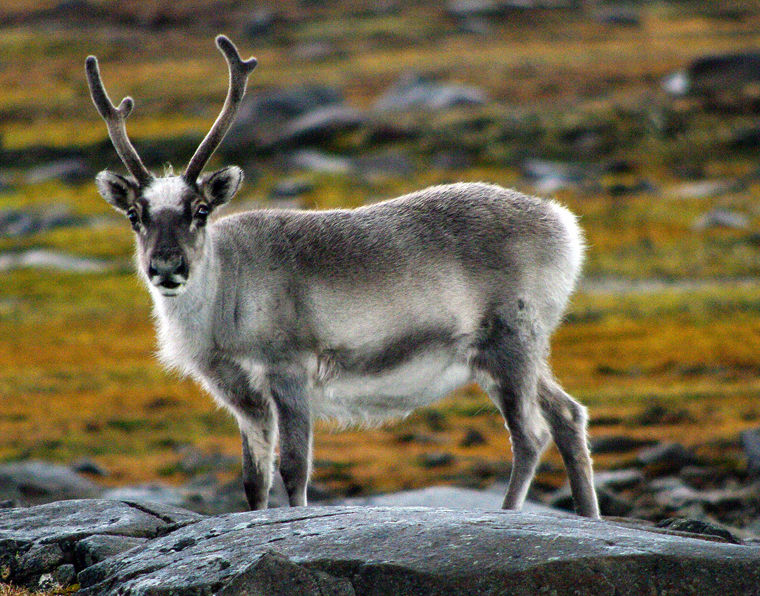
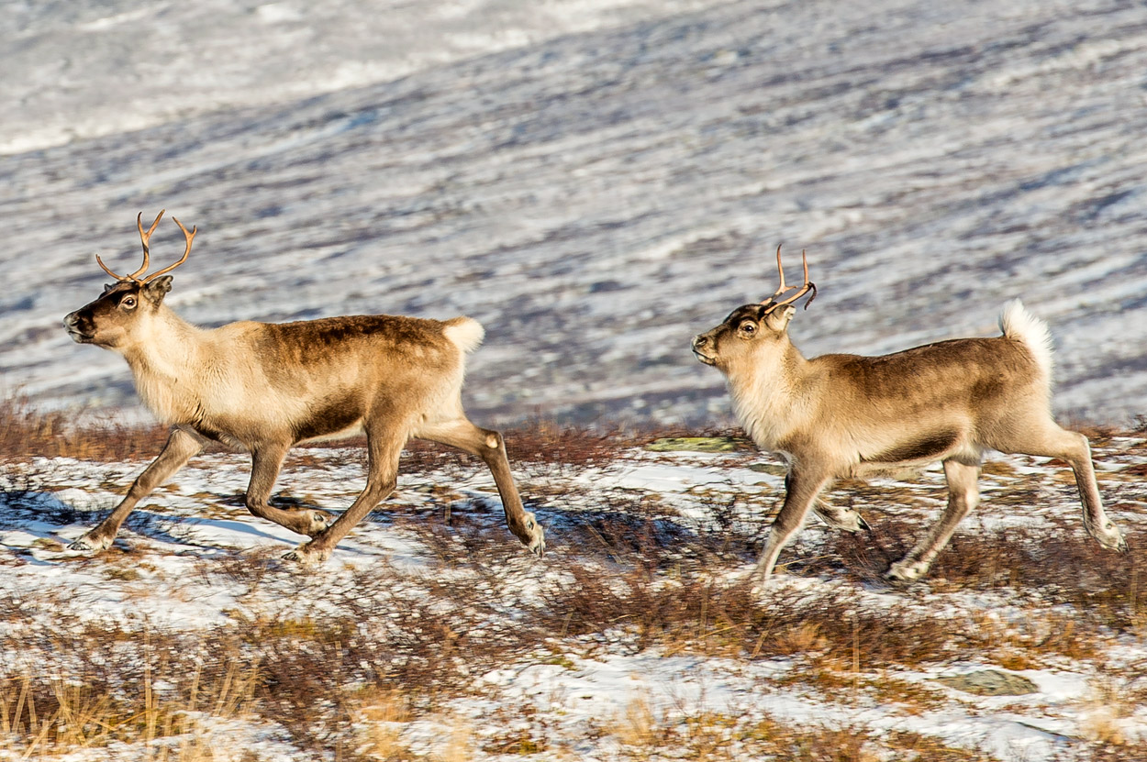

Historically reindeer were found across much of Eurasia above the line of latitude of 50Ãƒâ€šÃ‚Â° north. There was much concern a little while ago (2009) about the continuing decline of wild reindeer herds all across their range with global warming being blamed. No link was found however and some of the previously declining populations have begun to stabilise or increase in size again while others that were stable have begun to decline.
Herds are threatened by harvesting by hunters, regional climate trends and by increased development particularly of mining and oil and gas facilities which in their turn bring in more workers who may also hunt recreationally.
Reindeer have a relationship with humans going back thousands of years. As a hardy large herbivore they have been herded for food and to provide the muscle for transport by circumpolar peoples of the north. They are still hunted for food and other materials such as hides, antlers and bone to make tools by a number of Inuit peoples. They are herded in particular by the Sami and Nenets, they are not fully domesticated in the way that sheep and cattle are but are semi-wild roaming on pasture in a process of nomadic herding. There was a herd introduced to the Sub-Antarctic island of South Georgia where 10 animals landed in 1911 to provide food for whalers and sealers had grown to a population of 6,600 by early 2014 when they were all culled due to their impact on native bird life.
Reindeer / caribou Adaptations:
- Low surface area to volume ratio (anatomical) - Being large means it is easier to stay warm by retaining heat generated by the metabolism, adult reindeer vary from around 60kg to 300kg.
- 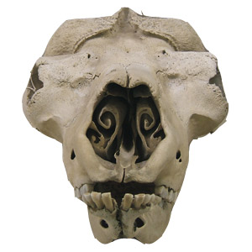Nasoturbinal bones in the nose (anatomical) - curled thin bones in the nose (see those in a related species in the picture to the right) that support thin tissues in the nose that are richly supplied with blood vessels to warm icy air when breathed in before it reaches the lungs. The incoming cold and therefore very dry air is also moistened before it reaches the lungs while the nasoturbinals help to recover this moisture again on the way out.
- Hooves that adapt to the season (anatomical) with footpads that are sponge-like in the summer so providing extra traction on the soft, wet and frequently slippery tundra and that have an exposed hoof in the winter following the shrinkage of the footpad. The exposed sharp hoof rim cuts into snow and ice so providing a secure footing also enabling the reindeer to dig through snow to find food in the winter.
- Ultra violet vision (physiological) an only recently discovered adaptation is that reindeer vision extends beyond the normal visible part of the spectrum into the ultra violet. Snow and ice are very UV reflective while urine, predators and lichens all strongly absorb UV light. Against a bright snow/ice background, dark urine may indicate the presence of predators or mates, predators such as wolves show up very strongly as dark silhouettes despite their camouflaged fur colour especially in low light conditions and lichens are a major food source, so again appearing as dark against light.
- Movement to higher altitude in the summer to avoid biting insects (behavioural) reindeer also form condensed groups at this time to protect those animals on the inside of the group from the irritation caused by the insects.
- The formation of herds (behavioural) Living in herds provides reindeer with protection against predators rather than being able to be picked off one by one. It also provides protection from biting insects in the summer months. Superherds of reindeer may contain from 50,000 to 500,000 individuals.
- 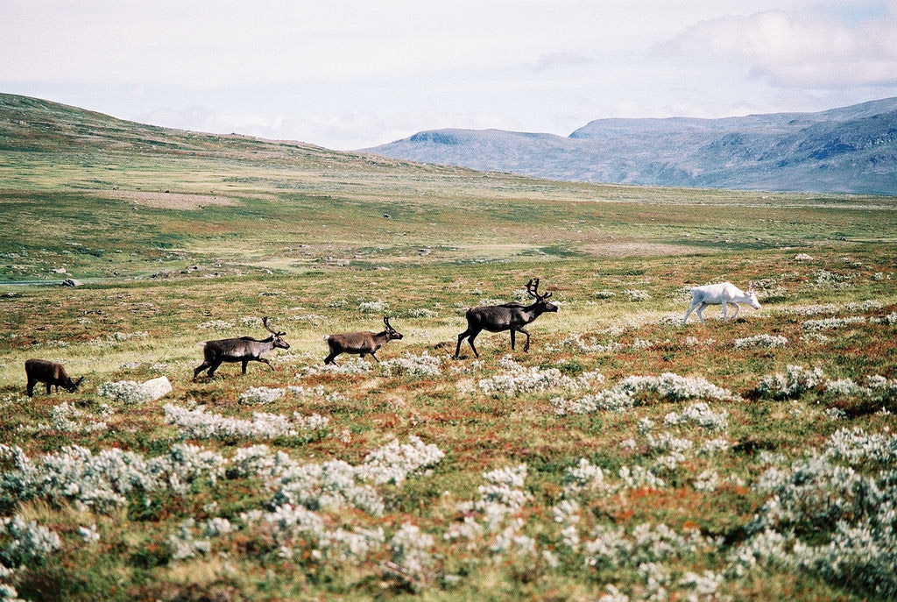Migration (behavioural) Reindeer migrate further than any other terrestrial animal, as much as 5,000 km (3,100 miles) a year. However some groups of reindeer don't migrate at all. In general they migrate north in summer where the increased day length leads to growth of plants to graze on though to areas that have few or no trees and so provide little shelter. Winters are spent further south and in forested areas which provide shelter from the worst of the weather especially during storms.
- Antlers for defence against predators, clearing snow and for males for competition for mates (anatomical) - Reindeer are the only deer where both males and females have antlers, they seem to have somewhat different roles in each. Antlers are made of bone, they are grown and shed annually unlike in animals with horns which are made of keratin, the same material that makes skin, fingernails and hair and are not shed. Male reindeer shed their antlers at the end of the year in November / December while females retain theirs until the following spring (a fact that is often used to show that Santa's reindeer were all female as they still have their antlers at Christmas). The females use the antlers in the winter to push snow aside and gain access to food, the males are thought to use their greater body weight for the same reason meaning they don't need antlers. Males start to grow new antlers around February and use them to compete for mates with other males. They may seem to be a pointless extravagance, though the ability to grow large antlers each year and the large metabolic burden this puts on the animal is a very good way of showing that the animal is fit, strong and in the peak of condition.
- A rich fur coat for retention of heat and protection from the weather (anatomical) - There is a soft fine undercoat of woolly insulating hairs and a longer coarser top coat of protective guard hairs. The longer guard hairs help to shed rain and the worst of the weather. The coat as a whole also traps air when in water which helps make the reindeer buoyant and so more able to be able to swim well. A thicker undercoat is grown for the winter which is then shed the next spring/summer.
https://coolantarctica.com/Antarctica%20fact%20file/wildlife/Arctic_animals/arctic-reindeer-caribou.php

