Barreleye Fish: Characteristics, types, reproduction and more…

Barreleye Fish : General Characteristics
This the only species of the genus Macropinna, having the scientific name Macropinna microstoma, belonging to the Opisthoproctidae family.
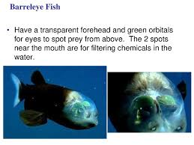

The Barreleye Fish has one of the most unusual appearances among deep sea creatures.
Their most outstanding trait’s its dome-shaped head that is transparent on the top since it’s filled with a transparent liquid.
If you look closely, you can see the entire inner part through it, that is, their eyes, brain and all the nerve endings that make up their head. The rest of their body is quite common to the rest of the other fish.

Moreover, Macropinna microstoma has quite long and V-shaped scales. As for its color, it’s magenta gray with a tail also transparent as the head.
However, from the tail we cannot observe its internal organs since it’s not completely transparent, but rather translucent.
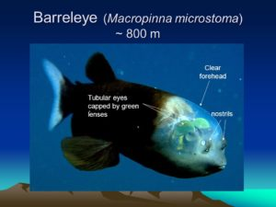
It’s as if we wanted to see through a glass that has been under water for a while and we find it on the shore of the beach.
Their mouth is quite small since it’s used to ingest smaller prey. Their evolutionary process hasn’t made them develop a larger mouth since they don’t need it.
As for their pectoral fins they are located in a lower area since they don’t on the sides.
They are quite long and flat and thanks to them they can remain still for a long time. This ability is used to stalk their prey with great stealth before eating them. Once they have detected their food, they pounce on it at high speed using their pectoral fins.

Despite being transparent, their head is not uncovered before their predators. On the contrary, it has a shield on its head that allows it to withstand the poison that jellyfish give off. This is because it’s their food and has developed this shield to protect themselves from them. We invite you to read our article the anatomy of fish to learn more about this interesting topic.

The Barreleye Fish’ Eyes
Although at first glance it seems that their eyes are at the front of their head in the form of two black holes, this is false. Such holes are their olfactory organs.
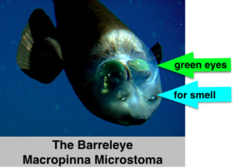
The Barreleye Fishes’ eyes are organs similar to green tubes located inside their skull, which being transparent allows them to see through it.
But this is not all, not only their eyes are strange, it’s that the Barreleye Fish has the particularity that can move them in all directions: forward, backward and sideways.
This gives a peripheral view with a very wide range of vision, unlike other fish with tubular eyes that remain fixed inside the skull.So the Barreleye Fish has an advantage over the other animals. If they try to look up they can rotate their eyes to an angle of 75 degrees.

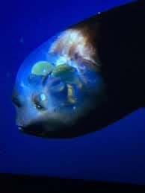
Another curious fact about their eyes is that they allow the animal a three-dimensional vision in the space it occupies.
Its greater field of vision allows it to expand its defense skills against predators and improve the offensive towards its prey, as well as to look straight ahead at the ones it’s eating.
Over the tubular eyes you can see some glasses, which are the lenses and fulfill the function of allowing the greatest possible absorption of light that comes from the surface.
Their eyes are very sensitive to light measuring about 2 centimeters in length. We invite you to read our article mantish shrimps to learn about other creature with interesting visions kills.

Other Interesting facts
The characteristic green pigment of their eyes and glasses is what allows them to filter the sunlight coming directly from the surface; this way they can look up looking at the bioluminescent light produced by jellyfish and other aquatic creatures.
Because of the particular shape of their eyes resembling a barrel is that they are known as «barreleye.»
In some cases they can present photophores, which are organs inside the eyes, responsible for emitting lightwhich allows them to attract their prey or keep predators away.

Let’s watch it

Studies About the Barreleye Fish
The Barreleye Fish was discovered in 1939 by researcher William Chapman, although none specimen had ever been photographed alive. Its discovery was almost a coincidence, since it was following animals that were trapped between the nets of fishermen.

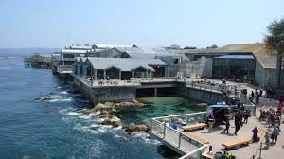
A very interesting fact is to know that the phenomenon of the transparent head of the Barreleye Fish is known only since 2004, the year in which a live specimen was photographed for the first time.
In the previous years when they took the fish from the deep sea, its head was destroyed due to the change in the conditions of sea pressure, so scientists did not know how it was.
But it was not until 2008 when these photos and new studies were published thanks to a team of researchers belonging to the Monterrey Bay Aquarium (California).

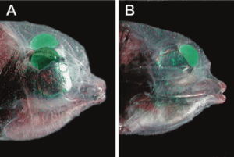
For a more complete data collection of the Barreleye Fish, specialized cameras that were placed in the ocean depths were necessary. They are small and fragile chambers made especially for the study of this specific animal, because an animal with more movement could spoil them.
With these studies, not only has the information that had been collected about their vision, behavior and stability at sea been explored, but the underwater cameras dedicated to the study of the seabed have also been modernized.
Marine vehicles have been developed capable of accurately capturing the movements and static moments in which the barrel eyes fish is found.
Researchers seek to learn more about the visual phenomena of this particular animal to be applied to specific areas of science.
The qualities presented by the pigment in the eyes of the barreleyes fish are probably useful for human beings on the surface due to their advanced way of perceiving light and brightness.

Barreleye fish: Habitat and Distribution
They are distributed mainly in the northern Pacific Ocean and in the Atlantic and Indian oceans.However, there are also known populations in the Bering Sea (Japan) and in the seas of Baja California in the United States and Mexico.
The barreleyes fish is a deep-sea creature, which usually inhabits the pelagic area of ​​the sea, between 200 and 1000 meters deep.

How Barreleye fish Reproduce?
Although there is not much information about it, it’s believed that there is no sexual dimorphism between the male and the female and they don’t care for their young.
They are oviparous and solitary, so it’s believed that fertilization of eggs is carried out in a dispersive manner. In other words, the female lays the eggs that the male subsequently fertilizes.
The eggs and larvae of the barreleye fish are pelagic, which means they are coated with a drop of oil that allows them to float on the closest surface of the sea until they hatch. After hatching they begin to descend to the depths as they grow, until they are located in the ideal habitat to live.
During this time they feed on zooplankton and small particles of organic material that floats in the water.

Feeding Habits

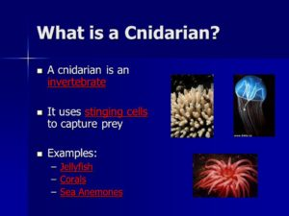
It’s not known for sure the exact diet of the barreleye fish, although some studies that have been carried out of their stomach reveal that they usually eat jellyfish and cnidarian animals.

On the other hand, their visceral anatomy demonstrates that plankton, small fish, siphonophores and nematocyst tentacles are also part of the diet of these strange creatures.
When the barreleye fish is so deep where there is little light, it can detect its prey just by seeing its silhouette.
It has been concluded that the shield that covers their head is intended to protect them from the stinging substances that the cnidarians and siphonophores secrete, so that they can be eaten safely.

Bruce Robinson and Kim Reisenbichler researchers at the Monterey Bay Aquatic Research Institute (MBARI) were able to observe that when a prey is seen the barreleyefish’ eyes rotate resembling binoculars, being able to look towards the rear. Moreover, it turns its body from a horizontal position to a vertical position to eat.
These researchers believe that the barreleye fish is able to steal small fish that are trapped in the tentacles of the siphonophores.

Other Barreleye Fish

Bathylychnops exilis. (Javelin spookfish)
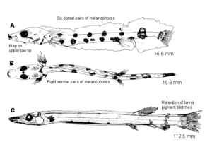
This species of barreleye fish is distributed in the deep waters of the North Pacific Ocean and in the eastern part of the Atlantic Ocean, reaching approximately 640 meters deep.
It usually reaches up to 50 centimeters in length with a thin body that is more reminiscent of a sardine with big eyes.
The most characteristic of this fish is that they have two unusual bumps in their eyes that allow them to have a much more developed vision than the common barreleye fish.
Each of the eyes has a super developed lens and a retina,which have earned it the popular name of six-eyed fish.
It’s believed that this protuberance or retina that is born in the lower part of the tubular eye, is intended to increase the field of vision of the fish, by allowing him to look at what is happening under it and to detect threats or any situation that is leading to out in deeper waters.
This barreleye fish belongs to the genus Bathylychnops, which was first discovered and described by the researcher Cohen in 1958.

Dolichopteroides binocularis.
This species of barreleye fish is found mainly in the oceanic waters of the Pacific at a depth that varies between 960 and 1200 meters below sea level.
It can grow to a length of 24.2 centimeters with an elongated and thin body. The most characteristic of its body are the large pectoral fins that it presents on both sides of the body. They are long and large a little disproportionate with the rest of the body.
It belongs to the genus of Dolichopteroides that was first discovered and described by researchers Parin, Belyanina and Evseenko in 2009; although there were already some previous studies of the author Beebe from the year 1932.
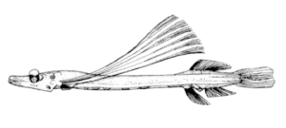

Brownsnout spookfish (Dolichopteryx longipes).

Its scientific name comes from the Greek that combines the words dolichos = long + pteryx = wing or fin + longipes referring to the long pelvic fins.
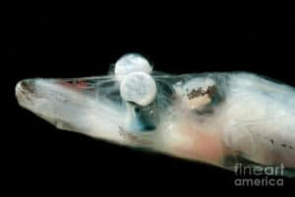
It belongs to the genus Dolichopteryx, being studied for the first time by the researcher Brauer in 1901, but there are basic studies of this animal by Vaillant in the remote year of 1888.
The brownsnout spookfish reaches a maximum length of 18 centimeters. A very curious fact is that it lack spines on the fins, its radii are soft reaching between 10 and 11 on the dorsal fin while having between 8 and 9 rays on the anal fin.
Its body is compressed, with the pectoral fins cut in contrast to the ventral fins that are long and with a relatively large head relative to its body.

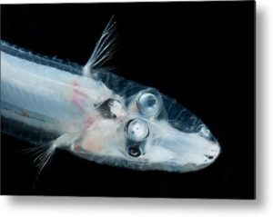
Moreover,Dolichopteryx longipes doesn’t have photophores, like some species of barreleyesfish . But instead it has a chromatophore that is an organ of light that is present throughout the entire body. In this case, it’s below the lateral line, allowing it to attract prey and remove predators.
This fish is normally found in the batpellagic area of ​​the ocean, living between 500 and 2400 meters below sea level. It’s of anodromus customs, that is to say it can migrate to more temperate or tropical waters like salmons do.
For this reason it’s highly distributed among the waters of the North Atlantic Ocean, North Pacific Ocean and the South China Sea. Many of its specimens are also found in California, United States.

Their diet is based on small crustaceans, especially copepods, which are small crustacean animals that are part of the zooplankton.

Eyes with mirrors.

Although the eyes of the conventional barrel eye fish and all the species of the family are very particular, the focus system used by this particular specimen will leave you with your mouth open.
And not only does he have the typical barrel eyes that he can move and look through his skull, but he has a bump on the bottom that at first glance looks like they were a pair of eyes.
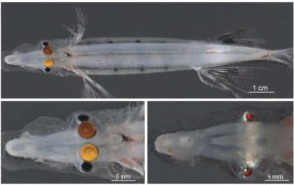

But it’s not so, they are actually mirrors, which allow them to collect the light of bioluminescent animals that live along with it the depths of the sea and are below their vulnerable belly.
And it’s that at the depth that this barreleye fish life, all the light it can collect is fundamental for its survival.

However, in 500 million years of animal evolution where thousands of animal species that have different kinds of eyes have lived, a specimen that used light-reflecting mirrors instead of refractive lenses had never been seen.
This discovery has been thanks to the intensive study of researcher Julian Partridge of the University of Bristol.

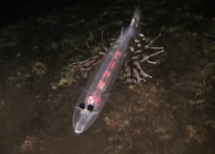
Only in recent years the capture of a specimen of this species was possible by Hans-Joachim Wagner of the University of Tuebingen, who along with his team captured one in the Pacific waters very close to the island of Tonga.
The main difference that this barreleye fish presents with respect to the rest of its relatives is that the eyes of its relatives are capable of providing them images without focusing, that is, they can see silhouettes and contours of the other animals.
While the Dolichopteryx longipes is able to focus sharp images and clearly observe everything that happens around it thanks to this extra reflective part.

Studies of Its eyes.

At the time of having a specimen for study, researcher Tammy Frank, took a flash photograph of the animal. In it you can see how the eyes that point up reflect the light of the camera producing the typical effect of red eyes.
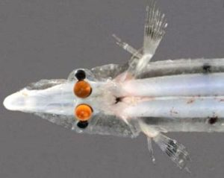
However, this does not happen with the diverticular part that points down, since this part collects the light that comes from the bottom.
To confirm this theory an anatomical study was carried out by Partridge.
He discovered that the eye mirror uses small plates of organic glass that are arranged in a stacked way forming multilayers. It’s believed that these structures were evolved as a result of the retinal covering that is the last layer of the retina in the common eyes.
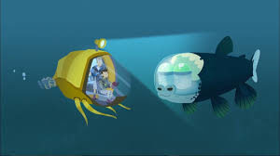
The most interesting thing is that this way of reflecting light is not a finding of isolated evolution, as it’s the main reason why some fish are silver in color.
However, the arrangement and orientation, which has a progressively variable angle, is controlled in a very punctual way to be able to reflect the light towards a specific focal point.
With some simulations in computers Partridge demonstrates that the precise orientation of the plates, which added to the curved surface make the perfect scenario to focus the light on the lateral retina of the barrel eye fish.
It’s also assumed that the use of a reflector mirror instead of a refractor lens can have great advantages when it comes to obtaining images with high contrast which translates into the fact that the ability to clearly observe moving objects at a depth of 1000 meters can mean the difference between life and death.

Here they are again

Opisthoproctus grimaldii.
This species of barreleye fish belongs to the genus Opisthoproctus, which was first discovered and described by Vaillant in 1888. However, in 1911 it was better studied by the researcher Zugmayer.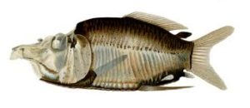
It’s a mainly tropical fish from the central waters of the southern Atlantic Ocean. However, it’s also very concentrated in the waters of the northern Pacific Ocean.Opisthoproctus grimaldii.
can also be found in tropical waters of the western Pacific.
It usually lives between 300 and 400 meters below sea level. Its maximum length is 18 centimeters while its body has a particular shape, since it’s small and plump, with the scales in light brown tones at the top while it darkens as it reaches the belly.
Like other species of fish, its head and tail are transparent; showing its barrel-shaped eyes and its mouth is shaped like a small beak.

Opisthoproctus soleatus.
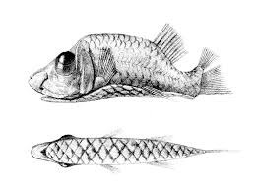
Like the previous species, it belongs to the Opisthoproctus genus and was discovered and described by Vaillant in 1888.
The maximum length of this leprechaun fish is 10.5 centimeters long without showing spines on the fins.
Its dorsal fin has 12 soft rays with a dark color on both sides of the body, having large amounts of melanophores, a melanin present in their body that allows them to absorb as much light as possible.
The anal fin has between 2 and 3 rays that are very rudimentary and almost invisible. Their snout is ventrally translucent.
It can live between 300 and 800 meters below sea level, although it prefers to stay between 500 and 700 meters deep.

Barreleye Fish name Error.
After its new discovery in 2004, the goblin fish was mistakenly known in Brazil by the name of Pokemon Fish. This is because an important newspaper in this country mistakenly extracted this name from a humorous blog. This news and the incorrect name were reproduced by several Portuguese media.
Let’s learn some other interesting deep sea creature species.

http://ourmarinespecies.com/c-fishes/barreleye-fish/

