Bioindicators
• A bioindicator is a living organism that gives us an idea of the health of an ecosystem. Some organisms are very sensitive to pollution in their environment, so if pollutants are present, the organism may change its morphology physiology or behaviour, or it could even die.
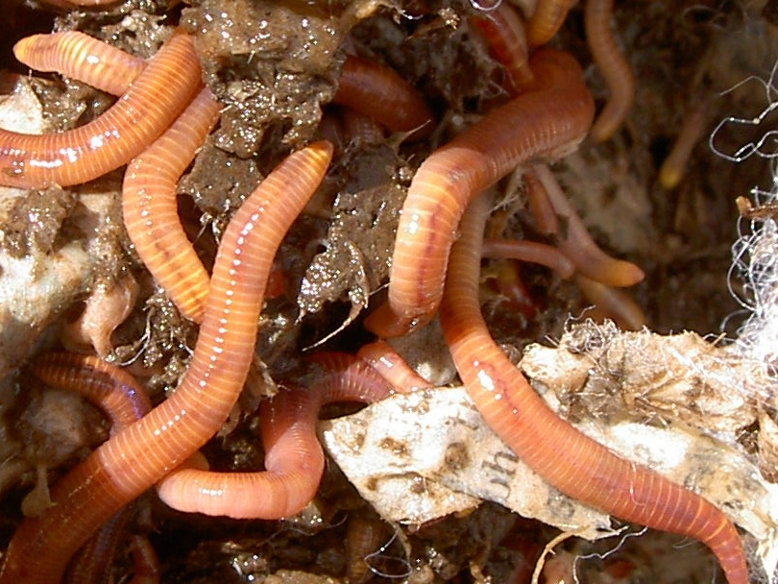
Worms
Changes in the functioning of the nervous systems of worms are used to measure levels of soil pollution. The numbers of earthworms in the soil can also be used to indicate the health of the soil.
One example of a bioindicator is lichens. These plants, which live on surfaces such as trees or rocks or soil, are very sensitive to toxins in the air. This is because they obtain their nutrients mostly from the air. We can tell our forests have clean air by the amount and types of lichens on the trees. Different species of lichen have different levels of susceptibility to air pollution, so we can also get an idea of the level of pollution by observing which species are present.

Nature of science
Living organisms can often be used to indirectly measure levels of chemicals in their environments. Population numbers can also be tracked over time to notice changes that may be a result of changes in the environment.

The advantage of using worms
Dr Ravi Gooneratne describes how using an organism to measure pollutants enables us to look at the effect a chemical has on living creatures rather than just the amount or type of the chemical.
Bioindicators can be plants, animals or microorganisms:
- If toxins are present, certain plants may not be able to grow in the area affected.
- Monitoring population numbers of animals may indicate damage to the ecosystem in which they live.
- Algae blooms are often used to indicate large increases of nitrates and phosphates in lakes and rivers.
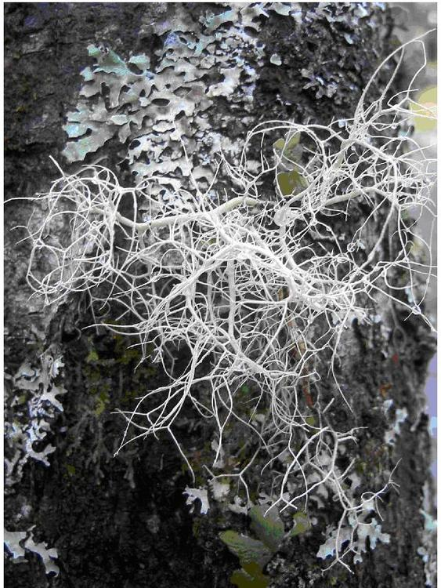
Lichens growing on rock
New Zealand has over 2,000 species of lichen. How many can you see on this tree trunk? How many can you find in the school playground?
If pollution causes the reduction of an important food source, the animals dependent on it for food may also decrease. Animals may also change their behaviour or physiology if a toxin is present. For example:
- the levels of certain liver enzymes in fish increase if they are exposed to pollutants in the water
- changes in the functioning of the nervous systems of worms are used to measure levels of soil pollution
- the increase in the number of mutated frogs found in the USA is used as an indicator of toxins in their environment.
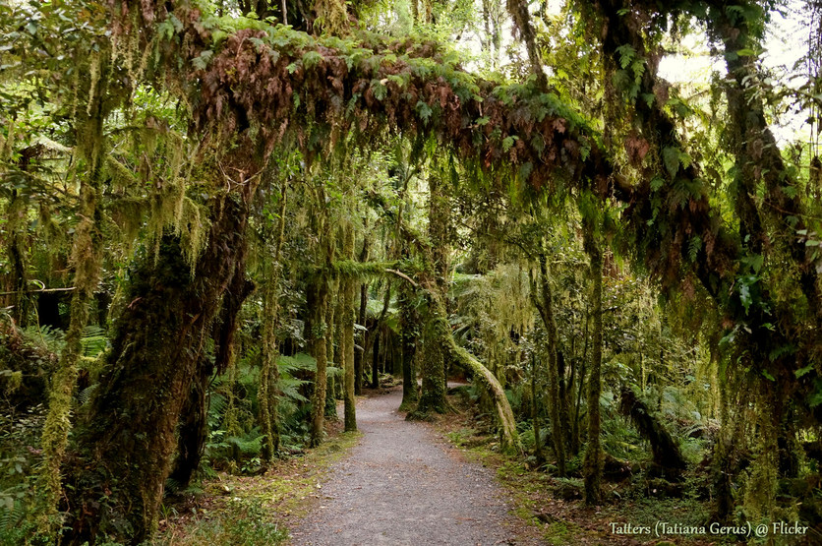
Lichen on forest trees
Lichens need clean air to flourish so are a good indicator of the air quality of the surrounding area. Much of the forest in the South Island is ideal for lichens, where many species can be found dripping from the trees. Pictured are miro, matai and silver beech trees covered with lichens and mosses.
Microorganisms can also be used as indicators of toxins in an ecosystem. Some microorganisms will produce stress proteins if exposed to certain pollutants. By measuring the levels of stress proteins, we can get an idea of the level of pollution present in the environment.
https://www.sciencelearn.org.nz/resources/1538-bioindicators

