Factsheet: Calculating water state

SUBMITTED BY LAWA AUTHOR Cawthron Institute PUBLISHED DATE 21 SEP 2019

Why are we recording the current state of our freshwaters?
We measure the current state of our rivers, streams and lakes to get an idea about whether our water is suitable for use for various purposes, and the effect of different pressures (e.g. urbanisation, farming, etc.) on the condition of our freshwater resources.
Some influence from people on our waterways is necessary to support our communities and agriculture, and it is not possible to return most water bodies in New Zealand to their pre-human state. Even where this is almost achievable, such as within national parks, introduced aquatic species such as trout, as well as native and exotic birds, insects and pest mammals, and natural processes such as erosion and atmospheric pollution, impact our waterways to some extent.

How is State calculated for our freshwater sites?
State in LAWA is described using two independent methods: state quartiles (rivers only), and NOF band scores (for rivers and lakes, described below). The state quartiles are a relative measure, comparing sites against each other, while the NOF band scores are an absolute measure, evaluating each site against expectations of water quality values in the National Policy Statement for Freshwater Management.

LAWA State Quartiles
The state quartile value presented for the river water quality sites on LAWA is based on the median of monitoring results from the last five years (2014-2018). A state median is calculated when there is at least 50% of the data available over this time-period, (i.e. at least 2.5 years' worth of data over a five-year period), and the quartile ranking is derived by comparison of each site’s median with others. The quartile ranking describes how each site ranks relative to the others – the 1stquartile being the best quarter, the 4th quartile being the worst quarter.
The results are then presented in four groups from those that are within the best 25% (Quartile 1), to those in the worst 25% (Quartile 4):
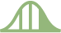  Q1: Best 0-25% of sites | Q2: Best 25-50% of sites | Q3: Worst 25-50% of sites | Q4: Worst 0-25% of sites

For river water quality indicators, quartiles can be derived for each site by comparing its median values with all other sites around the country, or compared to sites with similar land use and/or altitude. Thus a single site may have various quartile scores, depending on the group it’s being compared against.
The land use classification for a reach is determined by the predominant upstream land use, which may be forest (indigenous and exotic), urban or rural. For example, if the catchment of a reach is 50% or more covered in ‘forest’, the reach’s land use is classified as forest, however, if the catchment of a reach is 15% or more covered by urban land use, the reach’s land use is classified as urban. These land use definitions are based on the New Zealand River Environment Classification (REC). At some sites, the REC classification does not reflect current land use, and in these cases councils have provided LAWA with an updated land use classification.

NOF Band Scores
The National Policy Statement for Freshwater Management (NPS-FM) 2014 (amended 2017) includes a table in the National Objectives Framework (NOF) of ‘attribute states’ or ‘bands’, which range from A to D and in the case of E. coli from A to E. The current state of lake and some river water quality indicators are evaluated against these attribute state bands, and the scores displayed on the LAWA website. The NPS-FM is the Government’s direction to regional councils about how to manage freshwater.
‘Attributes’ in the NPS are characteristics of the water that need to be managed by regional councils, the equivalent of LAWA's 'indicators'.
LAWA shows the current state for freshwater quality indicators as the A, B, C D or E NOF-bands (along with descriptions for context) so you can see which attribute state the water is currently in. Attribute states for most indicators are defined by the annual median result for the site, the 95th percentile result or the annual maximum result. For example if the ammoniacal nitrogen annual median result was an A NOF-band and the annual maximum result was a B NOF-band, then LAWA shows this as a B NOF-band.
An example of the descriptions for the attribute states (e.g. total phosphorus for Lakes) is given below:
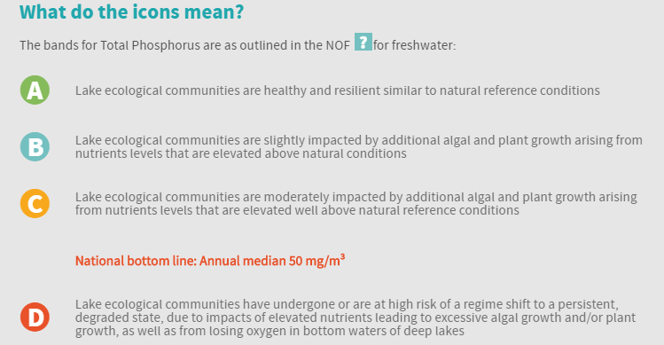
Councils need to set ‘freshwater objectives’ for these attributes, describing the band their communities want for each attribute. For each attribute (except E. coli) there is a national bottom line (between the C and D band). That means councils need to aim for a C or better, unless it is considered appropriate to set the freshwater objective below the national bottom line (e.g. the existing freshwater quality is caused by naturally occurring processes). If they are not already achieving these freshwater objectives they need to work towards achieving them over time.

The difference between State Quartiles and NOF Band Scores
State quartiles are a useful comparative ranking. They show us how a site compares against other sites. The NOF-band provides an absolute ‘score’ for some water quality indicators.
For some sites the water quality may be good (and score “A” under NOF), yet still be in the 4th quartile. This happens when all the sites are good (and meet the NOF “A” definition); some will still be better, leaving others in the 4th quartile. On LAWA that looks like this:

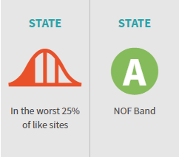

River ecological health monitoring sites
LAWA shows three indicators (Macroinvertebrate Community Index (MCI),taxonomic richness and %EPT) which are used to measure the ecological health of river sites.
The state presented for these sites uses the median calculated from data over the last five years (2014-2018). A minimum of three data points over the last five years are required for a median value to be calculated for sites that are sampled once a year. Sites that are sampled twice per year need a minimum of six samples over the last five years.

