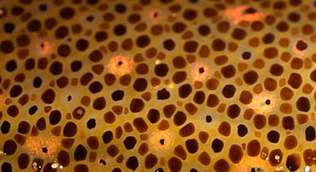

Chromatophores in the skin of a squid
Chromatophores are pigment-containing and light-reflecting cells, or groups of cells, found in a wide range of animals including amphibians, fish, reptiles, crustaceans and cephalopods. Mammalsand birds, in contrast, have a class of cells called melanocytes for coloration.

