Deep sea Angler fish (Melanocetus johnsoni)

Anglerfish belongs to the order Lophiiformes, which includes three suborders, 15 families, and about 215 species... (For all those who didn’t understand these scientific terms need not worry ;)…..)

Deep sea has scarcity of both light and food , thus organisms living here exhibit various adaptations ...

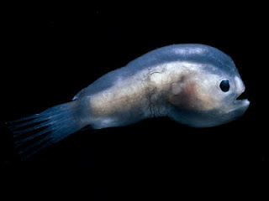

Male Angler Fish

Deep sea angler fish is also called as "common black devil". It is dark grey or black in color and the skin can reflect the blue light emitted by other bio luminescent organisms of deep, and thus can appear almost invisible to them.

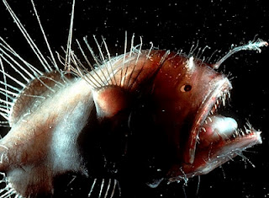

Female Angler Fish

An important adaptation of the female angler fish is the elongated dorsal spine, wide mouth with needle like teeth, round and wide body and much larger than the male (female is around 10 cm in length whereas males ten times smaller). Elongated dorsal spine supports photophore that can produce blue green light by bioluminescence which helps to attract prey. This illuminated lure can be moved in any direction while the fish is stationary …such that they are not noticed.

It has soft bones, jelly like skin and powerful jaws which can be widened to such an extent that it can swallow prey twice the size of its entire body.

Male angler is very tiny as compared to female and is black in color. Soon after birth, male angler fish searches for female to attach itself with help of their pincer like mouth. This is so because as it matures its digestive system degenerates and it can’t feed on its own…. only option is to find a female or die. Once he bites into her skin to attach itself, he releases an enzyme that dissolves the skin of his mouth and that of her body. Almost all his parts r degenerated including eyes but only gonads remain. Thus he becomes part of her body as the blood vessels fuse. Male spends the rest of its life joined to the female like a parasite, getting all of his nourishment from her body an thus his growth is ceased except for the development of reproductive organs. A female can carry up to six males on her body at a time such that when female is ready to spawn she has fresh supply of sperms. Below picture shows female angler with males attached to her body.

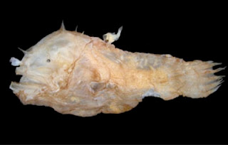

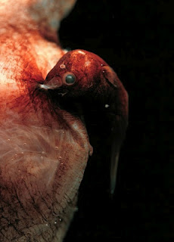

The female lays her eggs in thin sheet of gelatinous material (one meter wide and nine meters long). this sheet of eggs floats free in the sea until the eggs hatch into tiny larvae. Once hatched , the larvae swim to the surface and feed on plankton, Once they mature , they then return to the deep sea.

http://marine-mysteries.blogspot.co.nz/2012/01/deep-sea-angler-fish-melanocetus.html

