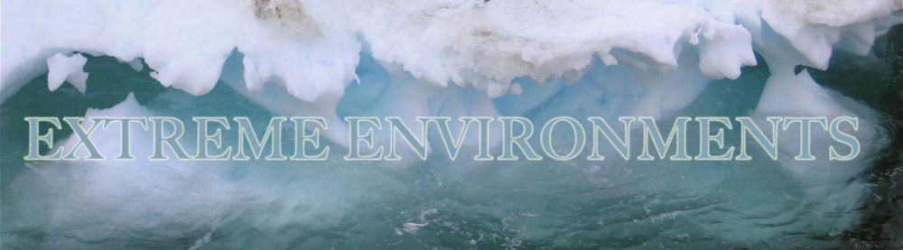 BIRGIT'S DISCOVER! MAIN PAGE
Extreme Environments and Their Inhabitants

Humans rely upon their natural surroundings to remain fairly consistent to ensure survival. Significant variations from the norm in factors such as pressure, temperature, acidity, salinity, water availability, oxygen levels, radiation levels, and pollutant and toxin concentrations can ultimately result in many organisms’ immediate death. However, some organisms—known as extremophiles—have evolved to thrive in these various extreme environments.
UNDER PRESSURE
A change in pressure can be of great consequence to an organism. The windows and doors on airplanes are sealed shut during flight for a reason, after all. As one travels higher into the atmosphere, pressure decreases concomitantly. In contrast, the deeper underwater or into the earth one travels, the greater the pressure measures. Humans cannot survive unassisted either high in the sky or deep below the ocean, however some extremophiles have evolved to such a degree that they thrive in either very high or very low pressures.
Piezophilic, or barophilic, microorganisms are extremophiles that colonize high-pressure areas. These organisms typically live deep below the ocean surface at depths reaching beyond 7,000ft (2121m). At this depth, pressures can reach over 3160 psi (pounds per square inch)--that is the equivalent of more than one adult male giraffe standing on each square inch of surface! Often times high concentrations of extremophiles will cluster around hydrothermal vents, thus coupling barophiles, organisms with an affinity for high pressure environments, with thermophiles, organisms that thrive in very hot surroundings. Conversely, microorganisms have also been discovered high up in the sky living in clouds. WINGS WOD Awardee Birgit Sattler helped to prove that despite the low-pressure environment, some organisms were able to thrive in the clouds.
RADIATION EXPOSURE: NO MUTANTS HERE
Radioresistant extremophiles are capable of surviving radiation levels over 1,000 times greater than what a typical human cell can endure. Radiation is harmful to a cell as it induces errors in genetic coding, some of which result in dangerous mutations that can cause problems such as cancer. Deinococcus radiodurans, one example of a radioresistant extremophile, battles this problem by constantly excising mutated genetic sequences and re-piecing together unharmed sequences. Different environments in which radioresistants have been improbably found thriving include nuclear waste sites, irradiated canned meat, and high mountain peaks (susceptible to increased UV radiation).
LIFE IN A VAT OF ACID
While the acid-base pH scale ranges from 0 to 14 (0 is most acidic, 14 is most basic/alkalinic, and 7 is neutral), humans typically seek pH levels from 6.5 to 7.5. One type of extremophile known as an acidophile, however, can live happily in areas with pH levels from 0 to 5! One such acidic environment is in fact the human stomach, with typical pH levels ranging from 1 to 3.
Microbes are able to defend against cell death occurring due to acids breaking down their outer­­­­ membranes via several techniques. Many find ways to protect their cell membranes, either by creating a buffer around them from secreted biofilms, increasing the density of fatty acids on the cell surface, or some other similar approach. Other acidophiles survive by managing to keep their internal pH levels around 6.5 despite the highly acidic outside surroundings. Similar strategies are used by alkaliphiles, extremophiles capable of surviving in very alkalinic environments.
Highly acidic environments can be found in a variety of locations, including sulfuric pools and geysers like those seen in Yellowstone National Park, Wyoming; regions polluted due to acid mine drainage activities; and closed digestive systems such as the human stomach. Highly alkalinic environments include Mono Lake in California; the slag dumps of Lake Calumet region, southeast Chicago, Illinois; Octopus Spring in Yellowstone National Park, Wyoming; and the East African Rift Desert.
HOT, COLD, and EVERYWHERE BETWEEN
Temperature is an important limiting factor for human habitation, although up to a point there remains some flexibility owing to warm clothing and the opportunity to seek shelter. Without additional efforts, however, humans cannot deviate too greatly from standard room temperature and expect to survive unscathed. Certain types of extremophiles, on the other hand, absolutely thrive in exceedingly hot or cold environments.
Thermophiles are microorganisms that live in very warm surroundings, such as in hot water springs or around hydrothermal ocean hot water vents. One type of bacteria, Thermus aquaticus, has been found living in nearly boiling water (212F, 100C). The rainbow-like hues that often define many people’s conception of hot water springs like those in Yellowstone National Park can be attributed to the brightly colored thermophiles and acidophiles that thrive in such otherwise inhospitable environments.
Psychrophiles and cryophiles, on the other hand, are extremophiles known for colonizing very cold regions such as the Arctic and the Antarctic. Many obstacles must be overcome when living in ice, such as the potential for ice crystals to form within the cell and puncture the cell membrane; the inaccessibility of water due to its frozen state; and the lack of sunlight or heat as energy sources when buried under thousands of meters of ice. To protect against ice crystals, some organisms have developed freeze-shock proteins, or proteins that inhibit water molecules from entering a frozen state. Additionally, other organisms have developed the ability to be repeatedly frozen and thawed, able to snap into action when the environment is favorable and lay dormant for long periods of time (over tens of thousands of years in some cases, but less than a day in others) when it is not.
SUFFOCATING SALINITY
Halophiles are microorganisms that can survive—and flourish—in environments with very high concentrations of salt. Whereas many creatures have adapted to living in the saline levels of the world’s great oceans, few have managed to adapt to the saline levels found in the extreme environments that are often ten times the salt content of typical ocean water. Some examples of very salty areas include the Great Salt Lake in Utah, California’s Owens Lake, and the Dead Sea. Although only fresh water enters the Great Salt Lake, because it is a terminal lake (no water flows out of it), the only way water leaves is through evaporation. As even fresh water has some salt and minerals dissolved within it, as the water evaporates over time it leaves behind an ever-increasing concentration of particles. The Great Salt Lake is particularly affected in this regard given its very high surface area to volume ratio. A shallow lake reaching maximum depths of only 33ft, a significant proportion of the water body’s volume is thus readily accessible for evaporation.
Very salty surroundings pose a problem for most organisms because they cannot properly regulate their cell surroundings. Osmosis, the natural process of water moving from an area of high concentration to one of low concentration, results in cell death when an organism is submerged in a high saline environment. This is because water will naturally move from within the cell to outside the cell owing to the relatively lower concentration of water molecules on the outside (the high concentration of salt and other minerals lowers the concentration of pure water molecules). Halophiles have designed mechanisms for combating this issue, however. They artificially increase the concentration of molecules within the cell, such as proteins and sugars, so that the concentration of water within the cell is equal to that outside of it, and thus water will not be lost to the environment.

http://explore.wingsworldquest.org/node/550

