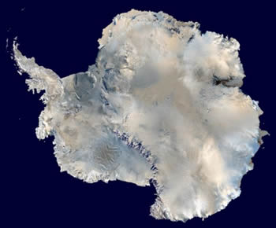

Extreme Environments

This picture shows the continent of Antarctica. Most of Antarctica is an extreme environment. I'll bet you know that Antarctica is very cold. Did you know that most of it is very dry, too? Antarctica is considered the largest desert on Earth!
Click on image for full size
NASA

Extreme environments are places where "normal" life finds it hard to survive. That doesn't mean that there isn't any life in extreme environments. Certain creatures can live and grow in extreme environments. Scientists have a special name for creatures that live in extreme environments. They are called "extremophiles".
What kinds of environments are "extreme"? Some extreme environments that you may know about are deserts, mountain peaks, caves, and frozen places like the Arctic and Antarctic. Some environments are very hot or very cold, extremely dry, or both. Other extreme environments are filled with acids, are blasted with radiation, are under high pressure, or are tough places for most living things in various other ways.
Some environments are extreme in more than one way. Most deserts are both hot and dry. The Dry Valleys in Antarctica are very cold and dry. Some hot springs are acidic as well as being nearly boiling hot. Hydrothermal ventson the sea floor don't receive any sunlight, spew out hot water filled with harsh chemicals, and are weighed down by the crushing pressure of the deep oceans.
When Earth was young, most environments on our planet were extreme compared to today. Environments on many other planets and moons within our Solar System and beyond are also extreme. In the last few decades, scientists have discovered life in extreme environments on Earth where they had thought it would be impossible for creatures to survive. Those discoveries made scientists more interested in studying extremophiles. Studying life in extreme environments may help us learn more about the history of life on Earth. It may also help us learn about the possibility of life on other worlds. Some extreme environments on Earth are a lot like extreme environments on other planets. Sometimes scientists test instruments for detecting life in extreme environments on Earth before they send them to other planets on space missions. For example, some instruments that are now on robots on Mars were first tested in the very, very dry Atacama Desert in Chile.
Last modified August 26, 2008 by Randy Russell.
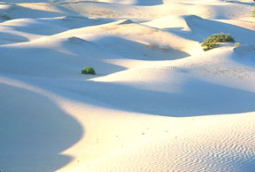
This picture shows sand dunes in a desert. Deserts are very dry. They are one kind of extreme environment. It is hard for most living creatures to survive with so little water. Some deserts are hot, like the Sahara in Africa. Others are cold, like the Dry Valleys in Antarctica.

Extreme Environments - Temperature and Moisture
This page describes environments that are very hot or very cold, extremely dry, or both. Extreme environmentsare places where "normal" life finds it hard to survive. That doesn't mean that there isn't any life in extreme environments. Certain creatures can live and grow in extreme environments. Scientists have a special name for creatures that live in extreme environments. They are called "extremophiles".
What kinds of environments are "extreme"? Some extreme environments that you may know about are deserts, mountain peaks, caves, and frozen places like the Arctic and Antarctic. Some other examples of extreme environments are places that are filled with acids, are blasted with radiation, or are under high pressure.
Many environments are too hot or too cold for most living creatures. The heat in deserts like the Sahara in Africa and Death Valley in North America makes it hard for life to survive there. What are some other hot environments that you may not know about? Hydrothermal vents in the ocean floor spew out very, very hot water. Geysers and hot springs in places like Yellowstone National Park in the USA also contain water that is too hot for most living creatures.
Really cold environments are tough on life too. The ice caps, snow fields, and sea ice found in the Arctic and Antarctic are examples of cold environments. High mountaintops around the world are also usually quite chilly. The deep oceans are not quite frozen, but they are still pretty cold, too. About 90% of ocean water is below a level called the thermocline. Water below the thermocline has a temperature between 0° and 4° C (32° and 39° F).
Places that are very dry are also extreme environments. The lack of water in deserts is hard on life. Many deserts are both very hot and very dry. Did you know that some deserts are cold instead of hot? Antarctica is actually Earth's largest desert! The Dry Valleys in Antarctica are some of the driest places on our planet. How dry can deserts be? Some places in the Atacama Desert in Chile get an average of less than 1 millimeter (0.04 inch) of rainfall a year! Sometimes many years go by there with no rain at all.
Last modified September 26, 2008 by Randy Russell.

https://www.windows2universe.org/earth/extreme_environments_hot_cold_dry.html

