How to format the chart you created for the example question:

Your chart currently looks like this:

Legend

- Change the title to a more descriptive title (The Effect of _____ on _____).
- Click on the chart to select it.
- Click on the current title, highlight and delete the existing text, and type the new title in the box: The Effect of Vegetation Type on the Total Number of Animals Photographed (you can change the font size and the size and position of the text box to fit the title above the graph)

- Remove the legend:

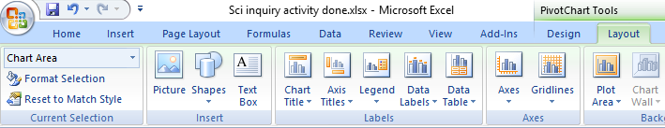

- Click on the graph to select it. Choose the Layout tab.
- Select the Legend drop down menu.
- Choose "None. Turn off legend"
- Label the axes:

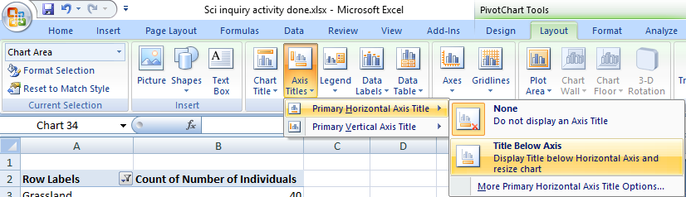

  - Click on the graph to select it. Choose the Layout tab.
  - Select the Axis Titles drop down menu.
  - Choose Primary Horizontal Axis Title and Title Below Axis
  - Change the x-axis title to Vegetation Type
  - From the Axis Titles drop down menu, choose Primary Vertical Axis Title and Rotated Title
  - Change the y-axis title to Total Number of Animals
How to format the chart you created for your research question:

- Change the title to a descriptive title using the model: The Effect of _____ on _____.
- Remove the legend if it is not needed. Ask if you are not sure.
- Label the axes. Include units!

