Freshwater macroinvertebrates

• New Zealand has over 200 species of freshwater macroinvertebrates. An invertebrate is an animal that lacks a backbone. ‘Macro’ means the invertebrates are large enough to be seen without magnification – even though some can be as small as 1 mm in length. Examples of aquatic macroinvertebrates include crustaceans (such as sand hoppers), insects (such as beetles and mayflies), molluscs (such as snails) and segmented worms (such as leeches).
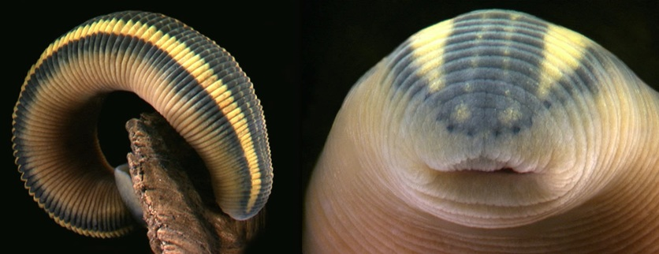
Native blood-sucking leech
Richardsonianus mauianus is one of the few blood-sucking leeches in New Zealand. Like other leeches, they are visibly segmented, very flexible and there is a suction disc at the tail end. They are occasionally found in lakes and slow-flowing weedy streams. They are common in the Oruarangi Creek in Mangere.The right-hand picture is a close up of the head.

Habitats
Freshwater macroinvertebrates live in all kinds of freshwater environments, from pristine mountain streams to wetlands to sewage ponds. They make their homes under rocks or leaves, in the sediment or in the vegetation along the sides of the waterway. Some creatures, like freshwater snails and mussels, spend their entire lives in the water. Other creatures, like dragonflies and mosquitoes, live in the water during their larval or nymph stages but out of the water as adults.
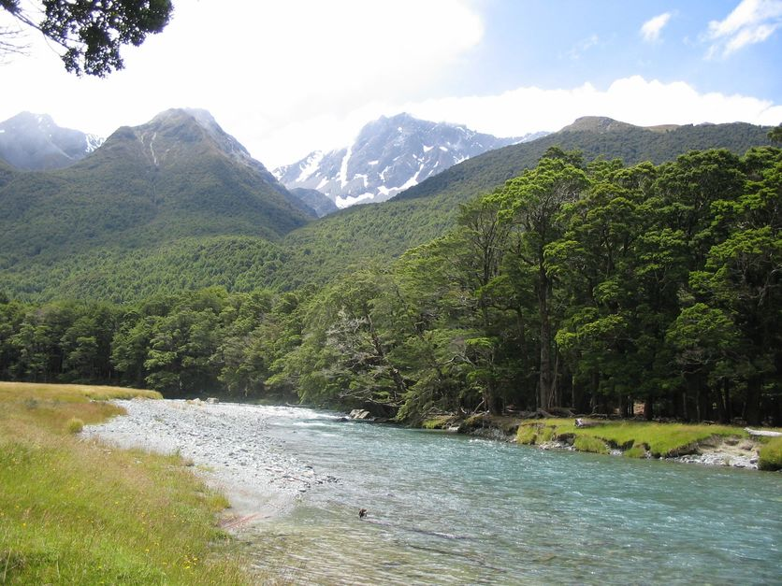
River edge
Rivers are important ecosystems that provide homes for many species of plants, insects and fish. These in turn provide food for our native birds and lizards. The riparian boundary is of particular importance to the river ecosystem because this is where most animals and plants seek shelter, but it is also the area most prone to damage by erosion. By protecting this margin we can help prevent erosion and also improve the quality of the water.

Waterways – especially streams – have different types of ‘bottoms’ or substrates. Hard bottoms are made up of rocks or gravels. Soft-bottomed waterways tend to be muddy or weedy. Burrowing creatures like worms prefer to live in the softer substrates.

Aquatic food webs
Some macroinvertebrates are carnivorous – they feed on other creatures in the water.
Some graze on algae – rather like guinea pigs nibble the grass. Other macroinvertebrates are filter feeders. They ingest tiny pieces of food suspended in the water.
Macroinvertebrates are an important food source for fish, birds and other animals. They also help to recycle nutrients in aquatic environments.

Physical adaptations
Macroinvertebrates have physical adaptations suited to living in specific aquatic environments. Creatures that live in fast-flowing water, like stoneflies and mayflies, often have claws or hooks for holding on to rocky substrates. Water boatmen live in slow-moving water so their legs are designed for swimming rather than holding on. The spiny-gilled mayfly has hairy legs to trap drifting food particles.
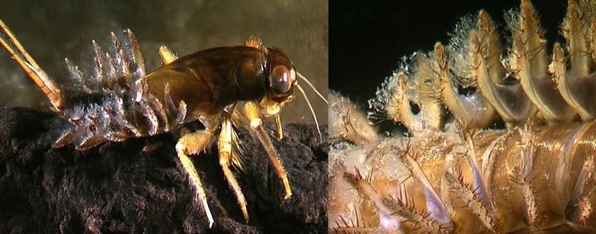
Spiny gilled mayfly (Coloburiscidae: Coloburiscus)
Coloburiscus mayfly nymphs are easily distinguished by the cactus-like gills covering the top of the abdomen (the right-hand picture). The front and mid legs are very hairy.
Some macroinvertebrates breathe through gills. Others, like diving beetles, trap air bubbles under their exoskeletons. Gill location (on the body, legs or even on the tail) helps scientists to identify different species.
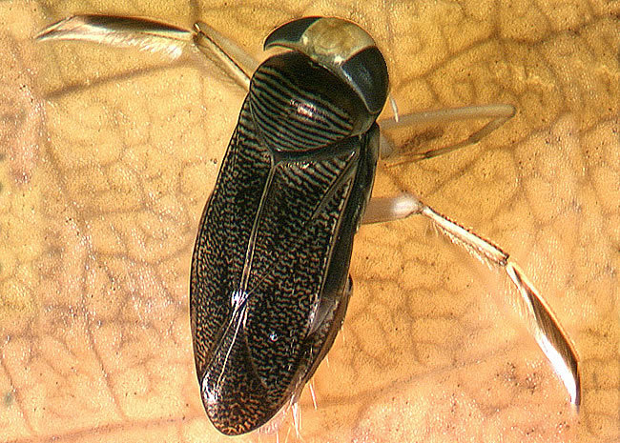
Water boatman
The water boatman (Corixidae: Sigara) is a macroinvertebrate found in streams, lakes and ponds. Their hairy legs are adapted for swimming in slow-moving water.

Human impacts on macroinvertebrates
Humans modify the land to build cities and farms. We dam rivers to produce electricity and divert streams to build roads. These changes have impacts on macroinvertebrates. Clearing vegetation from the banks removes food sources, breeding grounds and shade – so the water gets warmer. Dams, weirs and irrigation reduce water flow and velocity – causing sediments to build up, altering the substrate and making it difficult for gilled creatures to breathe. Nutrients from sewage or farm run-off alter the types of plants that grow in waterways. When the plants die, they use up dissolved oxygen and cause eutrophication. Spills and run-off from business and residential areas also change the water chemistry.
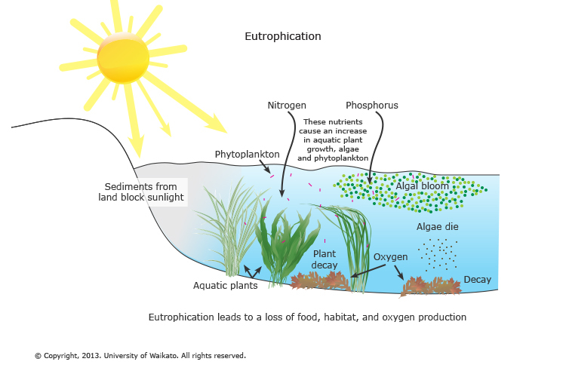
Eutrophication
Eutrophication occurs when nutrients are carried into waterways causing excessive growth of aquatic plants. As plants die off, they take up oxygen, causing other plants and organisms to die off.

Nature of science
Humans are part of the ecosystem. Our activities, such as modifying the land for our own use, alter the balance of natural ecosystems. Fortunately, science is helping us learn more about the impacts of change and how to manage ecosystems sustainably.

Water quality indicators
Many freshwater macroinvertebrates are trapped or confined to their particular habitat. They are unable to migrate or move to a new location if changes occur. For this reason, macroinvertebrate species identification and counts are often part of water quality surveys. Sensitive creatures like caddisflies and mayflies are associated with good water quality, whereas more tolerant creatures like snails and worms can survive in modified or degraded streams with poorer water quality.
Regional councils and water care groups monitor streams over time to develop baseline information about macroinvertebrates and water quality. Changes in species type or number may indicate changes to stream conditions, both good and bad. Other indicators like water clarity, temperature and water flow/velocity are also monitored.
Read about monitoring and restoration projects in these articles: Students help restore mauri to the Oruarangi Stream, Riparian restoration and Water quality in Rotorua lakes.
Macroinvertebrates are bioindicators. Read more about this concept in the article Bioindicators.

Related content
Find out more about water quality and use this article to read about who monitors our water quality and what they measure.

Activity idea
The student activity Observing freshwater invertebrates gets students out to their local stream, capturing, observing and developing classification systems based on what they find.

Useful link
Visit the Landcare Research website to discover some weird and wonderful freshwater invertebrates. Scroll through the species list to see which creatures have unusual adaptations, which are escapees from home aquariums and which ones might try to bite human toes that invade their habitat!
https://www.sciencelearn.org.nz/resources/1820-freshwater-macroinvertebrates

