STRANGE SCIENCE FROM THE DEEP SEA: WHY THE BARRELEYE IS THE COOLEST FISH I’VE SEEN
Chris Holdgraf
- Research highlights
7 years ago
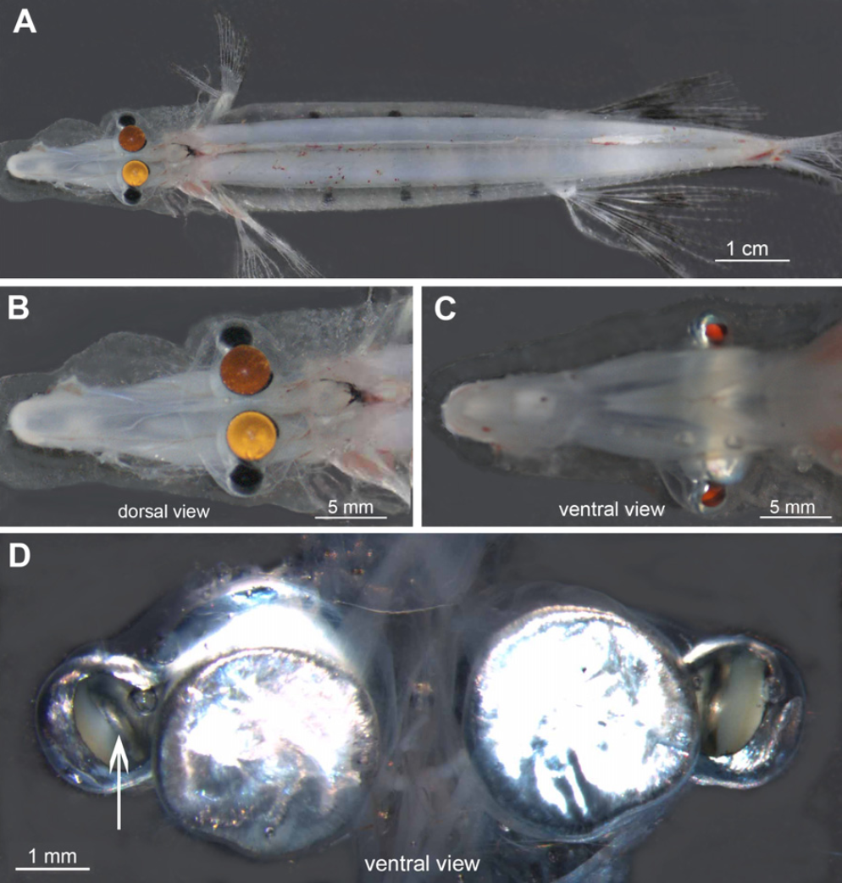
As a neuroscientist, I spend my time thinking about the inner workings of the brain and what they mean for human life. I often find myself carelessly losing sight of the amazing world that exists around me, with the assumption that what goes on in between our ears is more interesting than anything else. Every now and then, I hear about a scientific discovery that snaps me back to reality, making me realize that this planet is a much more mysterious, unknown place than I give it credit for. For a prime example of one of earth’s natural wonders, I present to you the Barreleye:

Hi Barreleye!
Now, I want you all to stop for a second and look at the picture above. Notice anything strange? That’s right—the fish’s head is transparent. And those two globular things inside: no, they’re not its brain, they’re actually the fish’s eyes. While the creature’s existence has been known for a while, researchers were recently able to capture a Barreleye on video with some pretty sophisticated deep-sea exploration.
The Barreleye (also called a Spookfish) needs to cope with the fact that sunlight can penetrate through water only so much. As a result, the amount of light that makes it to the depths of the sea is incredibly small. However, fish still need to be able to see in order to navigate, find food, and escape predators, so nature has equipped them with two massive light-sensing eyes that point directly upward.
The eyes are completely filled with so-called “rod” photoreceptors. These are a type of cell that will respond to very faint amounts of light. Because they are so sensitive, these photoreceptors will allow the Barreleye to detect very small changes in light from above. This is useful in spotting the silhouettes of food or predators. These two eyes are embedded within a translucent membrane that keeps the delicate cells safe as the animal steals food from the stinging tentacles of man o’ wars.
But it doesn’t stop there. A recent paper discovered that the Barreleye’s visual system is much more complicated than that. You might be thinking that seeing upward sounds very useful, but what about what goes on down below? There’s a lot of important activity coming from the depths of the sea (for instance, from bioluminescent creatures on the ocean floor). In order to cope with this, the Barreleye actually has another set of eyes.
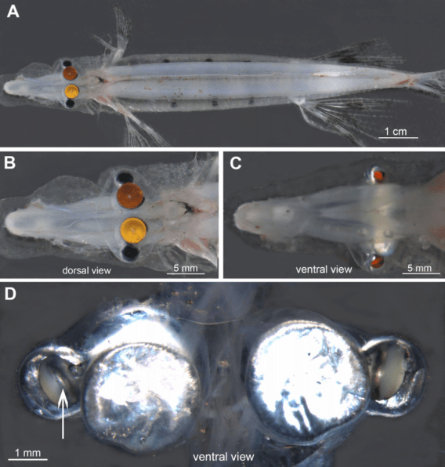
A/B show the fish from the top, and C/D show the fish from the bottom. The colored parts are the fish’s eyes.
The image above shows a top (A/B) as well as a bottom (C/D) view of the Barreleye fish. In particular, note that there are two little colored circles on the bottom of the fish’s body. These are the openings that the fish uses to see beneath itself. However, rather than being pointed straight down, the second pair of eyes use a complex system of mirrors to reflect light from below onto another retina. Look at the white arrow in D…notice that little which patch? That’s the series of mirrors that the fish uses in order to focus light from beneath.

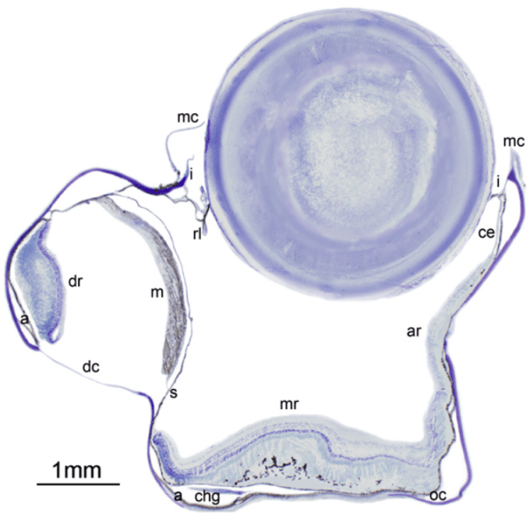
This is the Barreleye’s eye from the front.
Now take a look at the picture above. This is a slice of the fish’s eye, if the camera was facing the fish’s front. Notice that there are two chambers here…the big one on the right is for the giant, upward-facing eye, and the tiny one to the left is for the reflective eye that looks downwards. That little line of purple labeled “m” is a series of mirrors, each of which is oriented at a different angle. Just across from these mirrors is a second retina (labeled “dr”).

The Barreleye has two retinas to detect light from both below and above.
Light passes upwards from below, hits the mirror, and is then reflected across the smaller chamber to the retina. This allows the fish to focus on images beneath it, as well as to detect what’s going on above. On the right side, light comes in from above, and is focused by the large cornea onto the retina below.
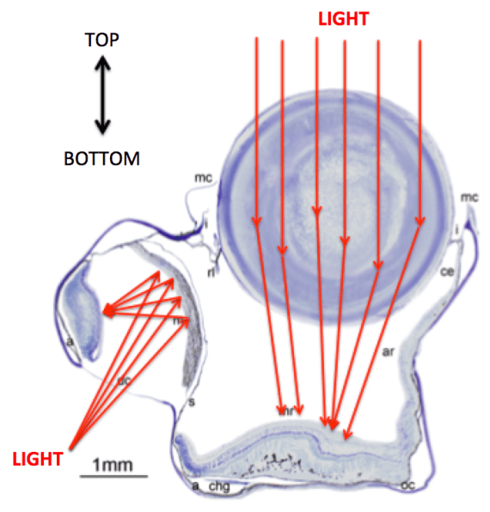
Using this combination of light-bending biology, the Barreleye is able to both detect incredibly faint movement coming from above, as well as the bioluminescent life down below. In its array of tools the Barreleye has managed to evolve not only a giant transparent dome to house two large “telescopes” that point towards the surface, it also contains a complex array of mirrors to focus light from below. All this from a tiny creature that gets most of its food by stealing from jellyfish.
Nature often solves problems in incredibly elegant ways, and the fact that it does so with the brute-force of gradual evolution and natural selection is truly an amazing feat. While we spend most of our times thinking about what lies beyond our own planet (or in my case, what goes on between our ears), we would do well to remember that there is still a fascinating unexplored universe that lies all around us. Whether it be in the sea or on land, this planet contains countless numbers of unexplored nooks that are brimming with wonderful creatures and amazing discoveries.

https://berkeleysciencereview.com/2013/05/strange-science-from-the-deep-sea-why-the-barreleye-is-the-coolest-fish-ive-seen/

