How Whales Work
BY TOM HARRIS

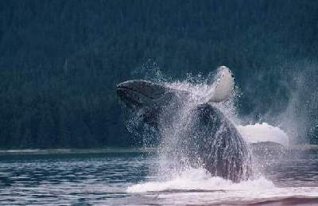
Humpbacks are known for their intelligence, playfulness and elaborate vocalizations. See more pictures of marine mammals. PHOTO COURTESY IAIN KERR, OCEAN ALLIANCE

In the world's great whale tales, including Herman Melville's "Moby Dick," the storytellers are preoccupied with one particular whale attribute: awesome size. Many whale species are staggeringly enormous. The blue whale, for example, can grow to 100 feet (30 m) long, about the height of a 10-story building, and can weigh as much as 150 tons (300,000 lb or 136077.7 kg). Its heart alone is the size of a small car, and there's enough room on its tongue for 50 people. It is the largest known animal in Earth's history.

Marine Mammal Pictures
But despite their monumental proportions, the most phenomenal thing about whales isn't how big they are: It's the way they live. Whales are mammals -- warm-blooded, air-breathing creatures -- but they spend their entire life in the ocean. In this article, we'll look at the remarkable adaptations that make this possible. We'll also explore the mysterious behavior of whales, and we'll investigate the history of commercial whaling and whale conservation.
Whales are mammals, just like us, and more than 50 million years ago, their ancestors walked on land as we do. It's not clear what these animals were like, but some paleontologists believe they may have been hoofed mammals, something like modern cows. Other paleontologists believe that whales were more like modern wolves. Over the course of millions of years, the ancient creatures spent more and more time in the water, living partly on land and partly in the sea, like modern sea lions or otters. Eventually, the creatures stopped climbing onto land altogether, and they slowly lost their now-useless legs and fur. The evidence for this hypothesis is fairly compelling: Paleontologists have even found fossilized whale-like creatures with legs so small that they couldn't possibly support the animal's weight.
Modern whales have wide tail flukes, extended flippers and, in some species, dorsal fins. Whales swim forward by flexing their tails up and down, instead of side to side as with most fish. To change direction, they move their flippers, similar to the way an airplane steers (read How Sharks Work for details). The dorsal fins, if present, serve to stabilize the whale's body as it swims.
In the next section we'll look at how the whale made the transition from land to water.

SPECIAL THANKS
Our thanks to the folks at Ocean Alliance and Sea World Orlando for the tremendous photos they provided for this article.

Whale Evolution

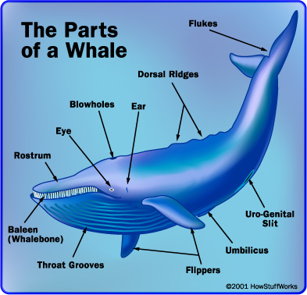
To us, the path of these creatures from land to sea may seem like an odd turn of events. Why would a land mammal, specifically adapted for life on solid ground, evolve into a sea creature, spending much of its time away from air and sunlight? The best guess is that the whale's ancestors simply went where the food was. The ocean is filled with a wide variety of fish and crustaceans, while food along the coast can be scarce. Most likely, whale ancestors first ventured into the water to take advantage of this bounty.
To make this transition, whales had to overcome a number of obstacles. First of all, they had to contend with reduced access to breathable air. This led to a number of remarkable adaptations. The whale's "nose" moved from the face to the top of the head. This blowhole makes it easy for whales to breathe in air without fully surfacing. Instead, a whale swims near the surface, arches its body so its back briefly emerges and then flexes its tail, propelling it quickly to lower depths.

To breathe in air at the surface, a whale flexes a muscle that opens the blowhole and then inhales in the same way as any other mammal. When the whale relaxes the muscle, the blowhole closes, so it is safe to submerge again. Since they can only breathe at the surface, whales have had to develop conscious breathing. They do not have the automatic breathing processes that we do. Contrary to popular belief, whales do not squirt seawater out of their blowholes. The spout people see is actually caused by exhaled air. Since the exhaled air is typically warmer than the surrounding air at the water's surface, it cools rapidly as it flows out. The water vapor in the air immediately condenses into a liquid, giving the appearance of spraying water. Since each species of whale has a uniquely shaped blowhole (and many have two blowholes), they also have their own distinctive spout shape. Experienced whale-watchers can identify a particular species by its spout alone.
In the next section, we'll learn more about how whales breathe and find out how whales sleep and survive underwater.

Whales aren't the only mammals that live in the water. Otters spend lots of time in rivers and oceans, and their bodies are adapted for moving smoothly through water. Dolphins are aquatic mammals, too. You can learn more in this mammal guide and from .

Blubber
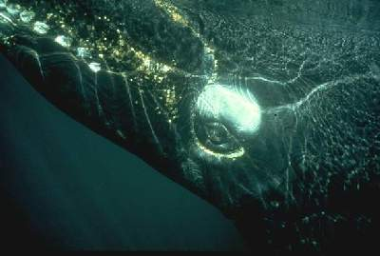
The eye of this whale is about the size of a big grapefruit.
PHOTO COURTESY IAIN KERR, OCEAN ALLIANCE

In order to have much of a life in the ocean, whales had to be able to swim for long periods of time without coming up for air. To do this, they developed highly specialized respiratory systems. A whale's lungs work the same basic way ours do, but they make the most of each breath. In one breath, your body might absorb 15 percent of the oxygen you inhale. The whale, on the other hand, absorbs as much as 90 percent of the oxygen it breathes in. When you consider the immense size of a whale's lungs, that's a lot of oxygen per breath!. As in other mammals, whales store this excess of oxygen in myoglobin, a specialized protein cell found in muscles. Whales have greater amounts of myoglobin than other animals, which allows them to store larger amounts of oxygen at a time.
Whales also make more efficient use of this oxygen. When they dive, their heart beats more slowly and select arteries are constricted. This slows the flow of blood to certain organs without decreasing blood pressure. Essentially, a whale's specialized physiology gives it better "gas mileage" -- they make each breath last. The sperm whale's respiratory system is among the most efficient in the world -- the huge animal can hold its breath for 80 to 90 minutes at a stretch. The beaked whale takes the prize, however. It can swim without a breath for as long as two hours.
Apart from the lack of breathable air, the most inhospitable element of the oceans is the extreme cold. Little sunlight penetrates the water's surface, and the temperature can drop below freezing even at relatively shallow depths. To deal with this biting cold, whales have developed a thick layer of blubber all around their bodies.
Blubber, a layer of stored-up fat beneath the skin and above the muscles, acts as a blanket to hold in the whale's body heat. In colder seasons, this insulating layer is the only thing keeping whales from freezing to death. Whales also use their blubber to store up energy for future use. Some species will feed heavily for half the year, when food is plentiful, and fast the rest of the year, living off their built-up blubber layer.
Next, we'll look at how whales sleep and handle the pressure of the ocean.
NEW SPECIES
In 2003, Japanese scientists reported that they had discovered a new whale species, based on DNA analysis of nine whale carcasses. Eight of the carcasses date back to 1970. At the time, researchers believed they were small fin whales. In examining a new carcass collected in 1998, scientists suspected they had an unidentified species.

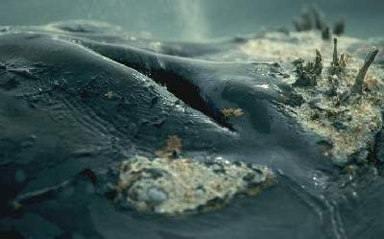
This southern right whale is actually snoring. Click here to listen in!
PHOTO COURTESY IAIN KERR, OCEAN ALLIANCE

One of the less obvious difficulties of ocean life is getting a good night's sleep. Since whales must make a conscious decision to breathe, it isn't feasible for them ever to be completely unconscious. They might not wake up in time to take a breath! Marine biologists have determined that whales get around this problem by letting only one-half of the brain sleep at a time. In this way, the whale is never completely unconscious, but it still gets all the rest it needs.

We can't know for sure what this rest state feels like, but most likely, it is something like the semi-conscious state we experience as we begin to fall asleep. We're pretty close to unconsciousness, but have enough awareness of our surroundings to wake up completely if we need to. It's not uncommon to see a whale logging, swimming slowly along the surface with very little movement. Presumably, whales behave this way when they are at rest.

Another problem with ocean life is water pressure. Because of the pull of gravity, water exerts greater pressure at lower depths than it does at higher depths; essentially, you feel the extreme weight of all the water above you. Humans and other land mammals can only swim down to a relatively shallow depth before the increased pressure crushes their bodies. This is because the air that mammals carry in their lungs exerts only a certain amount of outward pressure (pressure from the inside of your body). As the difference between the outward pressure in the lungs and the inward pressure of the water increases, there is a greater force pushing in on the sides of the body. At a certain point, this force exceeds the structural integrity of the rib cage, and the rib cage collapses. Obviously, this would kill a human being.
Whales can withstand this pressure because their bodies are more flexible. Their ribs are bound by loose, bendable cartilage, which allows the rib cage to collapse to some degree under high pressure that would easily snap our bones. A whale's lungs can also collapse safely under pressure, which keeps them from rupturing. When the lungs collapse, the air inside them is compressed, maintaining a balance between inward and outward pressure. These adaptations are particularly important to sperm whales, which dive to depths of 7,000 feet (2,133.6 m) or more, hunting for the giant squid that live at these great depths.

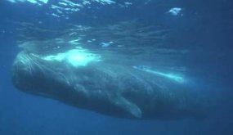
The lungs of a sperm whale (pictured here) can collapse as the whale dives to deeper depths for food.
PHOTO COURTESY OCEAN ALLIANCE, PHOTOGRAPHER CHRIS JOHNSON

In addition to adapting to the difficult conditions of ocean life, whales have also adapted to take full advantage of its rich resources. In the next sections, we'll look at some of the remarkable features that help whales catch their prey.

Feeding Time
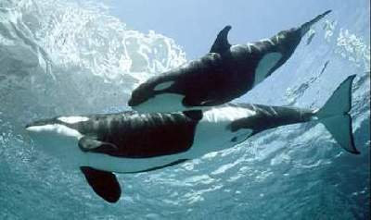
Orca whales are among the most successful ocean predators, hunting in groups and feeding on everything from small fish to other whales. They are also one of the most intelligent and playful whale species, and seem to be quite fond of humans.
PHOTO COURTESY SEA WORLD ORLANDO

All 75 species of whale are carnivores, but their hunting methods vary considerably. Toothed whales, such as the sperm whale and the killer whale (or orca), hunt in the same basic way as sharks. They have a row of strong teeth, and they tear into their prey or swallow it whole. Many toothed whales eat only small fish and other easy-to-catch prey. Orcas, on the other hand, may attack sea lions, seals and even other whales. Like wolves, polar bears and other land predators, they track and stalk their prey, picking out a weaker target (such as a baby humpback whale). Orcas and other species usually hunt in packs, sometimes surrounding their prey. Despite these tendencies, orcas and most other toothed-whale species pose little threat to humans. In fact, many species seem to enjoy human company.

Some of these hunters have developed echolocation abilities to help them find their prey and locate any obstacles. Echolocation is a very simple concept: The whale emits a series of clicks (or other sounds) from its mouth or from organs in its head, and the sound waves travel out in the surrounding water. When the sound waves reach an obstacle or another animal, they bounce off of it and travel back to the whale. Water conducts sound very well, and whales have excellent hearing, so they may pick up even the faintest echoes from an object miles away.
In a volume of water with consistent pressure, sound will always travel at the same speed. By processing how long it takes the echo to return, the whale can calculate how far the sound wave traveled, and therefore determine how far away the object is. Like most animals, whales have two ears, one on each side of their head. This lets them determine the direction a sound is coming from. If the sound reaches the right ear first and is slightly louder in the right ear, the sound source is to the right; if it reaches the left ear first, it is to the left. In the dark world of the ocean, whales must sense their environment primarily through sound. In whales, a greater percentage of the brain is dedicated to processing aural information than to processing visual information. (In humans, the reverse is true.)
CAN WHALES SENSE DANGER?
Thanks to their size, whales don't have to worry about sensing many dangerous predators -- other than man. Unfortunately, manmade noise is destroying whales' ability to make sense of their environment. Whales send out sounds and use the information that bounces back to "see" the ocean. They can determine where to find everything from nearby prey to navigational obstacles in murky waters, and they can communicate this information to other whales. However, sonar emitted by the U.S. Navy drowns out whale communication and may even be responsible for stranded whales.

Baleen Whale Feeding

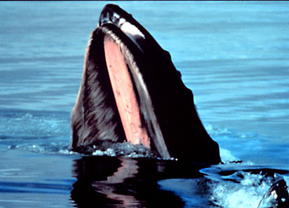
A humpback whale extending its baleen plate above the ocean surface
PHOTO COURTESY NOAA

Echolocation is mainly found in toothed whales, such as dolphins and sperm whales, not their toothless cousins. The toothless-whale group -- which includes humpback whales, blue whales and many other species -- possess a unique feeding adaptation called a baleen. The baleen is a wide plate in the whale's mouth, made up of hundreds of long, fringed blades, composed of keratin -- the same material in our fingernails. These blades form a sieve that the whale uses to filter small animals -- such as krill, plankton and small fish -- out of seawater. Because of this unique attribute, toothless whales are usually referred to as baleen whales.

There are two groups of baleen whales, distinguished by the way they use theses sieves. Skimmersopen their mouths and swim forward, catching fish, crustaceans and plankton as they go. After they've filtered a good bit of water, they knock any morsels loose and swallow them whole. Gulpers take in a mouthful of water and then push the tongue forward to force it all out through their baleen, catching any prey on the inside of the plate. Despite their large size, baleen whales typically have very small throats, measuring only a few inches across. This is all they need to devour the krill and other small creatures that make up their diet.
Since baleen whales filter water for their food, instead of ripping into their prey with sharp teeth, many people get the impression that they are passive hunters, simply cruising through the sea with their mouths open, snagging whatever happens to be in the way. But in fact, most baleen whales will seek out areas with high concentrations of food, and they may employ a number of tactics to catch their prey. Humpback whales, for example, trap fish with a sort of bubble net. When it has located a school of fish near the ocean's surface, a humpback swims in a circle underneath them, releasing air out of its blowhole. This builds up columns of bubbles all around the school, so they are contained in one small area. Then the whale charges up from below, catching the fish in its baleen. Humpback whales may also emit a loud shriek as they approach the fish, apparently in an effort to disorient their prey.
Humpback whales and other whale species can produce a wide range of sounds, which they use to communicate with each other over long distances. In the next section, we'll explore the noises whales make and find out what this might say about whale intelligence.

The Same Old Song
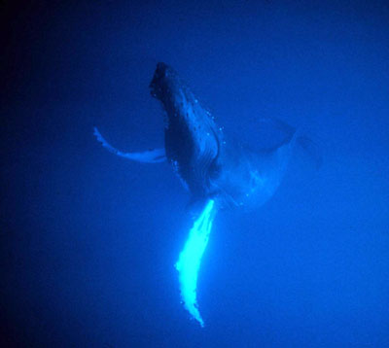
Male humpback whales are known for their long, vocal songs. A humpback's song can last as long as 30 minutes, and can be heard underwater miles away.
PHOTO COURTESY NOAA

In the past hundred years, the world's attitude toward whales has changed drastically. The animals are no longer seen as fearsome creatures, as represented in "Moby Dick," and worldwide protection efforts have significantly reduced whale hunting. Through extensive observation, scientists have demonstrated that whales are generally peaceful, playful creatures, and that they posses a high level of intelligence. Today, whales seem pleasantly familiar to us, while in the past, they were monstrous strangers.

But even now, whales are still a mystery of sorts. A lot of information gathered by whale researchers has raised new puzzles about the animals. Whale communication is particularly perplexing. Male humpbacks (also known as bulls), the most vocal whales, emit a complex sequence of low moans, high squeals and clicking noises. These noises are sometimes combined in songs that last as long as 30 minutes. The astounding thing about these songs is that whales will repeat them over and over again, verbatim. And in a particular region, every male will sing the same song, making small changes every once in a while so that it evolves into a completely different song over time.

This behavior seems to be related to reproduction. During mating season, a male humpback starts the long song sequence, cutting it short only to join a passing female whale (also known as a cow), escorting her and her calf as they swim along. Eventually, the bull and cow may dive deep into the ocean, presumably to mate. It seems logical that the male's song is analogous to the bright plumage that birds display to attract a mate, except that the sound carries over many miles, attracting any other male humpbacks in the area. It's very odd that a male would call his own competition to him, unless he actually wanted to test his strength against others. Some whale researchers believe that the songs are actually acoustic contests of strength, similar to rams butting heads, or deer clashing their antlers.
Whales don't produce sounds the way we do. Our vocal-cord system wouldn't work too well underwater. Instead, whales produce sound by moving inhaled air around the nasal cavity in front of their blowholes. In toothed whales, the sound-making system involves a complex arrangement of fatty tissues. In sperm whales and dolphins, these sound structures are so large that they form a pronounced bulbous shape on the forehead. Scientists still don't understand exactly how whale sound production works, but they know it is unlike anything else we've encountered in the animal kingdom.

Whale Language
Humpback whales and most other species produce a wide range of sounds on a daily basis. In many species, whales seem to form close bonds with one another, and their calls may serve to let their companion whales know where they are and what they are doing. Water is an excellent fluid for conducting sound, and whale calls can be extremely loud, so they may communicate with one another over hundreds, perhaps thousands of miles. Whale experts are concerned that the noise pollution caused by boats, offshore drilling and other human activities in the ocean is drowning out these calls, shutting down the whale's long-distance communication system.
We still don't know what whales are actually saying to each other, but some researchers believe that whales possess sophisticated language capabilities. Whales have large brains, with the complex folds biologists associate with higher intelligence, but the extent of their abilities is not clear. Many species do exhibit highly intelligent behavior, both in captivity and in the wild, learning complex tasks and demonstrating advanced problem-solving skills.
Whales also have excellent memories, as is evident in their migration patterns. As we'll see in the next section, individual whales seem to remember specific points along the coast and throughout the ocean, returning to the same choice feeding spots year after year.

NAME THAT TUNE
A number of whale species make their own distinctive sounds. Click on the links below to hear various whale songs and sounds, recorded by researchers at the Ocean Alliance. (RealPlayer plug-in required).
- The call of a blue whale. Blue whales are not only the largest known animals on Earth, they are also the loudest. Their calls can reach 185 decibels (that's 45 more decibels than a jet airplane) and travel for hundreds of miles underwater.
- A humpback whale, calling out as it charges toward a boat
- The call of a southern right whale
- A southern right whale "snoring," making deep guttural noise as it inhales and exhales while resting.

Long-distance Swimmers
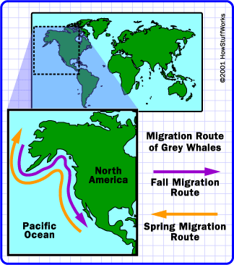
One of the most intriguing aspects of whale behavior is the creatures' migration habits. Humpback whales in the Pacific Ocean will travel up and down the U.S. coast and out to Hawaii, returning to the same food-rich areas year after year. They tend to migrate with the change of seasons, taking advantage of the warmer waters nearer the equator during the colder months and the overabundance of food in the Arctic during the warmer months. Most whale species do not migrate regularly across the equator, so there may be separate collections of each species in the Northern and Southern Hemispheres.

Scientists study whale migration in a number of ways. In many species, whales have distinctive markings on their tails, which enable researchers to identify specific whales and track the sightings to get an idea of where and when the whale is traveling. Researchers also use satellite tags, cigar-sized radio transmitters that communicate with satellites to track a whale's location. Researchers embed the barbed transmitters in a whales back using a basic crossbow. Since the blubber is thick and the barb is fairly small, the whales are not hurt by the shot.

Transmitters have shown that some whale species travel much greater distances than scientists previously estimated. Researchers have tracked humpback whales traveling thousands of miles in only a few weeks, swimming from high northern latitudes to equatorial latitudes and back again. Male sperm whales seem to be solitary wanderers, traveling from ocean to ocean with no particular pattern. A single sperm whale might easily swim around the entire Earth in its 70-year lifetime.
In most other whale species, migration is closely connected to reproduction. Generally, the female whales (cows) mate in the fall or winter, when they are in warmer waters, and give birth in the same region a year or so later. In the summer, between mating and birth, the cow will take advantage of the rich food resources of the colder northern waters. This builds up the energy the cow needs to suckle its calf.

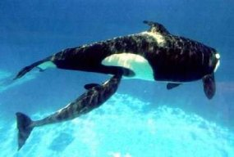
This baby orca whale is nursing from its mother. Whale calves drink an enormous amount of milk in the first months of life and may put on dozens of pounds a day.
PHOTO COURTESY SEA WORLD ORLANDO

Whale calves can swim as soon as they are born, and they rise to the surface to breathe soon after birth, but they need a lot of nurturing before they can venture out on their own. Depending on the species, whales may stick to their mother's side for a year or more before joining other young whales for extended play periods. For much of this time, the calf subsists only on its mother's milk. Cows have two teats, which are normally concealed inside slits behind the whale's abdomen, near the base of the tail. Whale milk is exceptionally rich, giving the calves the nutrients they need to grow to full size in a short period of time. A baby blue whale drinks 50 gallons (189 L) of milk every day and grows by as much as 10 pounds (4.54 kg) every hour. Of course, blue-whale calves are no shrimps to begin with. A newborn calf may measure 25 feet (7.62 m) from head to tail and typically weighs more than a full-grown African elephant.
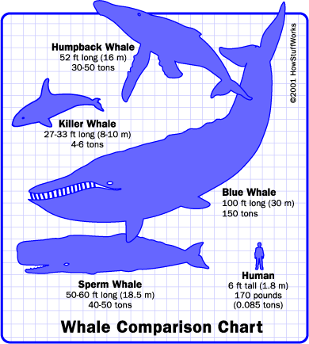
Whales vary considerably in size, but most all species dwarf a human being.
Since the gestation and rearing periods are so long in most whale species, and the suckling so draining, cows only give birth every two to four years. This slow reproductive rate means that any substantial whale hunting may have a detrimental effect on whale populations.
In the next section, we'll take a look at a fascinating acrobatic feat performed by whales -- breaching.

Breaching
This humpback whale is breaching, propelling itself out of the water and crashing back down again. Breaching is one of the most mysterious whale activities. Marine biologists aren't really sure what purpose it serves.
PHOTO COURTESY IAIN KERR, OCEAN ALLIANCE

One of the most spectacular behaviors in the animal kingdom is whale breaching. In this jaw-dropping acrobatic feat, whales weighing many tons build up enough velocity underwater to launch themselves above the ocean's surface, twist in the air and fall back, producing a tremendous splash.
Whale researchers still aren't sure why whales do this, but they have a number of guesses. It may be that the huge splashing sound is used to communicate with other whales, especially when there is a lot of other noise underwater. Another idea is that the whales are trying to knock off crustaceans and other parasites attached to their body. Some researchers think breaching may be a demonstration of prowess, and that it could play some role in courting rituals. One of the most popular ideas is that whales breach simply for the fun of it. Most likely, breaching serves many different purposes that vary depending on the species and situation.
In the next section, we'll discuss the differences between whales and dolphins. Think of it as explaining the difference between two cousins in the same family.

Whale or Dolphin?
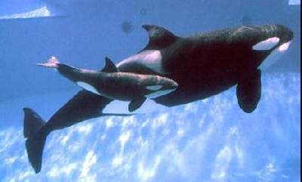
An orca mother and her calf. Orcas, commonly known as "killer whales," are members of the family Orcinus. Despite their common name, orcas pose very little threat to humans and even seem to enjoy human company.
PHOTO COURTESY SEA WORLD ORLANDO

In some cases, scientists use the term whale to describe all animals in the order Cetacea. This includes large species such as humpback and blue whales, as well as smaller species, such as the bottle-nosed dolphin. Most of the time, people use the term "whale" only to describe the larger whale species, and refer to smaller cetaceans as dolphins or porpoises.
A bottlenose dolphin mother with her calf. Dolphins, which make up the family Delphinidae within the order of whales, are thought to be among the smartest animals on Earth.
PHOTO COURTESY NOAA

Dolphins, which make up the family Delphinidae, are toothed whales characterized by their relatively small size, bulbous head and beaked snout. Orcas and pilot whales are also included in this family, though they are much larger and their beak is less pronounced. Porpoises, members of the family Phocaenidae, are small toothed whales that have a rounded head rather than a beaked snout.
In the next section, we'll explore the history of whale hunting and conservation to see how the relationship between whales and people has evolved over the years.

WHO ARE THE SEA SHEPHERDS?
The Sea Shepherd Conservation Society is a nonprofit environmental conservation group that vigilantly defends and protects marine life from the glacier-studded Southern Ocean to the tropical Galapagos Islands. Founded by Paul Watson in 1977, Sea Shepherd is best known for its anti-whaling campaigns, as documented in the Animal Planet series "Whale Wars."
Although commercial whaling was banned by the International Whaling Commission more than 20 years ago, a handful of countries, including Japan, continue to allow whale hunting under the auspices of scientific research. Since the commission's ruling, Sea Shepherd has reportedly rescued at least 1,400 whales from slaughter. Rather than protesting, Sea Shepherd engages in direct-action tactics, including spraying high-pressure water cannons at whaling ships and hurling rancid butter and slippery powder onto the decks. The tactics have attracted controversy, but the organization maintains a strict policy of nonviolence and stands by its effectiveness. In addition to anti-whaling activities, the Sea Shepherds also combats sealing activities in Canada's Labrador Front, dolphin hunting in Japan and illegal fishing in the Galapagos. You can learn more about the Sea Shepherd Conservation Society at Animal Planet.

https://animals.howstuffworks.com/mammals/whale.htm/printable

