Impact of dairy farming a key election issue
5:30 AM Monday Sep 8, 2014

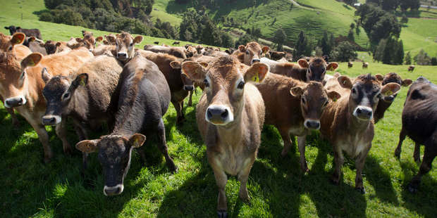
National believes dairy can continue to expand and environmental impacts can be controlled by fencing rivers and retiring farmland around waterways. Photo / Steven McNicholl
New Zealanders are evenly divided about whether farmers are moving quickly enough to reduce their impact on the environment, a Herald-DigiPoll survey shows.
A narrow majority of 47 per cent agreed with the statement that farmers were continually improving their practices and were unfairly criticised by environmentalists.
On the other hand, 39 per cent of respondents agreed that farmers were moving too slowly to improve their practices, and a further 7 per cent said they deserved all the criticism they received from environment groups.
People outside of Auckland and aged over 65 were more likely to be supportive of farmers, while Aucklanders and young and middle-aged people were more likely to be critical.
Federated Farmers dairy chairman Andrew Hoggard said the environmental impact of farming was an emotional issue and farmers often felt that opposition was overwhelming.
Begin Rubicon Project Tag Site: KPEX Display Zone: NZME (MREC=ContentRect) Size: Medium Rectangle RP: SAS Passback
Copyright the Rubicon Project 2010
End Rubicon Project Tag
"At times, I feel like it's a hell of a lot more than that who are negative and it's probably a pleasant surprise that [nearly] 50 per cent are actually happy with the job they're doing."
He said historically farmers had been slow to introduce mitigation measures, but 90 per cent of dairy farms had now fenced off their waterways and 96 per cent were complying with rules on dairy effluent.
"I think a number of those environmental groups have got a bit of a beef. What they need to realise now is that most of this industry are now invested in this space and do want to improve. A pat on the back wouldn't go amiss."
The environmental impact of dairy farming is a key issue at this election.

National believes dairy can continue to expand and environmental impacts can be controlled by fencing rivers and retiring farmland around waterways.
It has outlined plans to buy up farmland near the worst-polluted rivers and ban dairy cows from waterways.
Last year, National introduced environmental bottom lines for rivers and streams which required all councils to ensure rivers and streams were, at a minimum, clean enough for boating or wading.
Labour and Greens believe all New Zealand rivers should be clean enough to swim in, not just clean enough to "dip your toe in".
They believe environmental damage cannot be limited unless land intensification is controlled, and both parties support a tax on freshwater to encourage farmers to use natural resources more efficiently.
National does not want to consider an irrigation tax out of concern it would unfairly penalise New Zealand's biggest exporter.
Conservation group Forest and Bird said yesterday that the quality of New Zealand's lakes and rivers was voters' top conservation priority at this election. Spokesman Kevin Hackwell said: "Of all New Zealand's conservation issues, it's the freshwater situation that has seen the fastest decline of in recent decades.
"New Zealanders are concerned that the $400 million dollars in handouts for irrigation schemes is likely to lead to even higher levels of intensification - and even more damage being done to our waterways."
What best fits your view about New Zealand farmers and their attitude to the environment?
*They are continually improving their practices and are unfairly criticized by environmentalists - 47.3 per cent
*They are moving too slowly to improve practices - 39.2 per cent
*They deserve all the criticism they get from environmentalists - 7.1 per cent
*Don't Know/Refused - 6.4 per cent
* Poll of 750 voters August 28-September 3. Margin of error: 3.6 per cent
- NZ Herald

