Morphological analysis of a light-controlling organ suggests two new deep-sea fish species
AUGUST 10, 2016
Public Library of Science

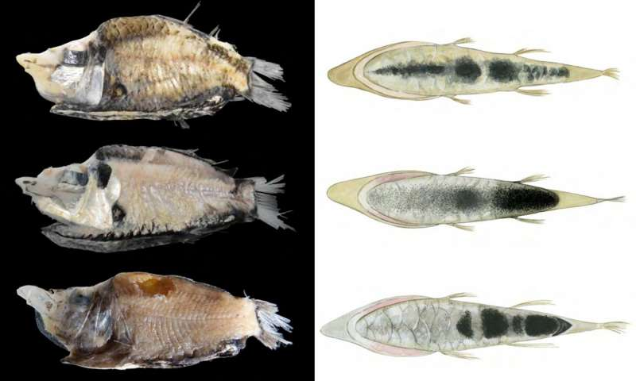Photographs and sole pigmentation patterns of type and comparative material included for both morphological and molecular comparisons in this study. Credit: Poulsen et al. (2016)

Two new species can be added to the bioluminescent deep-sea fish family Opisthoproctidae, or "barreleyes"—named for the fishes' tubular eyes—according to a study published August 10, 2016 in the open-access journal PLOS ONE by Jan Yde Poulsen from the Australian Museum, Sydney, and colleagues.
Owing to the rareness and fragility of specimens, barreleye fish are not well described, though previous work suggested the family included 19 species. Some species have organs called "soles" along their bellies, covered with pigmented scales that control the light emitted from an internal organ. Poulsen and colleagues compared sole pigment patterns and mitochondrial genomes of four specimens of a sole-bearing barreleye fish caught on recent research cruises near American Samoa and New Zealand with long-preserved specimens caught near the mid-Atlantic ridge and Australia. Examination of fresh material compared to preserved material was pivotal for this study as long-time preservation may obscure the pigment patterns that show variation between species.
The researchers found three different pigment patterns on the light-controlling organs of the fishes studied, suggesting that they were three distinct species. Differences in mitochondrial DNA supported this conclusion and the establishment of two new species in the resurrected genus Monacoa. Specimens of the two new species, M. niger and M. griseus, were found only in the Pacific while those of the long-standing species were found only in the Atlantic.
Most sole-bearing barreleye fish are caught at depths where some sunlight penetrates, and the researchers suggest that light emitted via the sole may be used for counter-illumination to camouflage the fish against the slightly sunlit water, as well as for communication. The new communication system observed in sole-bearing tube eyes shows these fishes are masters in controlling light emission on multiple levels.
"This new study on the deep-sea has shown unknown biodiversity in a group of fishes previously considered teratological variations of other species," said Jan Poulsen. "The different species of mirrorbelly-tube eyes can only be distinguished on pigmentation patterns that also constitutes a newly discovered communication system in deep-sea fishes."

Explore further
New research shines light on surprising numbers and evolutionary variety of bioluminescent ocean fish

More information: Poulsen JY, Sado T, Hahn C, Byrkjedal I, Moku M, Miya M (2016) Preservation Obscures Pelagic Deep-Sea Fish Diversity: Doubling the Number of Sole-Bearing Opisthoproctids and Resurrection of the Genus Monacoa (Opisthoproctidae, Argentiniformes). PLoS ONE11(8): e0159762. DOI: 10.1371/journal.pone.0159762
Journal information: PLoS ONE

