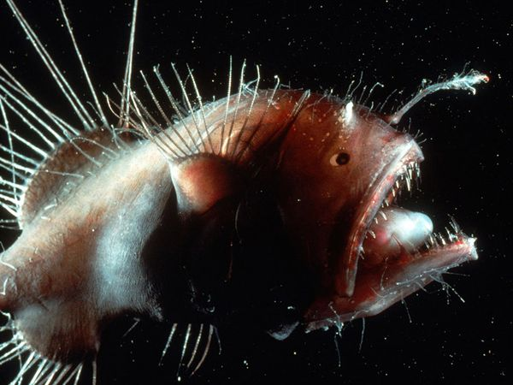
Looking like something out of a science fiction movie, the anglerfish uses a natural lure to draw its next meal nearer.
Photograph by Bruce Robison/Corbis
Map Anglerfish Range
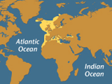
Fast Facts
Type:
Fish
Diet:
Carnivore
Size:
8 in (20 cm) up to 3.3 ft (1 m)
Weight:
Up to 110 lbs (50 kg)
Group name:
School
Did you know?
The anglerfish's lighted lure glows with the help of millions of bioluminescent bacteria.

Size relative to a tea cup:
The angry-looking deep sea anglerfish has a right to be cranky. It is quite possibly the ugliest animal on the planet, and it lives in what is easily Earth's most inhospitable habitat: the lonely, lightless bottom of the sea.
There are more than 200 species of anglerfish, most of which live in the murky depths of the Atlantic and Antarctic oceans, up to a mile below the surface, although some live in shallow, tropical environments. Generally dark gray to dark brown in color, they have huge heads and enormous crescent-shaped mouths filled with sharp, translucent teeth. Some angler fish can be quite large, reaching 3.3 feet (1 meter) in length. Most however are significantly smaller, often less than a foot.
Their most distinctive feature, worn only by females, is a piece of dorsal spine that protrudes above their mouths like a fishing pole—hence their name. Tipped with a lure of luminous flesh this built-in rod baits prey close enough to be snatched. Their mouths are so big and their bodies so pliable, they can actually swallow prey up to twice their own size.
The male, which is significantly smaller than the female, has no need for such an adaptation. In lieu of continually seeking the vast abyss for a female, it has evolved into a permanent parasitic mate. When a young, free-swimming male angler encounters a female, he latches onto her with his sharp teeth. Over time, the male physically fuses with the female, connecting to her skin and bloodstream and losing his eyes and all his internal organs except the testes. A female will carry six or more males on her body.

http://animals.nationalgeographic.com/animals/fish/anglerfish/

