Nitrate in waterways - What's the story?
Date: 05 Jul 2019
CATEGORY: NEWS | Water Quality | Environment | Hot topics | Compliance | Farming | Water
Recent news articles have discussed whether nitrate in our drinking water can cause health problems. Naturally, this is cause for concern for all of us living in Canterbury. In order to protect our water, farming practices are subject to the strictest farming rules in the country.
Over the past 10 years, the Canterbury Water Management Strategy, Canterbury Land and Water Regional Plan, and its later, sub-regional updates have started to address the problems caused by land-use intensification. Some of the impacts of these new rules are only starting to take effect, and there is a lot of work to be done by farmers, industry and Environment Canterbury in coming years.
In the meantime, nitrate concentrations will continue to cause problems in spring-fed streams and lakes for some years yet. While the drinking water from Christchurch’s deep aquifers remains clear of contaminants, anyone using a private well for drinking water needs to be aware of the risk.
Regardless of where we get our drinking water, we all need to understand the problem and what is being done about it.
Read on to learn more about the actions being taken.
What is nitrate?
At what concentrations does nitrate become a health issue?
Is Christchurch drinking water safe to drink?
Where does the city’s drinking water come from?
What about other council supplies?
Is private well water safe to drink?
What causes nitrate contamination?
Are nitrate concentrations in Canterbury water increasing?
Are nitrate levels increasing in any area that may have an impact on Christchurch drinking water, or drinking water anywhere else?
What is being done to stop the nitrate increase and improve water quality?
When can we expect the nitrate situation in Canterbury to improve?
What monitoring and reporting is being done?
Has chlorine been added to drinking water to protect it against nitrate?

More information
Canterbury's drinking water
Read about water quality in our monitored rivers and streams
To see water quality state and trend at individual sites on rivers in Canterbury visit the LAWA website.
Read about aggregated water quality trends in Canterbury.
Read about Canterbury’s water and What’s happening in my water zone?
View the video - Environment Canterbury's Chief Scientist's response to the claimed link between nitrate levels and health.

Related content
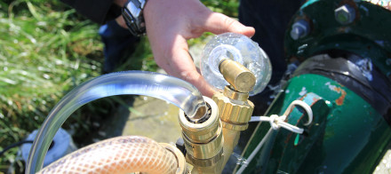

Annual groundwater quality survey shows little change
Date: 13 Jun 2019
Environment Canterbury released its annual groundwater quality survey for 2018.

Canterbury's water
Discover what is being done in the community to ensure we have clean and plentiful fresh water now and for...
News archives

https://www.ecan.govt.nz/get-involved/news-and-events/2019/nitrate-in-waterways-whats-the-story/

