Rangifer tarandus
More Than Just a Christmas Fantasy

Adaptations and Behavior
Reindeer have many unique adaptations that allow for their efficient survival in cold Arctic and subarctic boreal forest climates. First and foremost, they possess a coat that provides insulation against cold temperatures. They have hollow hairs that taper down tight against the body to trap heat and cover the short, curly underfur, and also enhance their swimming ability by keeping them afloat. Their fur is able to insulate so well that falling snow does not melt on their backs. Running reindeer, even on a cold day, can easily become overheated.² The hooves are large, and used as a support when walking on soft tundra and snow. In the winter, their foot pads shrink, become hard, and are covered with fur to function as snowshoes and better aid in walking on snow and ice.⁵

Reindeer are also able to travel distances greater than that of any other terrestrial animal! They move in packs of thousands, and can travel 5,000 kilometers a year, running at speeds up to 48 miles an hour and swimming up to 6 miles per hour. They are constantly moving to find new pastures with food, and escape from inclement weather or predators.

This makes reindeer unique in that most other deer species do not stray far from their birthplace.² Most migrations occur in the spring and fall, with those in the spring taking the reindeer to calving and summer feeding grounds. Reindeer are found in the largest groups in the summer, and this behavior is thought to have adapted to prevent being bothered by bot flies, gnats, and mosquitoes that bite and plague the individuals. In the fall they migrate back to the forests to find food and shelter from cold winter storms. During the winter, the size of groups decrease, and males of herds will fight other males to keep them from mating with females of their herd; some fights can result in death!¹⁷

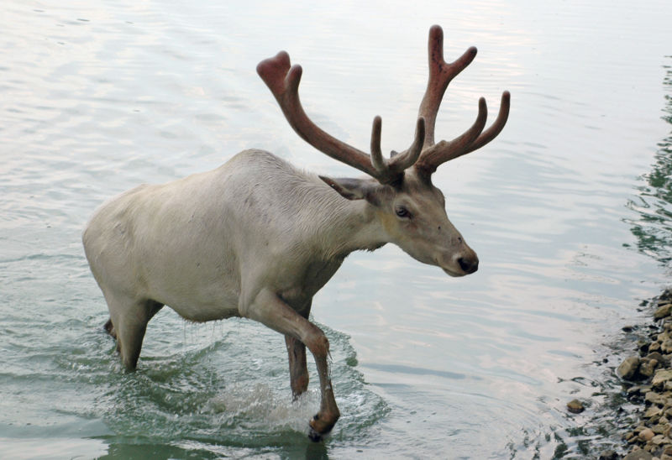
Most reindeer spend winters in forested areas where they are able to more readily find food under the snow, possessing an incredibly strong sense of smell to do so. However, their senses of sight and hearing are not well developed. Their front hooves provide them with the ability of digging craters to expose buried food. In warm weather they climb up mountain slopes to enjoy the cool snow of the high altitudes. Reindeer are able to communicate with one another vocally, visually, and chemically! The noises they make to communicate include a snort of alarm, bawl, and grunting roar by males during the rut.¹⁷

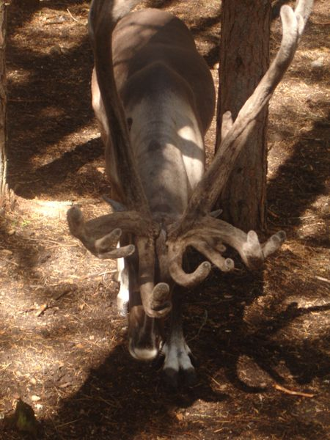
Both male and female reindeer possess antlers—the only species of deer in which this occurs! The sharp points of antlers can be used as a weapon to fight off predators, and pregnant females may use them to prevent other reindeer from eating their food. Antlers contain forward-projecting palm-like portions that can function as shovels. Male reindeer shed their antlers after the rut, aka breeding season (November and December), and females keep their antlers until May or June when they give birth to their calves. New antlers begin to grow back as soft knobs with a coating referred to as velvet. After antlers stop growing, the velvet dries and falls away. Reindeer polish their antlers by rubbing them against branches and shrubs.²

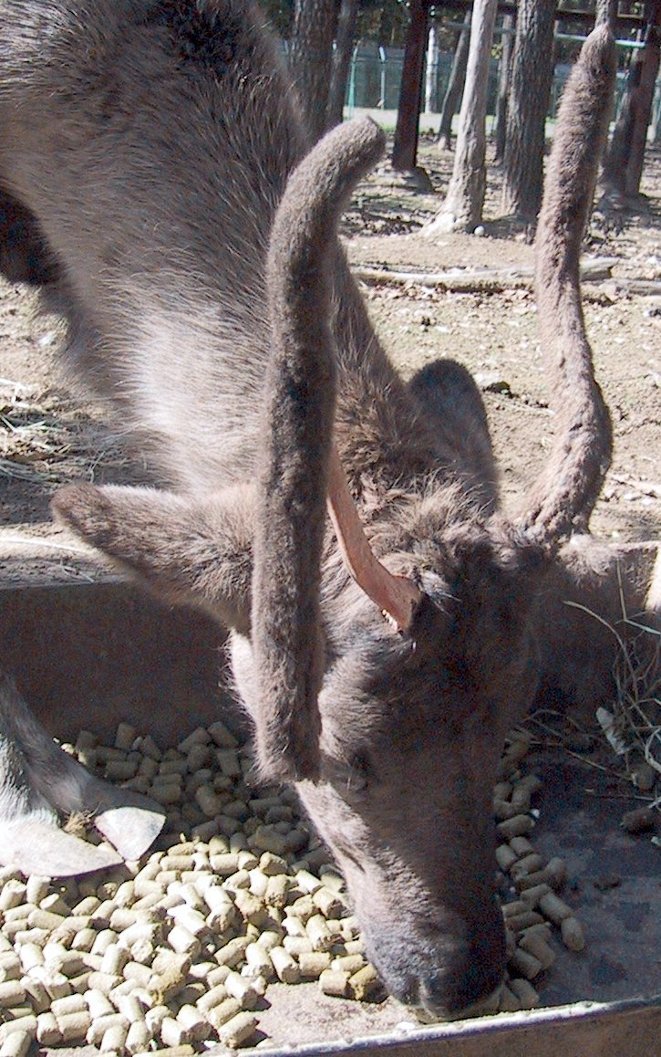
Reindeer in Alaska today are larger than those from the original stock imported into North America from Siberia in 1891. Alaska has a better range
and climate for the reindeer than in Siberia; it is not as bitter, harsh, and desolate. Thus, the Alaskan herds can average higher numbers of reindeer (tens of thousands), exhibitinganother environmental adaptation. The introduction of wild caribou into some of the herds has also subsequently increased the reindeer size in those herds.¹¹

Think this is neat? Check out what reindeer eat in their environment next!

http://bioweb.uwlax.edu/bio203/s2009/nelson_lau4/Adaptations.htm

