River stance
by Rebecca Macfie / 26 November 2015

Ecologist Mike Joy’s unsanitised views of the sorry state of our fresh waterways make him a target of vitriol. But he’s not about to change his tune.
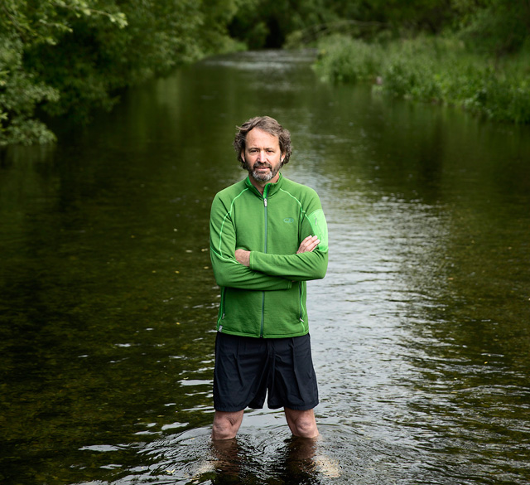

The cool water flowing around Mike Joy’s legs looks clear and clean. If it wasn’t for a stiff southerly blasting over the Canterbury Plains and across the bed of the Selwyn River, it might even look good enough for a quick dip.

But looks deceive. If the pollutants that leach through our intensively farmed soils and into lowland rivers such as the Selwyn made the water run red, we’d quickly grasp the scale of the problem, says Joy. Instead, the water at Coe’s Ford – a spot where he spent blissful days as a Christchurch schoolboy in the 1960s and 70s, and where he now stands as one of New Zealand’s loudest environmental whistleblowers – is polluted by invisible toxins.

It’s high in nitrogen, which fuels the growth of slime and algae, and there are regular spikes of E coli, meaning the swimming water quality is ranked as “poor”.

Trout used to run in their tens of thousands up this stretch of the river. Christchurch anglers could knock off after a day’s work and half an hour later be casting their lines into a fishery that rivalled the fabled Turangi. But these days Fish & Game rangers count just dozens of trout.

In the middle of the river bed there’s a tell-tale black streak. “It’s Phormidium,” says Joy. The naturally occurring algae thrives in rivers that have been altered by vegetation clearance and enriched by excess nutrients. It can quickly grow into a toxic mat across an entire river bed. Within a fortnight of the Listener photographing Joy here, Environment Canterbury had issued a fresh alert warning people to stay away from the site, reporting “significant quantities” of the potentially toxic algae, which can cause rashes, nausea, cramps, tingling and ­numbness around the mouth and fingertips.

And which can kill. There are instances in New Zealand of dogs dying after drinking contaminated river water and licking algae-covered rocks. “It seems it will only be a matter of time before a child dies after ingesting some of this,” Joy predicts.

Typical Joy – focusing on the negatives, looking past the postcard images of crystalline alpine rivers to shout about the ailing state of streams that flow through farmland, publicly undermining our clean green image. He became a household name three years ago after he was quoted in the New York Times on the eve of the release of The Hobbit saying the pristine environment portrayed in the film was at odds with this country’s poor showing against many international benchmarks. Previously, an article he’d written saying that New Zealand was “delusional” about its environmental performance was used to embarrass Prime Minister John Key in a high-profile interview with the BBC’s Stephen Sackur.

After the New York Times story, political lobbyist Mark Unsworth emailed Joy, accusing the Massey University ecologist of economic sabotage and describing him and his cohorts as “the foot and mouth disease” of the tourism industry. “Most ordinary people in NZ would happily have you lot locked up,” he wrote. Political activist Cameron Slater blogged that Joy ought to be “taken out and shot at dawn” for his treachery. The New Zealand Herald accused Joy of overstatement, and scolded that his damaging analysis had reached an international audience. When challenged by Sackur, Key shrugged off Joy’s critique as merely a “view” that could be easily countered by other scientists, and insisted that “for the most part” it’s possible to “jump into any New Zealand river” for a swim. Looking back on the backlash, Joy says he was hurt but undeterred. “For every one Unsworth, there are 20 people who ­randomly email me or ring me and thank me for what I’m doing.”

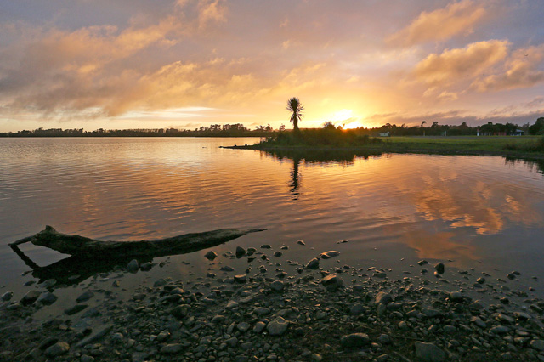
A $1.27m clean-up to reverse environmental damage in Levin’s Lake Horowhenua began in 2014. The Listener had labelled it a “lake of shame” in 2013 when it was ranked 107th out of 114 lakes for water quality. Photo/Hagen Hopkins

THE WAY HE SEES IT

He’s carried on putting his head above the parapet, increasingly abandoning the language of academic restraint to tell the story of what he sees as an environmental “crisis”. In the past two years alone he has delivered 102 public talks to environmental, farming, community and school groups. And this month, he has published the story in a long essay, “Polluted Inheritance”.

Referencing monitoring reports and studies that normally lie beyond the public gaze in scholarly journals and the archives of regional councils, Niwa and other crown research institutes (CRIs), the essay is effectively a Mike Joy “state of the environment” report – one that paints a far bleaker picture than the official version published a month ago by the Ministry for the Environment.

Of 112 monitored lakes, a 2010 Niwa study found 44% are eutrophic – so burdened by excess agricultural nutrients that they have become murky, smelly and inhospitable to many fish, reports Joy. Almost all (90%) our lowland wetlands – the “kidneys of our waterways” – have been destroyed. Three-quarters of our native freshwater fish are threatened with extinction (up from 20% in the early 1990s), yet only one – the grayling, which has been extinct for decades – has legal protection.

Digging through the data on more than 300 monitored river sites, he reports that more than two-thirds of those surrounded by farmland exceed Australasian guidelines for nitrogen levels in water, beyond which aquatic life starts to be affected. That’s up from 40% in 1990. Phosphorous – the other key agricultural pollutant, carried into rivers by soil erosion – exceeds guidelines in most intensively farmed areas (although levels have been slowly falling since the late 1990s).

And then there are the tiny creatures whose presence signals the well-being of rivers – invertebrates such as mayflies and stoneflies, which are measured by the Macro­invertebrate Community Index (MCI). Niwa has mapped MCI scores around the country, painting in red where low insect life denotes serious pollution: the map burns bright red throughout the intensively farmed regions of Canterbury, Southland, Auckland, ­Waikato and Taranaki.

We’ve squandered our environmental riches, argues Joy, and ended up with a pattern of degradation that places an inequitable burden on the poorest communities. Yes, the pristine rivers and lakes still exist, but they are largely in national parks where people with time and money to drive or fly long distances can enjoy them, whereas the worst effects of intensive agriculture are concentrated in lowland rivers and estuaries close to where people live – places which, in the past, have been available to those with limited income for food gathering and cheap recreation.
Mike Joy inspects Phormidium on the gravel bed of the lower Selwyn River, in Canterbury. The felt-like algae can quickly take over a river bed, and can be toxic to animals and humans. Photo/Martin Hunter

DAIRY BOOM

How has it come to this? Farmers, claims Joy, have been “incentivised to pollute”. The dairy-cow population has doubled since 1992 without there being regulation controlling the volume of nutrients and pathogens that flow from their free-range excrement through the soils and into waterways. This intensification has been enabled by new inputs such as palm-kernel expeller (PKE) and a 420% increase in nitrogen fertiliser use since 1990, leading to stocking rates than wouldn’t otherwise be possible. The ability of catchments to absorb the effects has simply been overwhelmed.

Twenty-five years after the dairy boom began, the Government has belatedly written environmental “bottom line” standards for freshwater into the rule book. But in Joy’s view (one shared by many others in the freshwater field), the proposed limits are so weak they would allow for further pollution, and crucial measures of aquatic health, such as the MCI index, have been left out altogether.

The underlying problem, he says, is that those who pollute don’t pay to clean up the damage. Instead, the cost falls on the public in the form of a degraded environment and lost opportunities. In his most controversial offering yet, earlier this year he co-authored a paper (with masters’ student Kyleisha Foote and Massey University colleague Russell Death) that extrapolated from a raft of published research on the cost of environmental clean-ups to conclude that if the pollution caused by the dairy industry was properly accounted for it would exceed the industry’s total economic value.

The farming sector was scandalised, and academics including Waikato University’s Jacqueline Rowarth and Frank Scrimgeour criticised Joy and his colleagues for naivety and sloppiness.

But if it confirmed Joy’s reputation as a stirrer and a troublemaker for the dairy industry, it seems not to have affected his standing with New Zealand’s biggest farmer, Landcorp. Suddenly, Joy – just three years ago condemned as a traitor and saboteur – has found himself inside the room with the leaders of the most influential agri-business in the country. How did that happen?

Landcorp chief executive Steven Carden says the strategy of the state-owned enterprise is to achieve both an economic return and environmental sustainability. Joy is one of six paid members of an environmental reference group to advise it on how to achieve that. “We thought we could take the safe path of finding experts who would tell us what we wanted to hear, or we could challenge ourselves and bring in people who are outspoken on the environmental impacts of dairying.”

Other group members include veteran environmentalist Guy Salmon, innovative farm consultant Alison Dewes and maverick water campaigner and businessman Angus Robson. Carden says debate in the first couple of meetings was “ferocious”, but the search now is for farming solutions that will work. “We will listen to them … It’s not a green stamp.”
ON THE INSIDE

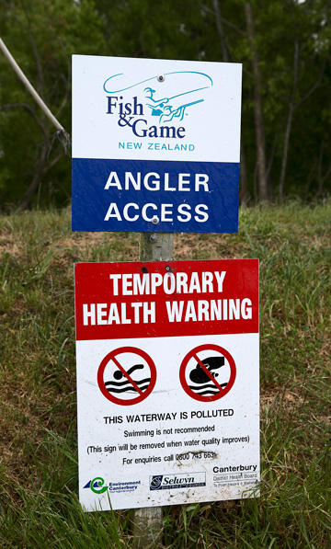
Dogs are known to have died after contact with the algae on the Hutt River and the Ashley in North Canterbury. Photo/Martin Hunte

Inside the room being listened to by influential people is a surprising place to be for a late-starting scientist who still sees himself as an outsider. Joy’s academic career didn’t begin until he was 33. He ditched school at 17, by which time his policeman father’s job had taken the family from Christchurch to Wellington. He was academically average and a bit of a bogan. “I was a hoon at school, always off chasing girls at lunchtime.”

His first job was in a bottle recycling factory in Petone. “It was rough as guts. I went from school to a full-time job there employing people coming out of jail, overstayers … I became the foreman at 17, running these guys driving trucks and forklifts.”

He moved to Palmerston North in pursuit of a girlfriend and got a job on a 65-cow dairy farm, which he ended up managing. “I loved it – loved the cows and the job.”

He moved on through a succession of jobs – labouring, truck driving, building. He did a stint driving taxis all night and spending his days doing up a 100-year-old yacht. He bought an empty section up 74 council steps in the Wellington suburb of Wadestown and built a kitset house on it, which is still there. He and his partner, Allie Hewitt, sailed across the Pacific to Tonga, and later found work on a remote outback farm in Australia. The place was owned by two estranged brothers who lived at opposite corners of the 40,000ha property, and it hadn’t seen rain for four years.

“We killed 6000 ewes,” recalls Joy. “The farmers had $2 a head in their wool fund to get rid of them. The market was shot.” At night, he and Hewitt would go spotlighting for kangaroos, legally, to sell for dog tucker, which brought in enough cash for the farm to pay their wages.

When they returned to New Zealand in 1993, jobs were scarce, and both decided to enrol at Massey. By the third year Joy was enrolled in Death’s freshwater ecology lectures, and he became immersed in the field of biomonitoring – using animals as a measure of ecological health. That interest became the basis for a PhD using artificial intelligence to develop predictive models of fish populations, drawing on a raft of environmental variables including climate and geology. The models describe, with a high level of accuracy, the freshwater fish communities that ought to be present in any given spot, which can then be used as the benchmark from which to identify the reasons the actual population may be depleted. The work was published internationally and, according to Death, was globally “ground breaking”.

Up to this point, Joy had no particular concerns about farming or the effect of land use on water. “I was a fan of farming. I’d been a farmer.”

But that started to change. “It was so frustrating, day after day, going to streams, setting up kit and finding the same old suspects – the three species that can handle any conditions instead of the 20 species that ought to have been there. At hundreds of sites, all you ever found were upland bullies and short-finned eels and a few trout.”

He started getting angry at the degradation he was seeing. Then he got angry about the failure of regulators to act on it.
HEADLINE-GRABBER

Fifteen years on, that anger has driven Joy onto the podium and into the media with a frequency and stridency that have attracted both respect and resentment from his peers. University of Otago ecologist Marc Schallenberg, president of the Freshwater Sciences Society, says for the most part Joy is simply reporting on publicly available data, and “the message he’s putting out there is right”.

Schallenberg says in his own field work on lakes and estuaries he sees the same decline in water quality that Joy describes, and the cause “couldn’t really be anything else [other than agriculture], unless there is a climate-change signal that none of us has picked up yet … But when you see what’s going on the land and the sheer amount of waste that’s put onto the land – it’s not rocket science.”

But he says most scientists have no appetite for the advocacy role Joy has assumed. “Scientists often are dispassionate people because part of our training is really just to look at the data and not get passionately involved in any particular outcome or finding … [Joy] has taken a lot of flak and that’s one of the reasons some of us would be reticent. But I appreciate what he does, and more than anyone he has brought these issues into the public perception.”

Given what’s at stake for New Zealand’s agricultural economy, Schallenberg says there’s a tendency among vested interests to “spin” the environmental data. “So you need people to come out and call a spade a spade and engage with the misinformation that’s out there. I’m quite grateful that Mike is that person for us.”

Waikato University ecologist Kevin Collier vouches for Joy’s scientific credentials and says the message he communicates resonates with him. “But people make contributions in different ways. Some are more comfortable doing the science through more conventional means and some are more comfortable being a bit more out­spoken. Certainly Mike has taken a lot of hits where other people would have given up because it was too hard.”

Others are affronted by Joy’s methods. He has come out swinging against scientists from Niwa (the agency whose monitoring data he widely cites), accusing them, in the midst of the stoush over the proposed Ruataniwha irrigation scheme in Hawke’s Bay, of providing advice on nutrient limits in the Tukituki River that was biased in favour of the client. “If you were working for Niwa and all your work came from these councils or the Ministry for the Environment … You’ve got to feed the kids and pay the mortgage. Are you going to say it’s a bad idea?”

Joy had breached a cardinal rule of scientific decorum – don’t slag off your peers in public. The Hawke’s Bay Regional Council strongly rejected his comments, and Niwa rejects the allegations as well. Ill-feeling between Joy and the CRI remains. When the Listener approached John Quinn, Niwa’s chief scientist (fresh­water and estuaries) for comment on Joy, he politely refused. “The behaviour we would like to see is where we talk about each other’s work in the context of [conferences and personal communications], not in the media … Having public spats is not helpful for the credibility of science.”

Waikato University’s Professor David Hamilton, immediate past president of the Freshwater Sciences Society, damns Joy with faint praise, calling his academic work “steady”. “He’s productive but he is not at the top of his field. If he was, he’d be a full professor.” Joy, he says, has raised the profile of water issues, but upset peers by casting aspersions on their independence and strayed beyond his core discipline by commenting on issues such as environmental economics and soil contamination.

COST OF SPEAKING OUT

Death says his former student and long-time Massey University colleague has taken up the mantle of environmental advocate at considerable expense to his academic career. Joy is a senior lecturer and was declined for promotion to asso­ciate professor recently. The university promotion system works on rewards for publication in scholarly journals, not for talking to community meetings or writing op-eds. “Traditional science is meant to be about helping the wider public and communicating, but in reality there are so many barriers to doing that, that you have to make a conscious decision to do it.”

Meaning? “New Zealand scientists tend to want to be like most Kiwis and not antagonise people, but if you go to conferences in the US it’s the complete opposite. They get up and criticise you – not personally – but the science. And that’s what science is meant to be. But New Zealand scientists tend not to want to do that. They tend to want to stay among the crowd and not speak out and upset anybody …

“The other unfortunate thing is funding. Most of the funding in New Zealand, in contrast to other countries, is very much tied to the Government directly or indirectly, and for whatever reason the Government is quite tightly linked with many of the industry lobby groups, particularly dairy, and dairy is certainly not very keen on us outlining that water quality in New Zealand is degrading as a result of what it is doing.”

Joy’s boss, Massey University vice-chancellor Steve Maharey, has backed the scientist through the various controversies, provided he can support his claims. (Maharey says he can.) But for Joy, there is more at stake than tenure and job security. There’s a fight to be had with the Government over what he sees as bogus bottom-line standards for fresh­water; there’s a battle to be won in boardrooms such as Landcorp’s to bring the true cost of environmental degradation to account; there’s a public to be enlightened.

“I’ve decided that this problem is more important to me than my career. This job is the longest job I’ve had in my life. I’m sure I’ll get by if I lose this job. I can go sailing or truck driving. It means far more to me to put guys like [Environment Minister] Nick Smith in the spotlight than it does to keep paying the mortgage. Maybe if I’d been a career academic I wouldn’t be like that … I’m looking for my next opportunity to tell New Zealand about this.”

The academic has become an activist, he says, “not because I chose to be, but because I have to be”.

Mike Joy was awarded the Reo mo te Awa award at the Morgan Foundation NZ River Awards on November 26, which Rebecca Macfie helped judge.

http://www.noted.co.nz/archive/listener-nz-2015/river-stance/

