Secrets of animals that dive deep into the ocean
Cuvier's beaked whales dive deeper than any other animal, going down almost 3km. How do they survive in the crushing pressure?

- By Jane Palmer
15 January 2015
When it comes to diving deep, Cuvier's beaked whales lead the pack. In a study published in March 2014, scientists tracked these typically elusive whales and reported one whale dived to the dizzying depths of 2,992 m (9,816ft). The same whale stayed underwater, without taking a single breath, for 138 minutes.
The feat was exceptional, breaking new mammalian dive records in two categories simultaneously. But while the Cuvier's beaked whales have proved themselves as the champion divers, other marine mammals have also evolved, and honed, the ability to dive deep and long. Sperm whales routinely dive between 500m and 1000m, Weddell seals go to 600m, and elephant seals can hold their breath for two hours.
"It's just astonishing what these animals can do," says Andreas Fahlman of Texas A&M University in Corpus Christi. "These animals do these deep dives day in, day out, sometimes repeating the dives a number of times a day, and don't seem to have any problems with it. So the constant question we ask ourselves is: how do they do that?"

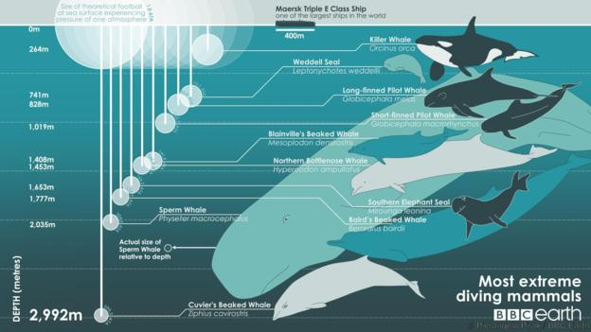
Discover the deepest-diving animals (Credit: Pierangelo Pirak / BBC Earth)
Animals dive deep for one reason, and one reason alone: to get food, says Randall Davis, who is also at Texas A&M University. "These whales are making these dives to tremendous depths because there's some payback in terms of a food resource," Davis says. "Animals don't do these kinds of things for fun. This is how they make a living."
But it's a challenging way to make a living. The most immediate problem is the extreme, crushing pressure. At 1000m down, a Cuvier's beaked whale experiences 100 times the pressure that they do at the surface, enough to completely compress the air in their lungs.
To avoid this, Randall says, they have rib cages that can fold down, collapsing their lungs and reducing air pockets. Then, right before diving, these mammals exhale 90% of the air in their lungs. This also reduces their buoyancy, making it easier to dive.
But that introduces a new problem. With little oxygen in their lungs, the whales have to be thrifty when it comes to using the gas on their dives. "They are very frugal," Fahlman says. "They're just really, really tightly holding onto this oxygen and trying to use it as conservatively as possible."

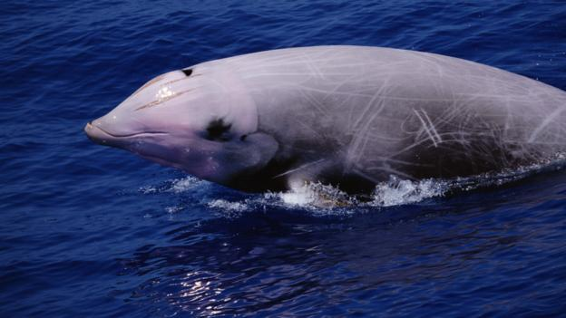
A Cuvier's beaked whale (Ziphius cavirostris) (Credit: Todd Pusser / NPL)
To stop using so much oxygen, diving mammals can stop their breathing and shunt blood flow from their extremities to the brain, heart, and muscles. They also shut down digestion, kidney and liver function.
Finally, they lower their heart rate. Most mammals can do this when they dive, even humans. But in marine mammals the slowdown can be extreme. Scientists have measured the heart rate of diving Weddell seals at a mere four beats per minute.
The animals also adapt their behaviour to conserve oxygen by reducing how much they move. In 2000, Terrie Williams of the University of California, Santa Cruz and colleagues attached miniature cameras to Weddell seals, a bottlenose dolphin, an elephant seal and a blue whale. They found that the animals simply glided downwards without moving a muscle. Their shrunken lungs reduced their buoyancy, allowing them to sink rather than swim.

But it's not enough to just be stingy with oxygen. Once they're in deep water, divers like Cuvier's beaked whales have to sneak up on, and overcome, their prey. For that, they need to find some oxygen.
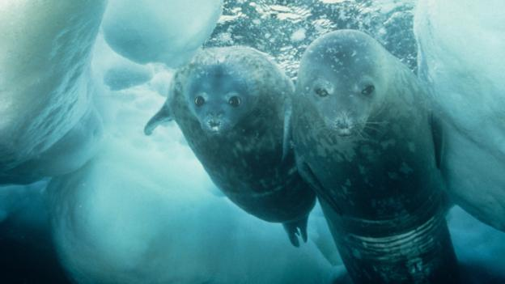
Weddell seals (Leptonychotes weddellii) (Credit: Nature Picture Library / Alamy)

Fortunately, they have a supply: they store oxygen in their blood and muscles. Marine mammals have a higher percentage of oxygen-storing red blood cells than most mammals, making their blood thick and viscous. They also have a high blood-to-body-volume ratio. "They simply have a bigger savings account than we do," Fahlman says.
But this shouldn't be enough. "From what people have estimated for the oxygen stored, and the rate at which they are consuming this oxygen, it shouldn't be possible for animals to dive to these depths at all," says Michael Berenbrink of the University of Liverpool in the UK.
Then in 2013, Berenbrink made a startling discovery about diving animals' muscles. Like all mammals, their muscles contain a protein called myoglobin that stores oxygen and gives meat its red colour. Myoglobin is ten times more concentrated in the muscles of diving animals than it is in human muscles. It is so concentrated in whales that their flesh appears almost black.
But there should be a limit to the amount of myoglobin that muscles can contain. If too many of the molecules pack into a small space, they could stick together. Such clumping can cause serious diseases in humans, such as diabetes and Alzheimer's. Yet Berenbrink found that diving animals' muscles seemingly carry too much myoglobin.
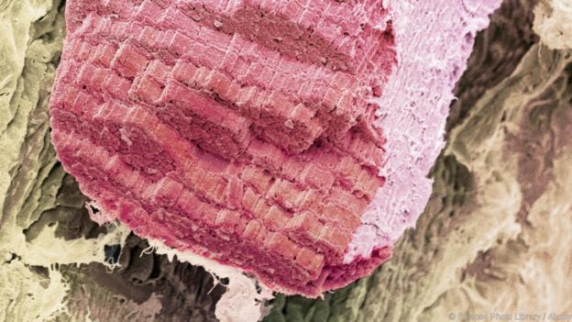
Muscle stores oxygen using myoglobin (Credit: Science Photo Library / Alamy)

What's their secret? Berenbrink found that the myoglobin of diving animals is positively charged. Since like charges repel each other, the positively-charged myoglobin molecules don't stick together. This means that huge amounts of myoglobin can be packed in, supplying plenty of oxygen.

Berenbrink found that all the diving mammals he studied had positively-charged myoglobin, although some had larger positive charges than others. The highest concentrations of myoglobin occur in the muscles needed for swimming, exactly where the divers need it the most. What's more, genetic analyses suggested that beaked whales should have the highest levels of myoglobin, as we would expect.
But while Berenbrink's work has found a veritable built-in oxygen tank in divers, he says we still don't know whether this tank provides enough for the long dives made by beaked whales. "There is still a lot that we don't know," Berenbrink says.

Even if the diving mammals do have enough oxygen, they're still not out of the woods. They must also deal with a disorder called decompression sickness, or "the bends". In humans, the bends can be fatal. And it turns out marine mammals are also at risk.

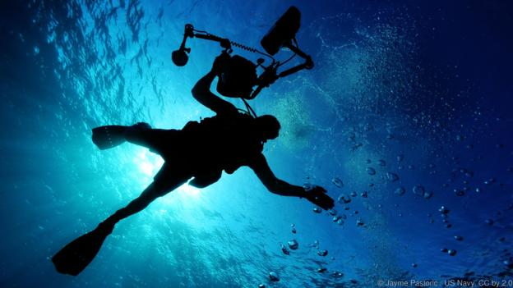
Divers must take care to avoid the bends (Credit: Jayme Pastoric / US Navy, CC by 2.0)

When a human scuba diver is at depth, gases dissolve in their blood. If the diver then comes up too quickly, the pressure drop causes gas bubbles to emerge from the bloodstream and get lodged in capillaries and critical organs. This causes discomfort and pain, and sometimes death.

Late in 2002, 14 beaked whales washed ashore together on a beach in the Canary Islands. When scientists performed an autopsy on 10 of the whales, they found deadly tissue damage that is usually associated with pockets of gas in vital organs. That suggested the whales had the bends.
Scientists had thought diving mammals were immune from the condition, even though they had found such bubbles before in stranded animals. Between 1992 and 2003, researchers found bubble-associated tissue injury in dolphins, porpoises and a single Blainville's beaked whale washed up on British shores.
The question was finally settled in 2013, when Daniel García-Párraga of Oceanografic in Valencia, Spain and his colleagues diagnosed the bends for the first time in live marine animals: loggerhead sea turtles.
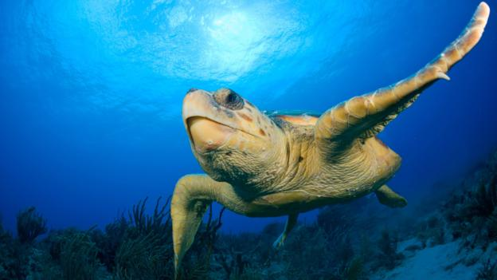

A loggerhead sea turtle (Caretta caretta) (Credit: Michael Patrick O'Neill / Alamy)
The turtles had been accidentally caught in commercial fishing nets and bought in by local fishermen. Of the 21 that arrived alive, 9 showed signs of spasticity. CT scans revealed bubbles in the turtles' organs.

It's easy to diagnose decompression sickness: simply put the animal under higher pressure and see if the symptoms clear. To that end, García placed the two smallest turtles in the lab autoclave and recompressed them using similar protocols to those used for human divers. The turtles made a full recovery and García eventually released them back into the wild.
"That is the first time anybody anywhere in the world has achieved a clinical diagnosis of decompression sickness in a live marine vertebrate," says Michael Moore of the Woods Hole Oceanographic Institution in Massachusetts.

The finding is important for efforts to conserve sea turtles. We now know that turtles caught up in fishing nets may suffer from the bends, and need treatment before being let go. If fishermen simply untangle them from the nets and release them immediately, the turtles may die of decompression sickness.

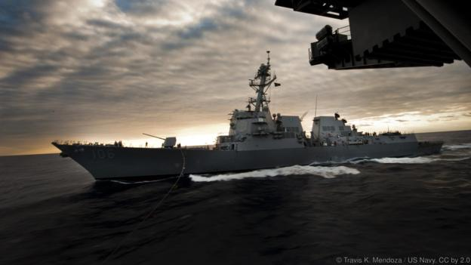
Could navy sonar harm marine life? (Credit: Travis K. Mendoza / US Navy, CC by 2.0)
Outside of fishing, though, it is hard to see why marine mammals would ever get the bends. A 2011 study by Fahlman and his colleagues indicated that they are always susceptible to the condition, yet in normal conditions are able to avoid getting it. Decompression sickness happens if they ascend too quickly, so surely they should have evolved not to do that. But maybe something is forcing them to rush to the surface?

In the 2002 beaching, a series of military exercises involving sonar took place in the region just four hours earlier. Since that incident, researchers have noted the links between sonar activity and strandings of marine mammals on beaches in the Mediterranean Sea, the Canary Islands, and the Bahamas.
In theory, if whales are 1000m or 2000m down, the noise of sonar could send them rocketing up to the surface. If they came up too quickly, their anti-decompression mechanisms might not keep up. But we can't confirm this, Fahlman says. "No one even understands how they avoid the bends, let alone how they then go on to get the bends in certain situations," Fahlman says.
Whales do seem to dislike sonar. When scientists exposed Cuvier's beaked whales to simulations of sonar for a 2013 study, the whales stopped fluking and echolocating, and swam away rapidly and silently. They then stayed underwater longer than normal.
"But really what does that show?" asks Fahlman. "It doesn't tell us anything about how the whales might behave underwater, at great depths."

A blue whale (Balaenoptera musculus) (Credit: RGB Ventures / SuperStock / Alamy)

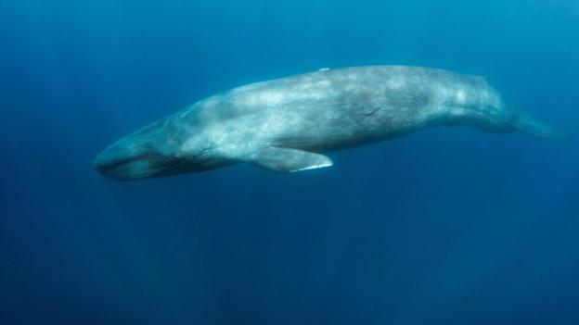
The qunderstand why the whales get the bends is to figure out their normal behaviour and physiology, in particular how they cope when deep diving. But that is no mean task, not least because whales are far too big to ever study in a laboratory.

These studies could have unexpected benefits, adds Fahlman. By unravelling the physiology of extreme diving, researchers may figure out how to treat certain clinical conditions in humans. One example is atelectasis, in which a person's lungs collapse, obstructing breathing. Marine mammals' extreme dives may point the way to a cure.

"They're diving to depths that are absolutely phenomenal," Fahlman says. "With our current knowledge of physiology, they're going way over and beyond what they're supposed to be able to do."
http://www.bbc.com/earth/story/20150115-extreme-divers-defy-explanation

TASK: Answer questions below.

