How do Sperm Whales communicate?
Alex Cuff and Lisa Bond

The ability to produce and perceive sound is important for whales – to navigate, find food, and also communicate.
Toothed whales such as the sperm whale use echolocation to hunt their prey. They send out high frequency clicks then listen for their echo as they bounce back from objects – like their next meal!
Echolocation means these whales are not dependent on light. They can hunt even in the darkness of the deep depths they are diving to – as with sperm whales seeking out giant squid.

At least a quarter of a sperm whale’s length is dedicated to its nose – a third in mature bull sperm whales. This giant nose is actually an elaborate sound-generating device.

A sperm whale’s blowhole is on the front left side of its head. This is the animal’s left nasal passage. The right nasal passage has no exterior opening. Instead, it supplies air to the ‘monkey lips’ for sound production.
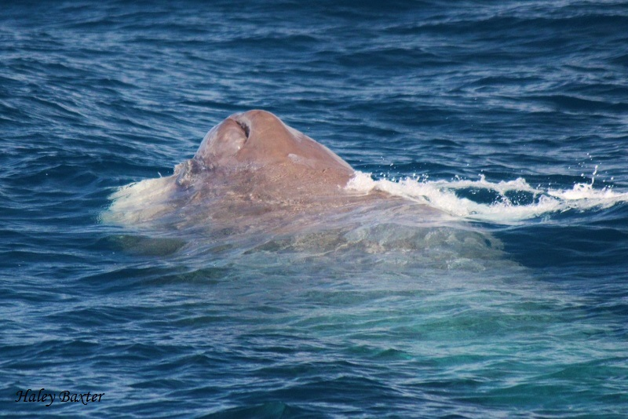
Sperm Whale Blow Hole
The monkey lips vibrate and the sounds they make bounce off an air sac. They then pass through the waxy, liquid contents of the spermaceti organ and are reflected off an air sac behind it.

The sounds pulse through several lenses of fat – whalers called them ‘the junk’ – which focus the sounds into a narrow beam. This beam of sound emerges from the front of the head, and sperm whales can direct it – like a searchlight used to sharply illuminate a target.
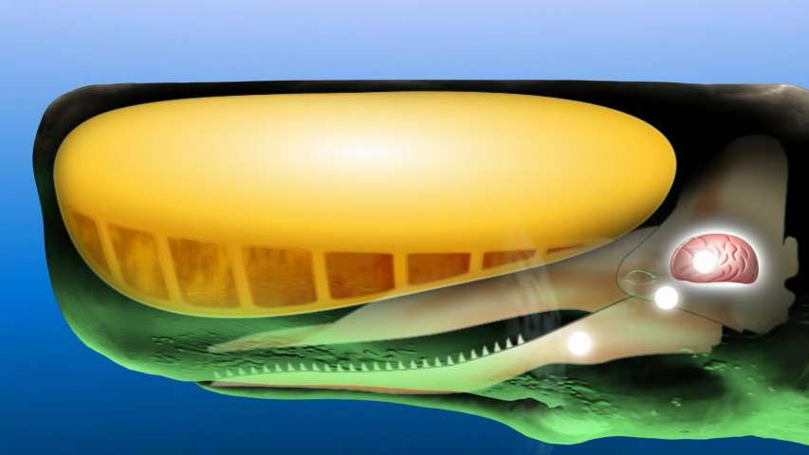
Spermaceti Organ
The sperm whale receives the sound much like the dolphin – through a large pad of fat in the rear of the jaw. This, in turn, is relayed along a fine channel of fat to the ear bones.
All rather fascinating stuff when you think about it – having the ability to make a sound picture of what is around them.

The sperm whales echolocation is what we listen out for when using our hydrophones, listening out for the rhythmic clicking sound (like the ticking of a clock) as they are in search mode of their prey or navigating their way around but that is another blog post in itself...

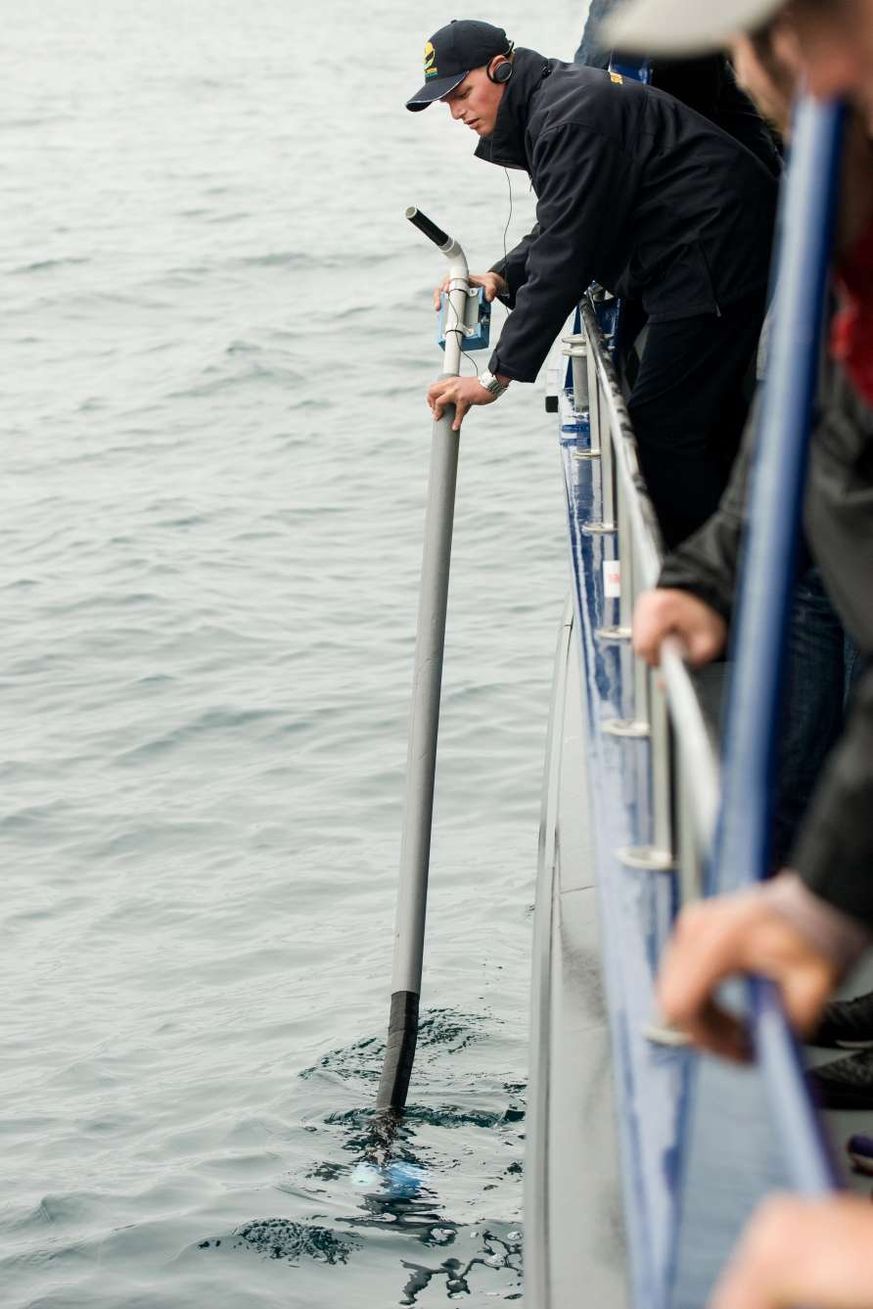
Cpt Shannon listening in on the whale
411
https://www.whalewatch.co.nz/our-nature/latest-news/how-do-sperm-whales-communicate/

