The Deep Sea Angler Fish:

Diet: Carnivorous (Mostly feed on Crustaceans)
Size: 8 in - 3.3 ft
Weight: up to 100+ lbs.
Scientific Name: Melanocetus johnsoni
Ocean Range: Typically found between 2,300 and 3,300 feet
Habitat: The variety of species of the Angler fish makes it a creature that is found in the majority of deep sea ocean areas worldwide.

The Angler has earned the nickname "The Common Black Devil"
because of it's strange and to some, scary appearance.

Features of the Deep Sea Angler:
The Deep Sea Angler has a small glowing "lure" located above its mouth which it uses to attract prey. This glowing component of this "lure" is actually a small vessel in which millions of tiny, light-producing bacteria are housed.

The Angler can be a variety of different colors including black, brown, gray and all the shades in between. There are over 200 species of Angler Fish known to man. The Angler's skeleton is mostly composed of cartilage and it is not an incredibly structurally strong fish. Despite their thin bones, the female fish have very large stretchy stomachs and are capable of eating prey that are larger than themselves.

This fish has tiny eyes and its skin is the consistency of jelly and it reflects blue light. This is also an environmental adaptation for protection because the majority of fish in the deep sea that emit bio-luminescent light produce a blue color, and because the skin of the Angler is capable of reflecting this light, the fish is practically invisible to some predators.

Did you know?
The Deep Sea Angler fish is considered a delicacy in many parts of the world and its taste has been compared to that of Lobster.

Mating:
The Deep Sea Angler has a particularly unique way of mating. This is thought to be largely due to the environment in which they live. The deep dark ocean is vast and pitch black, making it difficult for these creatures to find each other and mate. Therefore, the females of this species release a chemical into the water that the males can sense and pick up their trail. The males can be as small as 1/40th the size of the female Deep Sea Angler, and when they find a female to mate with they will latch onto the side of her body and will remain attached to her for the remainder of her life. All of the male's organs will dissolve except for the testes and the female will be supplied with sperm to fertilize her eggs, in exchange, the female's blood will continue to circulate throughout the male's body, keeping him alive to supply sperm. Females have been found with as many as SIX males permanently attached to their bodies.

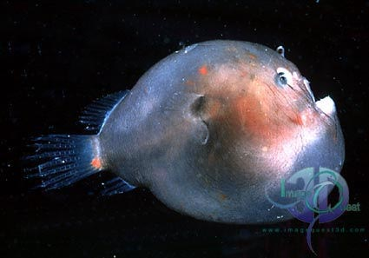
Larval Form of the Angler:

The larval form of the Deep Sea Angler fish (shown at right) has almost transparent, jelly-like skin and has not yet developed the "lure" at the front of its head or the sharp fang-like teeth that Angler fish are known for.

https://sites.google.com/site/groupbioproject/deep-sea-angler

