The fish with FOUR eyes: Deep sea creature has 360° vision to spot prey and predators

- The glasshead barreleye fish (Rhynchohyalus natalensis) lives at depths of between 800metres to 1,000metres in the Tasman Sea, near New Zealand
- It has two primary cylindrical eyes pointing upwards so it can see prey or predators silhouetted against the gloomy light above
- A second set of silvery eyes on the side of its head have a mirror-like second lens and retina so that it see to the sides and below
- Scientists from the University of Tubingen, Germany, claim the fish has a previously unknown type of eye
By SARAH GRIFFITHS
PUBLISHED: 23:38 AEST, 24 March 2014 | UPDATED: 02:33 AEST, 25 March 2014

It might look like an alien from outer space, but this bizarre creature is a four-eyed fish that lives deep beneath the ocean on our planet.
The fish's extra pair of eyes give it 360° vision, even though the animal lives deep below the ocean's surface in almost pitch-black waters.
The scientist who made the discovery believes the glasshead barreleye fish has evolved with extra eyes so it can detect prey, predators and potential mates.

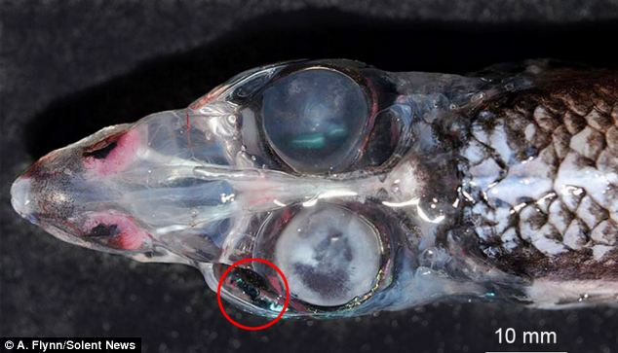
+4
The glasshead barreleye fish (rhynchohyalus natalensis) has four eyes with 360° vision. It is thought that the peculiar creature has evolved with extra eyes (one is circled) so that it can detect prey, predators and mates from every angle

THE GLASSHEAD BARRELEYE FISH
Rhynchohyalus natalensis was first discovered in 1924.
It lives at depths of between 800 and 1,000metres.
The species has been spotted in the eastern Atlantic Ocean near Cape Town, South Africa, the western Atlantic in tropical waters and the western Pacific between Australia and New Zealand.
The barreleyes are an unusual family of deep sea fish, most of which have upwardly-directed eyes.
The 'main' eyes detect the silhouettes of prey swimming above, while 'extra' side eyes give it a view of what's going on below it and by its sides.

- Also known as Rhynchohyalus natalensis, it lives at depths of between 2,600ft (800 metres) and 3,300ft (1,000 metres).
- It has two primary cylindrical eyes pointing upwards so it can see prey or predators silhouetted against the gloomy light above.
- It also has a second set of silvery eyes on the side of its head which have a mirror-like second lens and retina. These contribute to the fish's strange appearance.
- The German scientists who explored how the fish is likely to see claim it has a previously unknown type of eye.
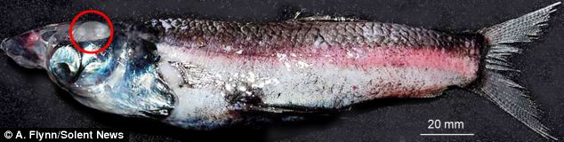
The fish has two primary cylindrical eyes pointing upwards so it can see prey or predators silhouetted against the gloomy light above. It also has a second set of oval-shaped silvery eyes on the side of its head (pictured) which have a mirror-like second lens and retina

HOW DOES THE FISH HAVE 360°VISION?
The glasshead barreleye fish has two primary cylindrical eyes pointing upwards so it can see prey or predators.
It also has a second set of silvery eyes on the side of its head with a mirror-like second lens.
The silvery 'extra' eyes detect bioluminescent flashes created by deep-sea creatures to give the glasshead barreleye fish views to its sides and below.
The light coming from below is focused onto a second 'retina' by a curved mirror composed of many layers of small reflective plates made of guanine crystals, giving the fish a much bigger field of vision.
Reflector eyes are usually only found in invertebrates, such as molluscs and crustaceans.
- Its silvery 'extra' eyes detect bioluminescent flashes created by deep-sea creatures to give the glasshead barreleye fish views to its sides and below, according to a study in the journal Proceedings of the Royal Society.
- The light coming from below is focused onto a second 'retina' by a curved mirror composed of many layers of small reflective plates made of guanine crystals, giving the fish a much bigger field of vision.
- It was caught in the Tasman Sea during an international research project and measures 18cm in length.
- The results of the study into the fish's vision were unexpected as reflector eyes are usually only found in invertebrates, such as molluscs and crustaceans.
- However, one other vertebrate, the deep-sea brownsnout spookfish or (Dolichopteryx longipes) also uses a combination of reflective and refractive lenses in its eyes.
- Professor Hans-Joachim Wagner, of the University of Tubingen's Institute of Anatomy in Baden-Wurttemberg, Germany, made the discovery. He said: ‘Obviously, a broad field of vision is an advantage even at great depths.’
+4
The fish studied was caught in the Tasman Sea (illustrated) during an international research project and measures 18cm in length

+4

The deep ocean fish's silvery eyes (marked with arrows) detect bioluminescent flashes of light created by deep-sea creatures to give the glasshead barreleye fish views to its sides and below

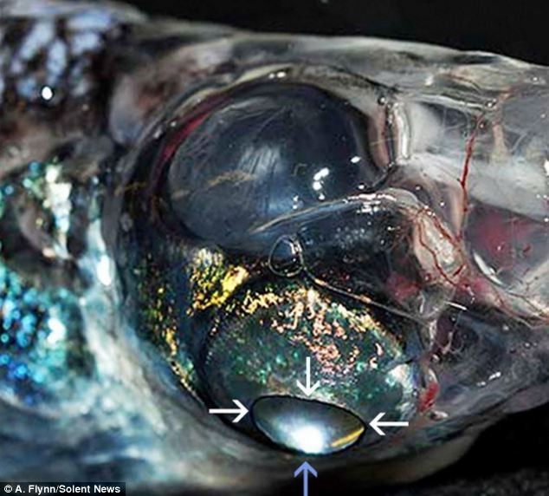
DIFFERENT FISH HAVE EYES IN DIFFERENT PLACES

Most fish have eyes on the sides of their heads because their eyes are bifocal so that light entering from some directions has a short journey to the retina than light from other directions.
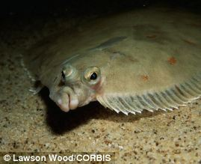
The whole eye tends to protrude from the fish's head, which combined with the animal's movement, means fish have good all-round vision.

A deep sea fish called Opisthoproctus soleatus has telescopic eyes that are placed on its head so that it looks straight up towards the sky.

Mud skippers have eyes on 'turrets' so they can see all around and when they are on mud they can withdraw their eyes into turrets to clean and lubricate them.
Another four-eyed fish called Anableps tetrophthalmus has eyes on top of its body. Each eye is divided into two parts. The upper part is designed for seeing in air, while the lower part has evolved for underwater vision, allowing the animal to swim effectively at the water's surface.
Flatfish such as soles, turbots and plaice (pictured, above) have both eyes on the same side of their heads so they can 'lie' on one side but face upwards - an adaptation to living on the seabed.
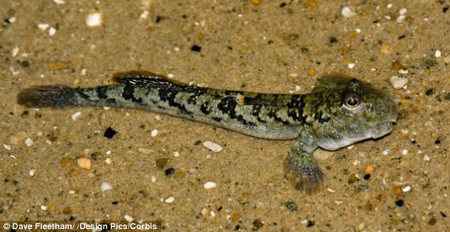
+4
Mud skippers (pictured) have eyes on 'turrets' so they can see all around. When they are on mud they can withdraw their eyes into the turrets to clean and lubricate them

https://www.dailymail.co.uk/sciencetech/article-2587906/The-fish-FOUR-eyes-Deep-sea-creature-360-vision-spot-prey-predators-mates.html

