Unique Glow Helps Identify Two New Fish Species
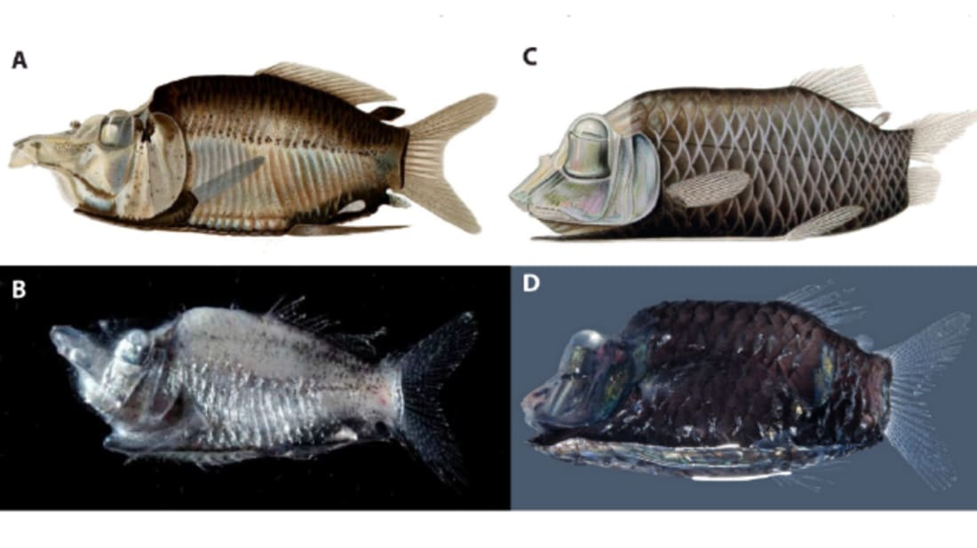
POULSEN ET AL. 2016.

Scientists have found two new species of glowing fish with tube-shaped eyes and mirrors on their bellies, according to their research in journal PLOS One.

The Opisthoproctidae, or barreleyes, are a unusual family. For example, take a look at the transparent-headed, tiny-mouthed Macropinna microstoma. Those green objects pointing upward are its eyes, and what appear to be eyes at front are actually the barreleye equivalent of nostrils.
Scientists have had a hard time getting to know the barreleyes better because the fishes’ delicate bodies kind of collapse once they’re out of the water. M. microstoma, for example, was first described in 1939, but nobody knew about its clear, fragile forehead until a remotely operated vehicle captured the video above in 2004.

Based on the evidence they had, researchers believed there were 19 species in the barreleye family. Some of these species have bioluminescent, or light-producing, organs in their bellies, along with mirror-like organs called soles that lie beneath the glow, controlling and directing its light.

During a research cruise in 2013 and 2014, the Japanese research vessel Hakuho-Maru pulled up four fish that looked like barreleyes. Researchers onboard the boat took tissue samples, then dropped the fish into ethanol and stored them in a sub-zero freezer to help the specimens keep their shape.

An international team of scientists took it from there. They examined and photographed the specimens and sequenced their DNA, then compared these results with data on existing barreleye species. They found that, while similar to one another, the new fishes’ mirror bellies showed three different types of markings. The DNA tests confirmed it: They were three different species, two of which had never been seen before. The new species were definitely barreleyes, but were so distinct from known species that the researchers put them in a separate genus, Monacoa. (They suggest calling them "long-nosed mirrorbellies" in the vernacular.)

Monacoa is what’s called a resurrected genus. A long time ago, ichthyologist GP Whitley believed he’d found a fish different enough from its kin to merit a new genus, which he named Monacoa. Later, other scientists disagreed, and moved Monacoa grimaldii into the genus Opisthoproctus. But based on the markings on the new fishes’ bellies, the authors of the current study say Whitley was right. They realized that the old specimens could never have led to this conclusion, as the formalin used to preserve the fish damaged their markings.

The two new species, M. niger and M. griseus, are both native to the Pacific Ocean. Unlike other fish that prefer pure blackness, these fish inhabit depths that still get some sunlight. In semi-lit conditions, the authors say, the barreleyes might use their bioluminescence as camouflage, or to communicate with one another.

"This new study on the deep-sea has shown unknown biodiversity in a group of fishes previously considered teratological variations of other species," lead author Jan Poulsen of the Australian Museum said in a press statement. "The different species of mirrorbelly-tube eyes can only be distinguished on pigmentation patterns that also constitutes a newly discovered communication system in deep-sea fishes."

https://www.mentalfloss.com/article/84641/unique-glow-helps-identify-two-new-fish-species

